**VIETNAM NATIONAL UNIVERSITY - HO CHI MINH CITY**

**UNIVERSITY OF INFORMATION TECHNOLOGY**

**FACULTY OF INFORMATION SYSTEMS**

**PROJECT FINAL REPORT**

**INFORMATION SYSTEM ANALYSIS AND DESIGN**

**COFFEE SHOP MANAGEMENT SYSTEM**

**Instructors: PhD. Cao Thị Nhạn, M.S. Dương Phi Long**

Nguyen Le Thai Hien - 20521308

To Thai Duy - 20521247

Tran Thi Tuyet Linh - 20521540

Nguyen Viet Hoang - 20521348

**HO CHI MINH CITY. 2022**

**TABLE OF CONTENTS**

Chapter 1: INTRODUCTION 8

1.1. Introduction 8

1.2. Research problems / Problems of the project 8

1.3. Research Objectives / Objectives of the project 9

1.4. Scope of project / Limitations of the study 9

Chapter 2: REQUIREMENT SPECIFICATION 10

2.1. Situation survey/ Survey of the current situation 10

2.1.1 Interview 10

2.1.2. Survey of the organization/ Current organizational situation 13

2.1.3. Survey of business processes, and major activities 13

2.1.3.1 Business Department 13

2.1.3.2 Accountant 14

2.1.3.3 Human Department 15

2.2. Software requirements 15

2.2.1. Functional requirements 15

2.2.2. Non-functional requirements 16

Chapter 3: ANALYSIS AND DESIGN 17

3.1. Use-case Diagram 17

3.1.1 List of actors 18

3.1.2 List of Use-case 19

3.2. Use-case specification and activity diagram (Activity Diagram) 20

3.2.1 Sign in 20

3.2.2 Manage employees 21

3.2.2.1 Insert employee 21

3.2.2.2 Update employees 23

3.2.2.3 Delete employee 25

3.2.2.4 Search employees 27

3.2.3 Manage menu 28

3.2.3.1 Insert menu 28

3.2.3.2 Update menu 30

3.2.3.3 Delete menu 34

3.2.3.4 Search menu 37

3.2.4 Manage promotion 40

3.2.4.1 Insert promotion 40

3.2.4.2 Update promotion 42

3.2.4.3 Delete promotion 44

3.2.4.4 Search promotion 46

3.2.5 Manage Membership 48

3.2.5.1 Insert Membership 48

3.2.5.2 Update Membership 50

3.2.5.3 Delete Membership 52

3.2.5.4 Search Membership 54

3.2.6 Statistic product 56

3.2.6.1 Analysis 56

3.2.6.2 Statistic (for the product) 57

3.2.7 Statistic revenue 58

3.2.7.1 Search revenue history 58

3.2.7.2 Statistic (for revenue) 59

3.2.8 Sign in (for employee) 60

3.2.9 Forgot password (for employee) 62

3.2.10 Change password (for employee) 64

3.2.11 Place an invoice 66

3.2.11.1 Add order 66

3.2.11.2 Apply promotion 68

3.2.11.3 Apply membership 69

3.2.11.4 Payment 71

3.3. Sequence Diagram and Class Diagram 73

3.3.1 Sign in 73

3.3.1.1 Sequence Diagram 73

3.3.1.2 Class Diagram 74

3.3.2 Manage employees 75

3.3.2.1 Sequence Diagram 75

3.3.2.2 Class Diagram 78

3.3.3 Manage menu 79

3.3.3.1 Sequence Diagram 79

3.3.3.2 Class Diagram 89

3.3.4 Manage membership 90

3.3.4.1 Sequence Diagram 90

3.3.4.2 Class Diagram 95

3.3.5 Manage promotion 96

3.3.5.1 Sequence Diagram 96

3.3.5.2 Class Diagram 100

3.3.6 Statistic product 101

3.3.6.1 Sequence Diagram 101

3.3.6.2 Class Diagram 102

3.3.7 Statistic revenue 103

3.3.7.1 Sequence Diagram 103

3.3.7.2 Class Diagram 104

3.3.8 Sign in 105

3.3.8.1 Sequence Diagram 105

3.3.8.2 Class Diagram 106

3.3.9 Change password 107

3.3.9.1 Sequence Diagram 107

3.3.9.2 Class Diagram 108

3.3.10 Forgot password 109

3.3.10.1 Sequence Diagram 109

3.3.10.2 Class Diagram 110

3.3.11 Place an invoice 110

3.3.11.1 Sequence Diagram 110

3.3.11.2 Class diagram 114

3.4. Class Diagram and Entity class diagram 115

3.4.1 Administrator overview class diagram 115

3.4.2 Employee overview class diagram 116

3.4.3 Entity class diagram 117

3.4.4 Class diagram specification 118

3.4.4.1 User 118

3.4.4.2 Employee 118

3.4.4.3 Product type 120

3.4.4.4 Product 120

3.4.4.5 Membership 121

3.4.4.6 Promotion 122

3.4.4.7 Invoices 123

3.4.4.8 Sign_In_Controller 124

3.4.4.9 Employee_Management_Controller 124

3.4.4.10 Menu_Management_Controller 125

3.4.4.11 Membership_Management_Controller 126

3.4.4.12 Promotion_Management_Controller 127

3.4.4.13 Statistic_Product_Controller 127

3.4.4.14 Statistic_Revenue_Controller 128

3.4.4.15 Change_Password_Controller 128

3.4.4.16 Forgot_Password_Controller 128

3.4.4.17 Place_An_Invoice_Controller 129

3.5. State Diagram 130

3.6. Mapping to Relational Model from Entity class diagram 131

Chapter 4: IMPLEMENTATION AND TESTING 132

4.1. Introduction to the implementationenvironment 132

4.1.1 Development System 132

4.1.2 Deployment environment 132

4.2. User Interface 132

4.2.1 Employee Interface 132

4.2.2 Admin Interface 134

Chapter 5: CONCLUSION 139

5.1 Project achievement 139

5.2 Limitations 139

5.3 Development direction 140

**Structure of the report**

**Chapter 1: INTRODUCTION**

Introducing the contents of the key topics. Contents of chapter 1 include:

Introduction,Problems of the project, Objectives of the project, Scope of the project. **Chapter 2: REQUIREMENT SPECIFICATION**

In this chapter, we will do some research that the system requirements based on a survey of the current situation, current organizational situation, and software requirements

**Chapter 3: ANALYSIS AND DESIGN**

Our system requirements models will be created and develop some diagrams such as class diagrams, sequence diagrams, and state diagrams.

**Chapter 4: IMPLEMENTATION AND TESTING**

Content in this chapter is the result of the implementation of the group. Description of some test cases of the system, database implementation results, construction results, and user interface.

**Chapter 5: CONCLUSION**

The group will summarize the results that we have achieved when implementing the topic, the issues solutions, and the shortcomings of the subject. After that, we will put additional ideas and development ideas for the topic.

# Chapter 1: INTRODUCTION

## 1.1. Introduction

Nowadays, coffee has been deeply woven into Vietnamese's social and economic fabric. Coffee shops are popping up by the day, ranging from small independent stores to huge chain stores. Moreover, the coffee shop provides not only coffee but also a wide variety of drinks. Sitting at a coffee shop, for the young generation, offers a means of escapism in that it frees their mind of all the stress and burden of everyday life.

Since the number of customers who visit coffee shops is increasing rapidly, these shop owners get into trouble with managing their system. Therefore, it is of significance to build a coffee management system that can handle their tasks. The coffee shop management system will help business owners solve problems such as invoice management, expenditure, staff, and raw materials, … Moreover, the system must be friendly designed, increase data accuracy, make coffee shop management more secure, effective, and begin to coordinate information across the system. Besides, the system is easy to use and can adjust to any business frame. This system can lift off the weight of managing shops heavily and lets the owners focus on running the coffee shop more efficiently and also without costing a lot.

## 1.2. Research problems / Problems of the project

Due to the fact that there are numerous coffee shops in Viet Nam, customers have a wide range of shops for them to choose from, and those shops already have their system. If the shop doesn't serve the customer as quickly as possible, the customer may start to feel uncomfortable because of waiting and maybe leaving which leads to losing the customer. With the help of our system, the employee can immediately and easily research information about the shop’s product, ingredients, membership customers, and promotions and the order can be created. The coffee shops take advantage of customers’ information and feedback to make promotions for marketing, and update menu based on bestseller drinks. In these times, a large number of coffee shops have been applying technology to manage their systems but still cannot handle some unpredictable situations in the system. However, our new system has updated some new methods that could easily solve some of those situations.

## 1.3. Research Objectives / Objectives of the project

In the objectives of this project, we would like to build a system that allows users to manage their coffee shops effectively.

There are some of our system’s main features:

* Output sheet for reports.
* Employee management.
* Membership management.
* Import process management.
* Promotion management.
* Revenue management.
* Menu management.
* Analysis and statistics.
* Latest information update.
* Place an invoice for the customer
* Backup.

## 1.4. Scope of project / Limitations of the study

* Employee management.
* Menu management.
* Promotion management.
* Membership management.
* Analysis of revenue and order.
* Place an invoice.

# Chapter 2: REQUIREMENT SPECIFICATION

## 2.1. Situation survey/ Survey of the current situation

### 2.1.1 Interview

|  |  |  |  |  |
| --- | --- | --- | --- | --- |
| **General survey**  **System**: Highland Coffee **Creator**: Nguyễn Lê Thái Hiền **Created Date**: 20/03/2022 | | | | |
| **Order** | **Topic** | **Requirement** | **Start** | **End** |
| 1 | Employee management | Understand the management and organization of work for employees. | 20/03/2022 | 20/03/2022 |
| 2 | Membership management | Customers who sign up for membership will be awarded membership reward points depending on their payment. | 20/03/2022 | 20/03/2022 |
| 3 | Revenue management | Understand the process of importing sales. Process of making a report on drinks and food  sales based on the database. | 20/03/2022 | 20/03/2022 |
| 4 | Menu management | Update drinks based on the customer's favorite flavor in order to bring the best experience for them. | 20/03/2022 | 20/03/2022 |
| 5 | Promotion management | Add deals or promotions to attract customers. Moreover, each of the customers will be given a special promotion based on their information. | 20/03/2022 | 20/03/2022 |

**Table 1. Survey Strategy**

|  |  |
| --- | --- |
| **Survey forms**  **System**: Highland Coffee | |
| **Interviewee**: Lê Anh Thơ | **Interviewer**: Nguyễn Việt Hoàng |
| Place: Highland Coffee shop Target: Gathering information to know clearly about the working process of the coffee shop | Date: 21/03/2022  Time start: 8h30 AM Time end: 10h AM |
| Details of the interview:   * Introduction * Overview of the survey topics and the current system * Survey plan:   + Topic 1: Employee management   + Topic 2: Membership management   + Topic 3: Revenue management   + Topic 4: Menu management   + Topic 5: Promotion management | Estimated time:  7 minutes 15 minutes  35 minutes |

**Table 2. Survey form**

|  |  |  |
| --- | --- | --- |
| **Interviewee**: Lê Anh Thơ | | 21/03/2022 |
| **Questions** | | **Records** |
| **Topic 1** | What is the structure of the coffee shop? | The organization is divided into 4 sets including the manager department, business department, human department, accountant department. |
| What are the salary and bonus regimes of the restaurant and the treatment regime for employees? | For each department, there will be a different salary. About the bonuses, it will depend on the revenue of the restaurant and the working attitude of the staff. |
| **Topic 2** | Why do we need a membership? | Membership helps us have the customer information in order to apply the suitable promotions for customer’s events. |
| What are the benefits of being a member? | Customers will have their promotions on special days such as birthdays, holidays,… During each purchase, customers will earn member points and they can use that to redeem the promotions |
| **Topic 3** | What happens when the staff input the wrong information on bills? | Scenario analysis in automated revenue technology allows staff/ managers/ admin to explore the outcomes of potential rate changes. This capability will help us to change/ fix the bills. |
| What is the main goal of revenue management? | The primary aim of revenue management is selling the right product to the right customer at the right time for the right price and with the right pack. |
| How revenue management can benefit your business? | This will allow the manager to predict what customers want and need. So, we can launch a more effective price strategy. |
| **Topic 4** | What happens if the drinks or foods are out of order but it is still "Available" for staff to choose from? | Our system will automatically cancel the option if the staff chooses an expired dish. |
| How can customers know if there are new dishes on a menu? | We will have a poster on our menu to announce and update if there are new upcoming drinks or foods. |
| **Topic 5** | Why do we need promotion management? | Because there might be 2 or 3 promotions going on at the same time. Promotion management will combine the promotions and give the customer the best deal. |
| How can we decide on a promotion program? | Depending on the customer’s order we can find out top-selling drinks, and foods,... and create more profit by giving a promotion on the least favorite item to free up inventory. |

### 2.1.2. Survey of the organization/ Current organizational situation

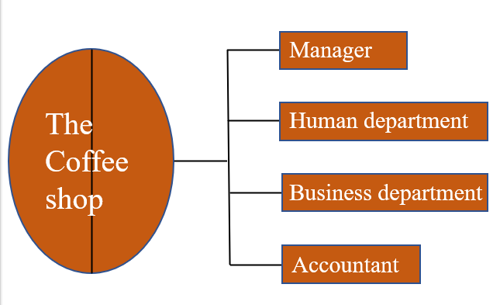

### 2.1.3. Survey of business processes, and major activities

#### 2.1.3.1 Business Department

* **Menu management business:** inputting information about foods, drinks, formulas, prices, etc. Including inputting information and pricing.
* Importing information process:
* Input data and store it in our database for future transactions.
* Some kinds of data: foods and drinks information, formulas, prices, etc.
* Pricing process:
* Based on original price from the ingredients and the markets.
* With a specific formula.
* Store in database.
* **Marketing business:** making new promotions for selling a product or advertising a brand new product. Including promotions and customer services.
* Promotion process:
* Came up with strategies to attract customers on buying the goods.
* Expand the coffee brand on the marketplace.
* Customer services process: make customers familiar with the system and provide information to customers as quickly as possible.
* Manage customer information.
* Fulfill any customer's needs in time.

#### 2.1.3.2 Accountant

* **Analysis of business:** a disciplined approach for introducing and managing change to organizations, whether they are for-profit businesses, or non-profits.

Department in monitoring the performance system. Including the process of calculating wages and paying employees' salaries, and reports.

* **Salaries process:**
* Collect data about each employee working shift at the Human Department.
* Calculate salary and bonus for each employee at the end of the month.
* Store data into the database.
* **Reporting process:**
* Get data from the database.
* Create reports main-based on the number of receipts, promotions, and customer feedbacks.
* Evaluate the report and transfer it to the manager.

#### 2.1.3.3 Human Department

* **Human resource management business:** monitor the activities of all employees in the coffee shop, including employee information management process, employee activity management process, and other processes.
* ***Employee information management process:***
* Recruitment.
* Enter employee information.
* Update employee information.
* Delete employee information.
* ***Employee activity management process:***
* Employee working hours and activity history.
* Create a report every week based on employee activities.

## 2.2. Software requirements

### 2.2.1. Functional requirements

**Storage**:

> Employee’s information: name, id, password, age, gender, phone number, email, start_date, wage, image.

> Menu’s information: name, id, price, image.

> Revenue’s information: id, date, price.

> Customer’s information: id, name, phone number.

> Promotion’s information: id, name, date.

**Query**: able to respond to requests from managers/employees such as: find the name of drinks or foods, find bill's information, find promotion information….

**Calculate:** automatically calculate the employee wage, calculate the sum of orders, and calculate employee’s working hours,...

**Statistical, analysis, reporting:** help the manager give the solutions and changes to the menu, promotions, and employees based on reports analysis.

**Update**: the system must ensure that the update function is convenient and

avoid errors due to the user's negligence.

### 2.2.2. Non-functional requirements

Besides those Functional requirements, we want our employees to easily interact with the system and have the best experience with it. So, there are some Non-functional requirements :

* The management GUI requirements: easy for beginners to understand, simple to use, and easy to query.

Quality requirements:

* Evolution: easy to upgrade or increase utility modules.
* Convenience:

‣ Clear specifications and instructions for use.

‣ The system has an intuitive, user-friendly, and easy-to-use interface.

* Security:

‣ Authentication and password management, safety for all employees.

‣ Only direct managers can see personnel records of staff.

# 

# Chapter 3: ANALYSIS AND DESIGN

## 3.1. Use-case Diagram

Employees must be signed in to use all employee services

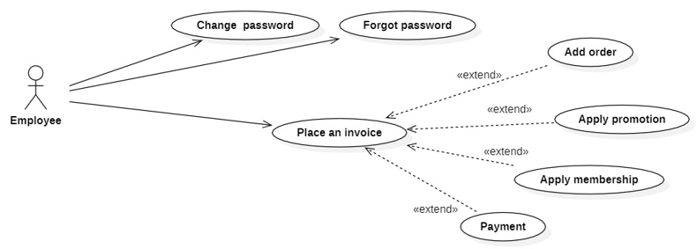

**Diagram 1: Use case diagram as an employee**

Administrator must be signed in to use all management services

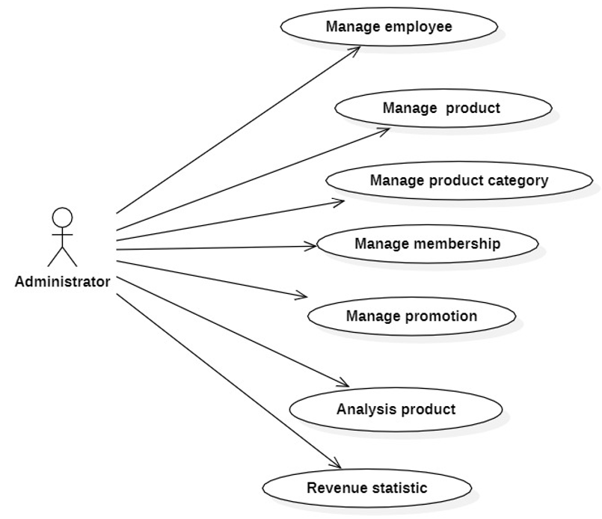

**Diagram 2: Use case diagram as an administrator**

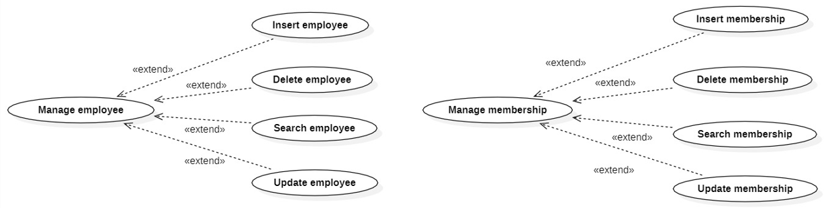

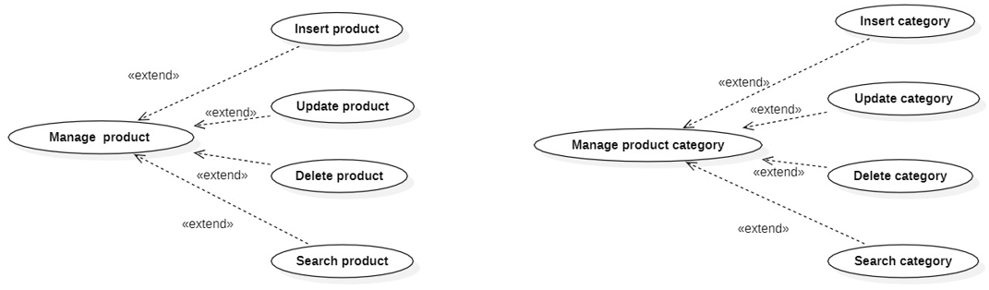

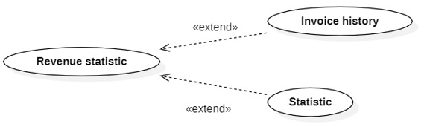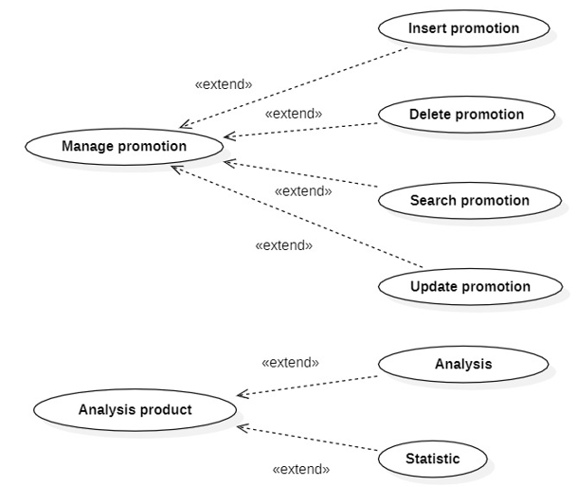

**Diagram 3: Administrator use-case diagram in detail**

### 3.1.1 List of actors

|  |  |  |
| --- | --- | --- |
| **Index** | **Actors** | **Meaning** |
| 1 | Administrator | People who take charge of the system management |
| 2 | Employees | People who use the system service partially |

### 

### 3.1.2 List of Use-case

|  |  |  |  |
| --- | --- | --- | --- |
| **Role** | **Index** | **Usecase** | **Meaning** |
| Administrator's role | 1 | Sign in | Sign in to use the management services |
| 2 | Manage employees | Insert/Update/Delete/Search employees |
| 3 | Manage product | Insert/Update/Delete/Search products |
| 4 | Manage product category | Insert/Update/Delete/Search product categories |
| 5 | Manage membership | Insert/Update/Delete/Search members |
| 6 | Manage promotion | Insert/Update/Delete/Search promotions |
| 7 | Analysis product | Analysis of customer’s order based on invoice details |
| 8 | Revenue statistic | Statistic revenue every month based on invoice revenue |
| Employee’s role | 1 | Sign in | Sign in to use the services |
| 2 | Change password | Change password to remember easier and increase the account security |
| 3 | Forgot password | Recreate the password if forgetting it |
| 4 | Place an invoice | Place order to serve the customer’s needs |
| 5 | Email | Send promotion no |

## 

## 3.2. Use-case specification and activity diagram (Activity Diagram)

### 3.2.1 Sign in

|  |  |
| --- | --- |
| **Use-case name** | **Sign in** |
| Description | User uses the registered account to sign into the system for all services |
| Trigger | User clicks on the “Sign-in” button |
| Precondition | User’s account has already existed |
| Post-condition | User gets a notification about “Sign-in” success  User redirected to manager page and can use the management services |
| Basic flow | 1. System displays the sign-in page  2. User enters username and password then clicks the “Sign-in” button  3. System validates username and password in the correct format.  4. System validates the user’s data with an existed administrator account in the database  5. System stores the signed-in status of administrators using sessions  6. System displays successful signed-in and redirects to the management page |
| Alternative flow | 3a. System displays invalid information due to the wrong format.  Use-case continues at step 2.  4a. System displays invalid information due to the user’s account information does not match with existing account information in the database  Use-case continues at step 2. |
| Exception flow |  |

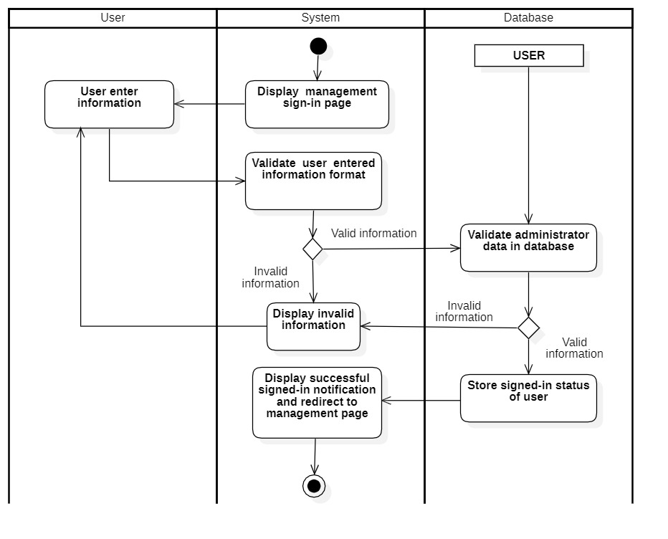

### 3.2.2 Manage employees

#### 3.2.2.1 Insert employee

|  |  |
| --- | --- |
| **Use-case name** | **Insert employee** |
| Description | Administrator can insert employee’s information into the database |
| Trigger | Administrator click on the button “Insert” at manage employee’s page |
| Precondition | Administrators’ account existed  Administrator’s status is signed-in |
| Post-condition | Employee information was successful insert into the database  Data on the management page is updated (with new employee) |
| Basic flow | 1. System displays employee management page with data loaded from database (existing employees)  2. Administrators enter employee information  3. System validates employee information in correct format  4. System validates employee information with existing data in the database.  5. System stores employee information in database  6. System updates data on employee management page with inserted data (new data). |
| Alternative flow | 3a. System displays invalid information due to the wrong format.  Use-case continues at step 2.  4b. System display invalid information because data had existed in the database.  Use-case continues at step 2. |
| Exception flow |  |

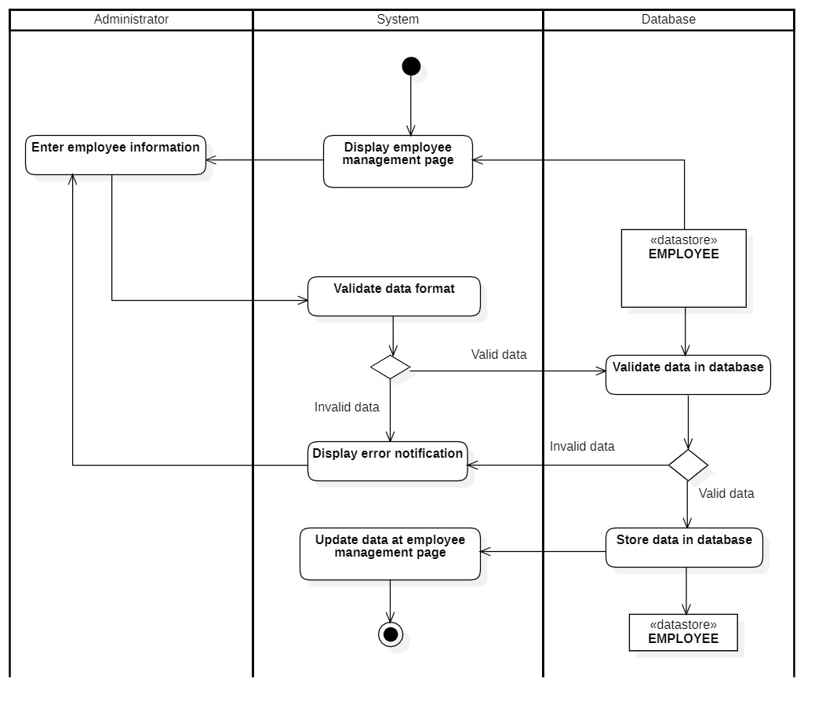

#### 3.2.2.2 Update employees

|  |  |
| --- | --- |
| **Use-case name** | **Update employee** |
| Description | Administrator can update employee’s information in database |
| Trigger | Administrator click on button “Update” on manage employee page |
| Precondition | Administrators’ account existed  Administrator’s status is signed-in.  Employee information must be existed in database before updating |
| Post-condition | Data at management is updated (with updated information at selected employee) |
| Basic flow | 1. System display employee management page with data loaded from database (existed employee)  2. Administrators select item to be updated  3. System display employee information form with existed data  4. Administrators modify employee information  5. System validate employee information in correct format  6. System validates employee information with existing data in the database.  7. System updates employee information in the database  8. System updates data at employee management page with updated data at selected item. |
| Alternative flow | 5a. System displays invalid information due to the wrong format.  Use-case continues at step 4.  6b. System display invalid information because selected data hadn’t been existed in the database.  Use-case continues at step 4. |
| Exception flow |  |

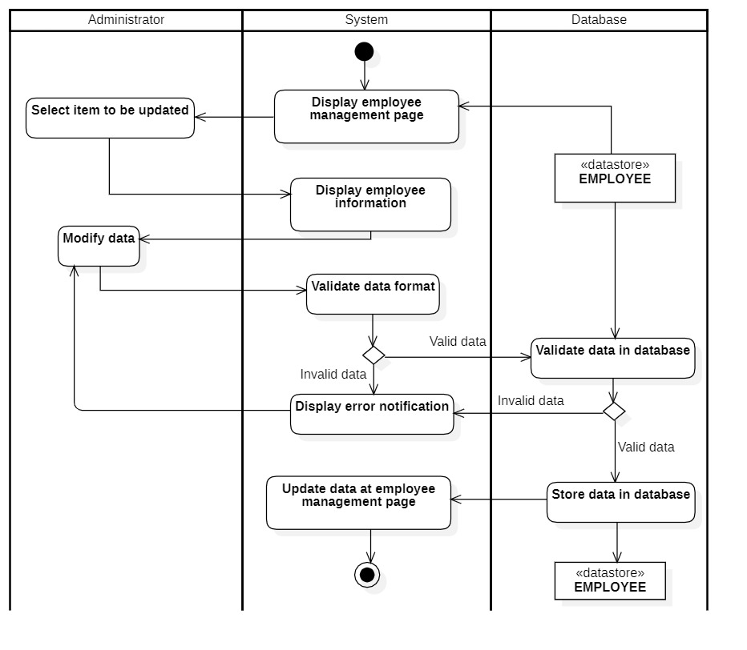

#### 3.2.2.3 Delete employee

|  |  |
| --- | --- |
| **Use-case name** | **Delete employee** |
| Description | Administrator can delete an existed employee’s information from database |
| Trigger | Administrator click on button “Delete” at manage employee page |
| Precondition | Administrators’ account existed  Administrator’s status is signed-in.  Employee information must be existed in database before deleting |
| Post-condition | Data at management page is updated (selected employee had been deleted) |
| Basic flow | 1. System display employee management page with data loaded from database (existed employee)  2. Administrators select item to be deleted and delete button.  3. System display confirm message  4. System deletes employee information in the database  5. System updates data at employee management page with selected item deleted. |
| Alternative flow |  |
| Exception flow | 3a. Administrator chooses no  Use-case stop. |

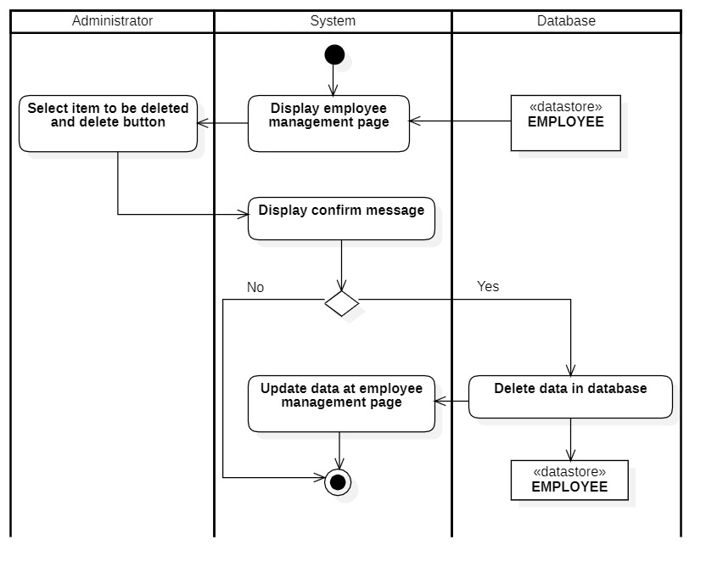

#### 3.2.2.4 Search employees

|  |  |
| --- | --- |
| **Use-case name** | **Search employee** |
| Description | Administrator can search employee’s information in the database |
| Trigger | Administrator click on button “Search” at manage employees page |
| Precondition | Administrators’ account existed  Administrator’s status is signed-in |
| Post-condition | Data on management page is filtered by keywords |
| Basic flow | 1. System display employee management page with data loaded from database (existed employee)  2. Administrators enter keywords in the search box  3. System processes searching data  4. System queries data based on keywords  5. System updates data on the employee management page (data related to the keyword is retained) |
| Alternative flow | 4a. Use-case stops because there is no result related to keywords |
| Exception flow |  |

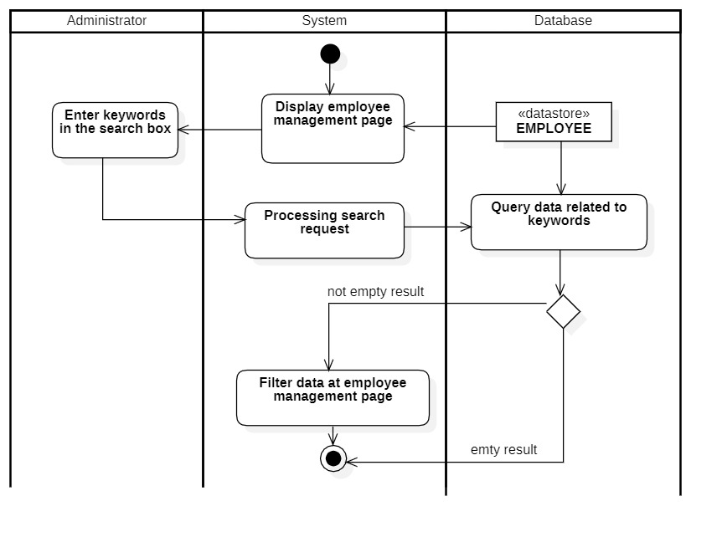

### 

### 3.2.3 Manage product

#### 3.2.3.1 Insert product

|  |  |
| --- | --- |
| **Use-case name** | **Insert menu** |
| Description | Administrator can insert a new product to database |
| Trigger | Administrator click on button “Insert” at manage menu page |
| Precondition | Administrators’ account existed  Administrator’s status is signed-in |
| Post-condition | Product successful insert into menu database  Data at menu page is updated (with new item) |
| Basic flow | 1. System display menu management page with data loaded from database (existed menu)  2. Administrators enter product information  3. System validates product information in correct format  4. System validates product information with existing data in the database.  5. System stores item information in database  6. System updates data at menu management page with inserted data (new data). |
| Alternative flow | 3a. System displays invalid information due to the wrong format.  Use-case continues at step 2.  4b. System display invalid information because item had been existed in the database.  Use-case continues at step 2. |
| Exception flow |  |

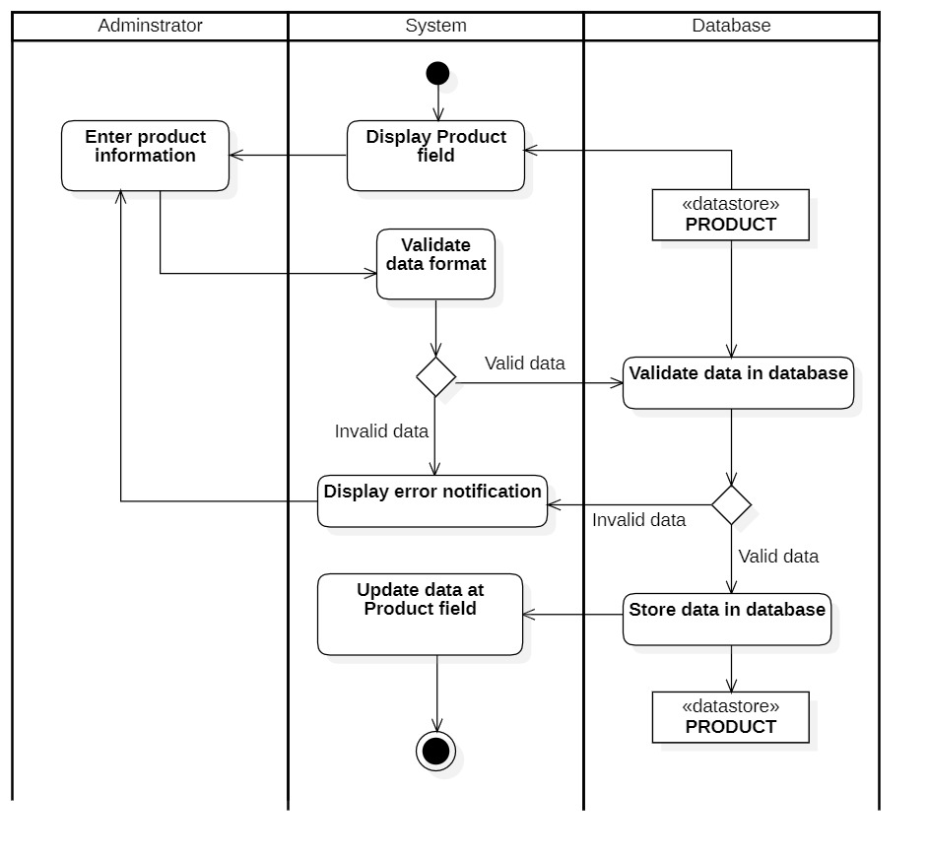

#### 3.2.3.2 Update product

|  |  |
| --- | --- |
| **Use-case name** | **Update menu** |
| Description | Administrator can update product information to database |
| Trigger | Administrator click on button “Update” at manage menu page |
| Precondition | Administrators’ account existed  Administrator’s status is signed-in  Product information must be existed in database before updating |
| Post-condition | Data at management is updated (with updated information at selected product) |
| Basic flow | 1. System display menu management page with data loaded from database (existed employee)  2. Administrators select item to be updated  3. System display product information with existed data  4. Administrators modify product nformation  5. System validate product information in correct format  6. System validates product information with existing data in the database.  7. System updates product information in the database  8. System updates data at menu management page with updated data at selected item. |
| Alternative flow | 5a. System displays invalid information due to the wrong format.  Use-case continues at step 4.  6b. System display invalid information because selected data hadn’t been existed in the database.  Use-case continues at step 4. |
| Exception flow |  |

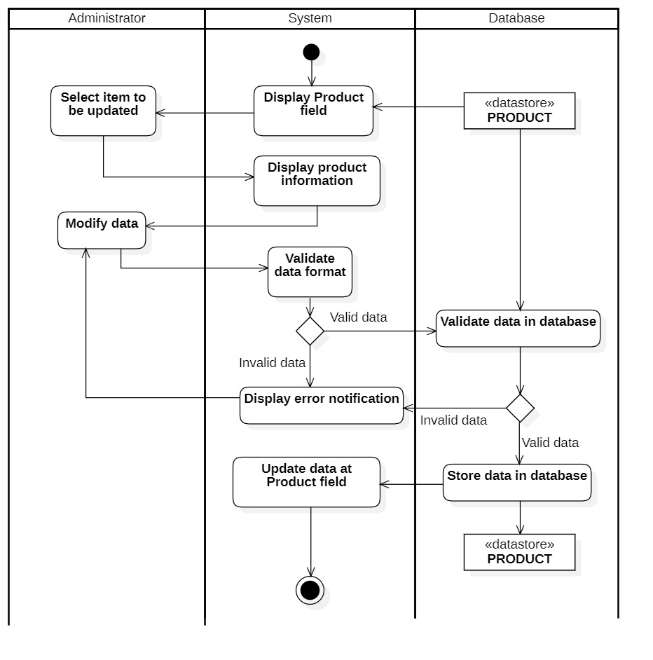

#### 3.2.3.3 Delete product

|  |  |
| --- | --- |
| **Use-case name** | **Delete menu** |
| Description | Administrator can delete an existed product from menu database |
| Trigger | Administrator click on button “Delete” at manage menu page |
| Precondition | Administrators’ account existed  Administrator’s status is signed-in.  Product information must be existed in database before deleting |
| Post-condition | Data at management page is updated (selected category/product had been deleted) |
| Basic flow | 1. System display menu management page with data loaded from database (existed category/product)  2. Administrators select item to be deleted and delete button  3. System display confirm message  5. System deletes product information in the database  6. System updates data at menu management page with selected item deleted. |
| Alternative flow |  |
| Exception flow | 3a. Administrator choose no  Use-case stop. |

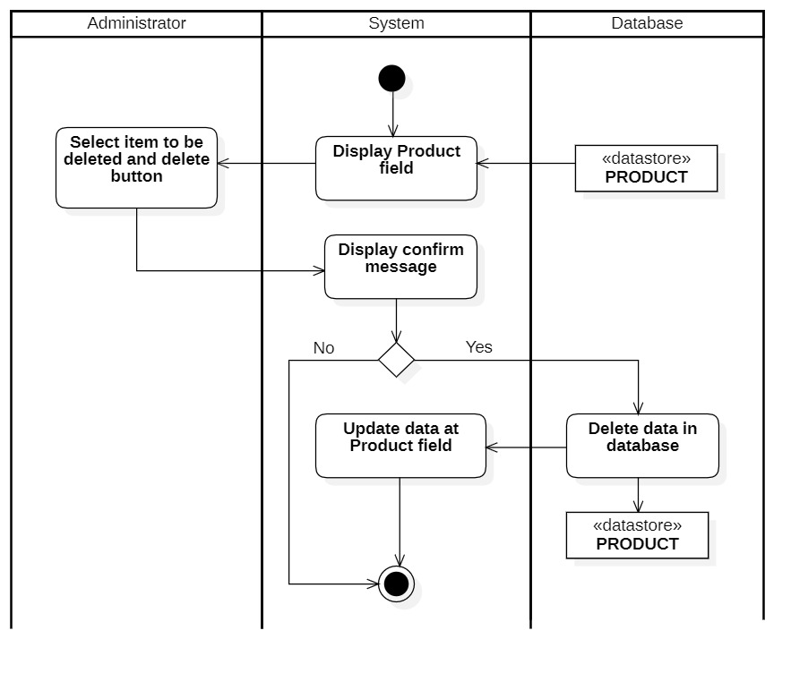

#### 3.2.3.4 Search product

|  |  |
| --- | --- |
| **Use-case name** | **Search menu** |
| Description | Administrator can search product information in the database |
| Trigger | Administrator click on button “Search” at menu page |
| Precondition | Administrators’ account existed  Administrator’s status is signed-in |
| Post-condition | Data at management page is filtered by keywords |
| Basic flow | 1. System display menu management page with data loaded from database (existed )  2. Administrators enter keywords in search box  3. System processes searching data  4. System queries data related to keywords  5. System updates data at menu management page (data related to keyword is retained) |
| Alternative flow | 4a. Use-case stops because there is no result related to keywords |
| Exception flow |  |

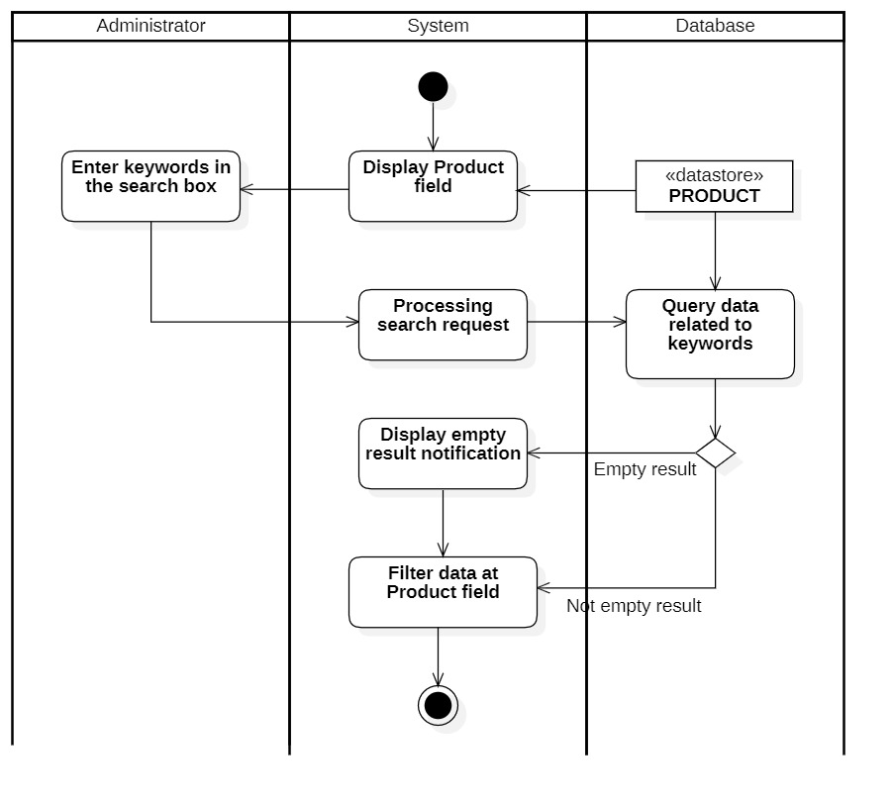

### 3.2.4 Manage category

#### 3.2.4.1 Insert category

|  |  |
| --- | --- |
| **Use-case name** | **Insert menu** |
| Description | Administrator can insert a new category to database |
| Trigger | Administrator click on button “Insert” at manage menu page |
| Precondition | Administrators’ account existed  Administrator’s status is signed-in |
| Post-condition | Category successful insert into menu database  Data at menu page is updated (with new item) |
| Basic flow | 1. System display menu management page with data loaded from database (existed menu)  2. Administrators enter category information  3. System validates category information in correct format  4. System validates category information with existing data in the database.  5. System stores item information in database  6. System updates data at menu management page with inserted data (new data). |
| Alternative flow | 3a. System displays invalid information due to the wrong format.  Use-case continues at step 2.  4b. System display invalid information because item had been existed in the database.  Use-case continues at step 2. |
| Exception flow |  |

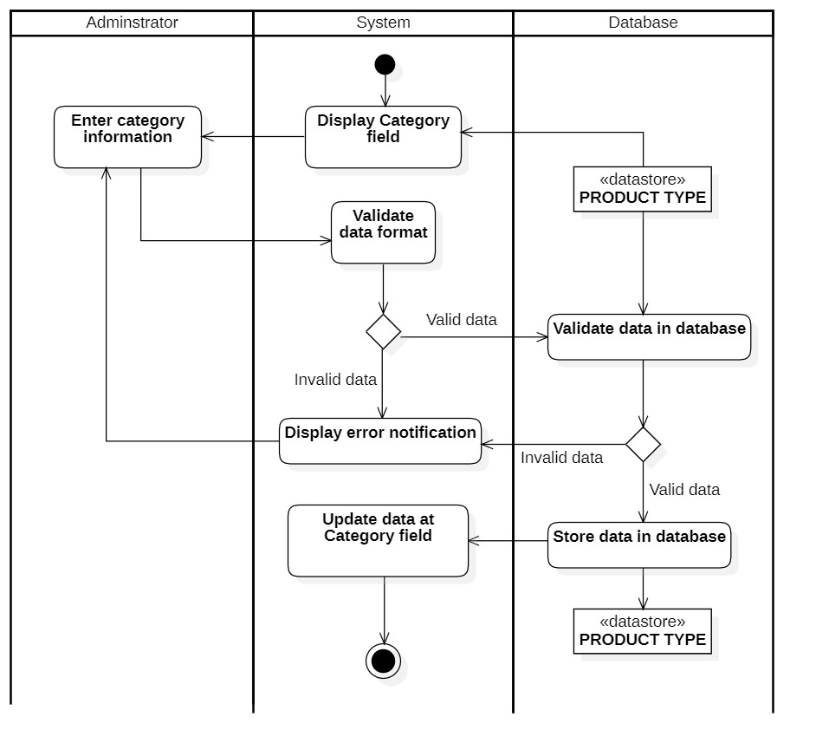

#### 3.2.4.2 Update category

|  |  |
| --- | --- |
| **Use-case name** | **Update menu** |
| Description | Administrator can update category information to database |
| Trigger | Administrator click on button “Update” at manage menu page |
| Precondition | Administrators’ account existed  Administrator’s status is signed-in  Category information must be existed in database before updating |
| Post-condition | Data at management is updated (with updated information at selected category/product) |
| Basic flow | 1. System display menu management page with data loaded from database (existed employee)  2. Administrators select item to be updated  3. System display category information with existed data  4. Administrators modify category nformation  5. System validate category information in correct format  6. System validates category information with existing data in the database.  7. System updates category information in the database  8. System updates data at menu management page with updated data at selected item. |
| Alternative flow | 5a. System displays invalid information due to the wrong format.  Use-case continues at step 4.  6b. System display invalid information because selected data hadn’t been existed in the database.  Use-case continues at step 4. |
| Exception flow |  |

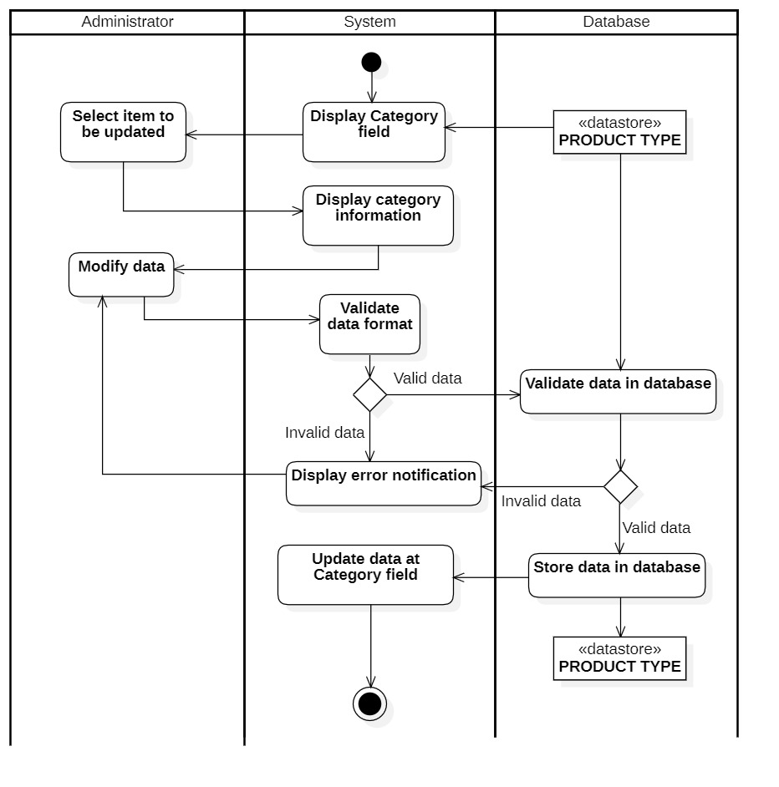

#### 3.2.4.3 Delete category

|  |  |
| --- | --- |
| **Use-case name** | **Delete menu** |
| Description | Administrator can delete an existed category from menu database |
| Trigger | Administrator click on button “Delete” at manage menu page |
| Precondition | Administrators’ account existed  Administrator’s status is signed-in.  Category information must be existed in database before deleting |
| Post-condition | Data at management page is updated (selected category/product had been deleted) |
| Basic flow | 1. System display menu management page with data loaded from database (existed category/product)  2. Administrators select item to be deleted and delete button  3. System display confirm message  5. System deletes category information in the database  6. System updates data at menu management page with selected item deleted. |
| Alternative flow |  |
| Exception flow | 3a. Administrator choose no  Use-case stop. |

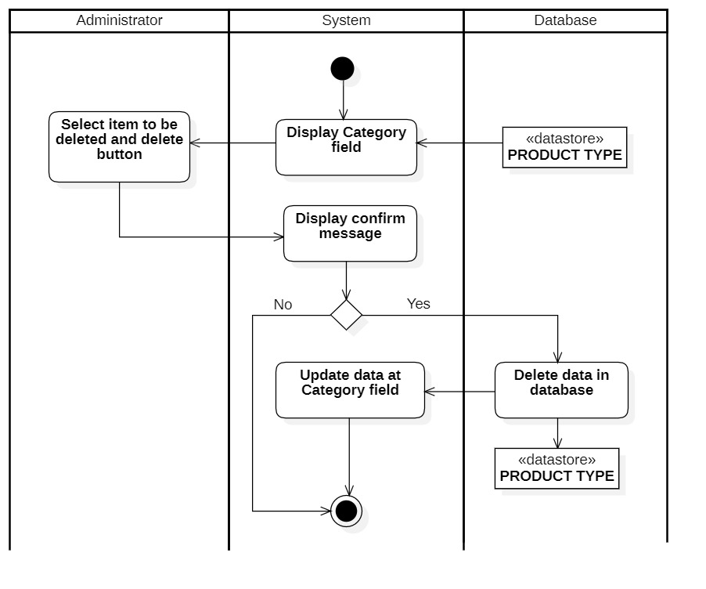

#### 3.2.4.4 Search category

|  |  |
| --- | --- |
| **Use-case name** | **Search menu** |
| Description | Administrator can search category information in the database |
| Trigger | Administrator click on button “Search” at menu page |
| Precondition | Administrators’ account existed  Administrator’s status is signed-in |
| Post-condition | Data at management page is filtered by keywords |
| Basic flow | 1. System display menu management page with data loaded from database (existed )  2. Administrators enter keywords in search box  3. System processes searching data  4. System queries data related to keywords  5. System updates data at menu management page (data related to keyword is retained) |
| Alternative flow | 4a. Use-case stops because there is no result related to keywords |
| Exception flow |  |

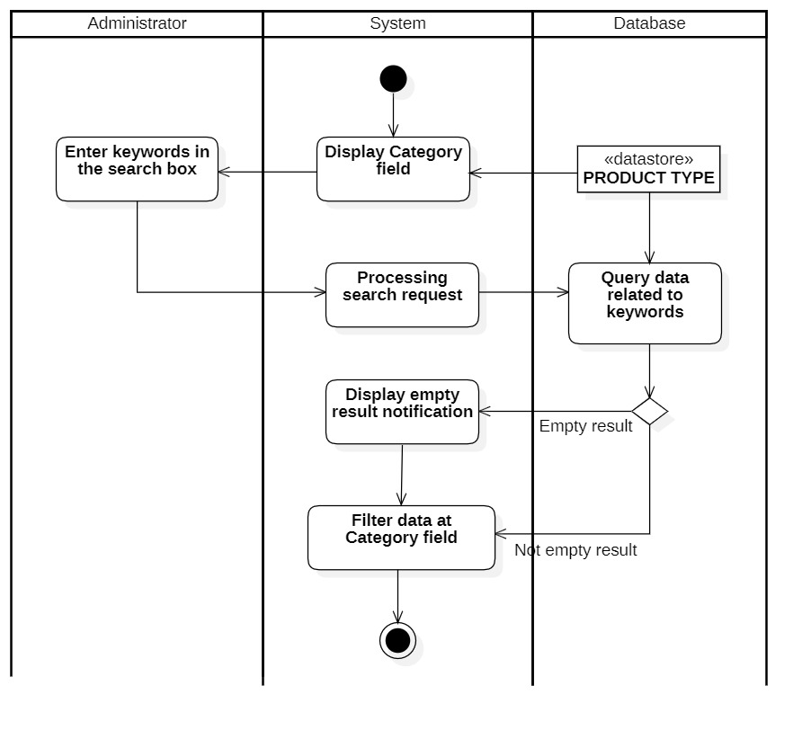

### 3.2.5 Manage promotion

#### 3.2.5.1 Insert promotion

|  |  |
| --- | --- |
| **Use-case name** | **Insert promotion** |
| Description | Administrator can insert promotion information to database |
| Trigger | Administrator click on button “Insert” at manage promotion’s page |
| Precondition | Administrators’ account existed  Administrator’s status is signed-in |
| Post-condition | Promotion information successful insert to database  Data at management page is updated (with new promotion) |
| Basic flow | 1. System display promotion management page with data loaded from database (existed promotions)  2. Administrators enter promotion information  3. System validate promotion information in correct format  4. System validates promotion information with existing data in the database.  5. System stores promotion information in database  6. System updates data at promotion management page with inserted data (new data). |
| Alternative flow | 3a. System displays invalid information due to the wrong format.  Use-case continues at step 2.  4b. System display invalid information because data had been existed in the database.  Use-case continues at step 2. |
| Exception flow |  |

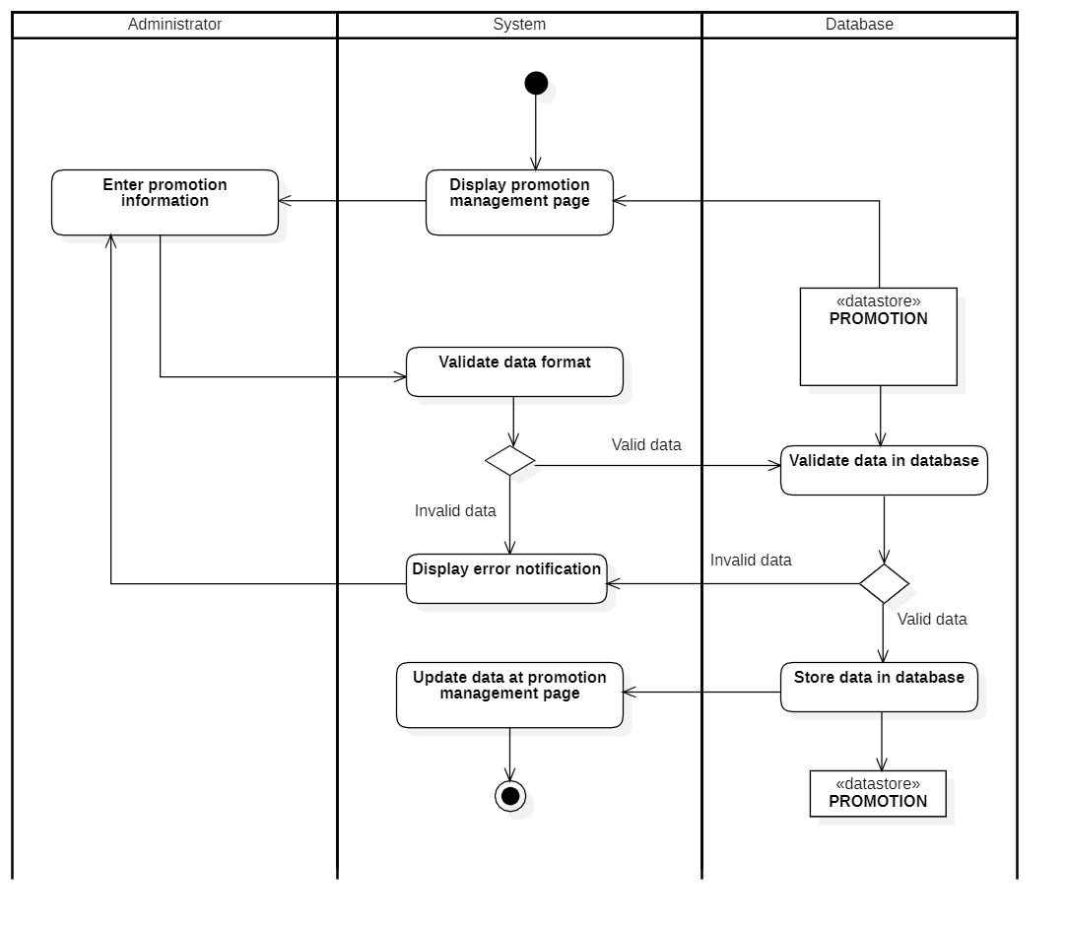

#### 

#### 3.2.5.2 Update promotion

|  |  |
| --- | --- |
| Use-case name | Update promotion |
| Description | Administrator can update promotion’s information to database |
| Trigger | Administrator click on button “Update” at manage promotion’s page |
| Precondition | Administrators’ account existed  Administrator’s status is signed-in.  Promotion information must be existed in database before updating |
| Post-condition | Data at management is updated (with updated information at selected promotion) |
| Basic flow | 1. System display promotion management page with data loaded from database (existed employee)  2. Administrators select item to be updated  3. System display promotion information form with existed data  4. Administrators modify promotion information  5. System validate promotion information in correct format  6. System validates promotion information with existing data in the database.  7. System updates promotion information in the database  8. System updates data at promotion management page with updated data at selected item. |
| Alternative flow | 5a. System displays invalid information due to the wrong format.  Use-case continues at step 4.  6b. System display invalid information because selected data hadn’t been existed in the database.  Use-case continues at step 4. |
| Exception flow |  |

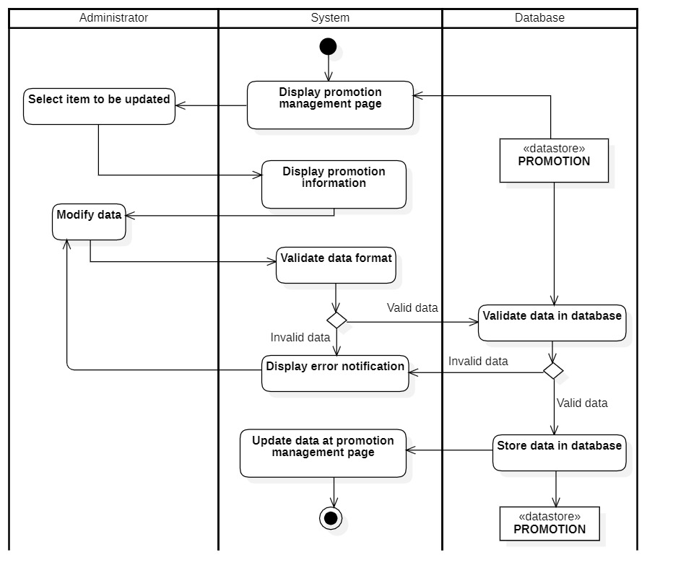

#### 

#### 3.2.5.3 Delete promotion

|  |  |
| --- | --- |
| **Use-case name** | **Delete promotion** |
| Description | Administrator can delete an existed promotion’s information from database |
| Trigger | Administrator click on button “Delete” at manage promotion page |
| Precondition | Administrators’ account existed  Administrator’s status is signed-in.  Promotion information must be existed in database before deleting |
| Post-condition | Data at management page is updated (selected promotion had been deleted) |
| Basic flow | 1. System display promotion management page with data loaded from database (existed promotion)  2. Administrators select item to be deleted and delete button.  3. System display confirm message  4. System deletes promotion information in the database  5. System updates data at promotion management page with selected item deleted. |
| Alternative flow |  |
| Exception flow | 3a. Administrator choose no  Use-case stop. |

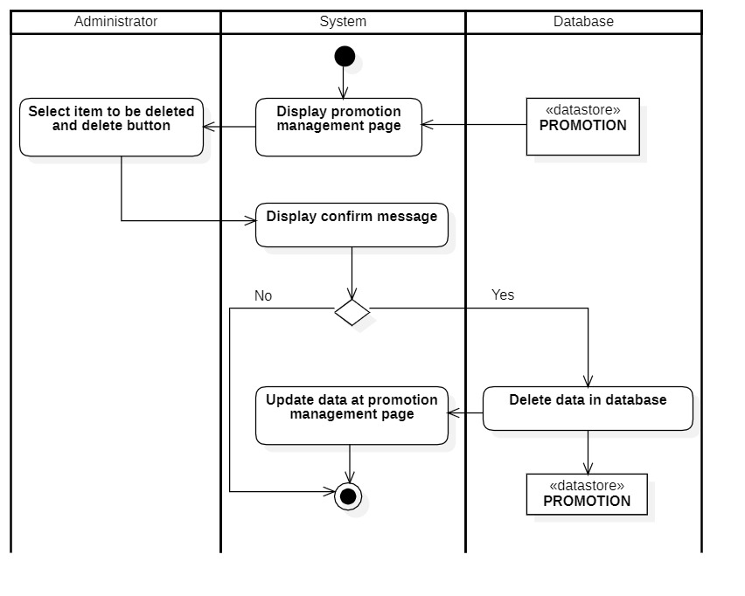

#### 

#### 3.2.5.4 Search promotion

|  |  |
| --- | --- |
| **Use-case name** | **Search promotion** |
| Description | Administrator can search promotion’s information in the database |
| Trigger | Administrator click on button “Search” at manage promotion page |
| Precondition | Administrators’ account existed  Administrator’s status is signed-in |
| Post-condition | Data at management page is filtered by keywords |
| Basic flow | 1. System display promotion management page with data loaded from database (existed promotion)  2. Administrators enter keywords in the search box  3. System processes searching data  4. System queries data based on keywords  5. System updates data at promotion management page (data related to keyword is retained) |
| Alternative flow | 4a. Use-case stops because there is no result related to keywords |
| Exception flow |  |

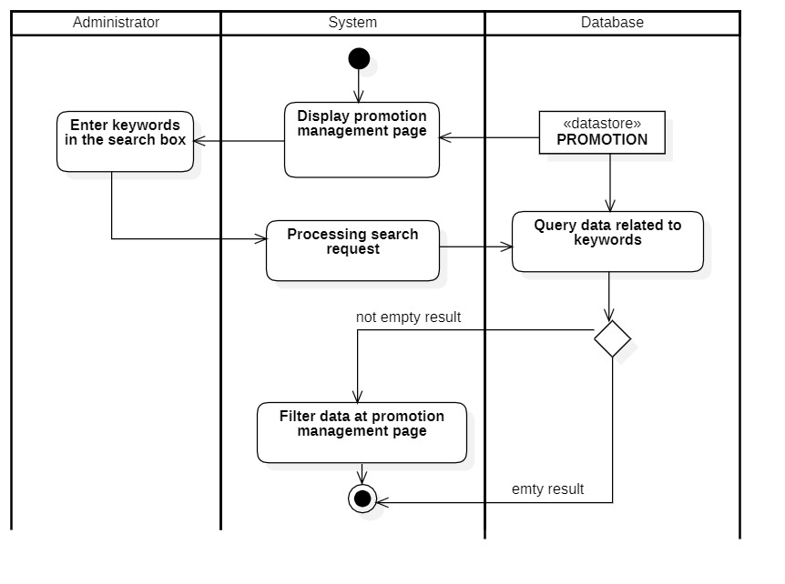

### 

### 3.2.6 Manage Membership

#### 3.2.6.1 Insert Membership

|  |  |
| --- | --- |
| **Use-case name** | **Insert membership** |
| Description | Administrator can insert membership’s information to database |
| Trigger | Administrator click on button “Insert” at manage membership’s page |
| Precondition | Administrators’ account existed  Administrator’s status is signed-in |
| Post-condition | Membership information successful insert to database  Data at management page is updated (with new membership) |
| Basic flow | 1. System display membership management page with data loaded from database (existed memberships)  2. Administrators enter membership information  3. System validate membership information in correct format  4. System validates membership information with existing data in the database.  5. System stores membership information in database  6. System updates data at membership management page with inserted data (new data). |
| Alternative flow | 3a. System displays invalid information due to the wrong format.  Use-case continues at step 2.  4b. System display invalid information because data had been existed in the database.  Use-case continues at step 2. |
| Exception flow |  |

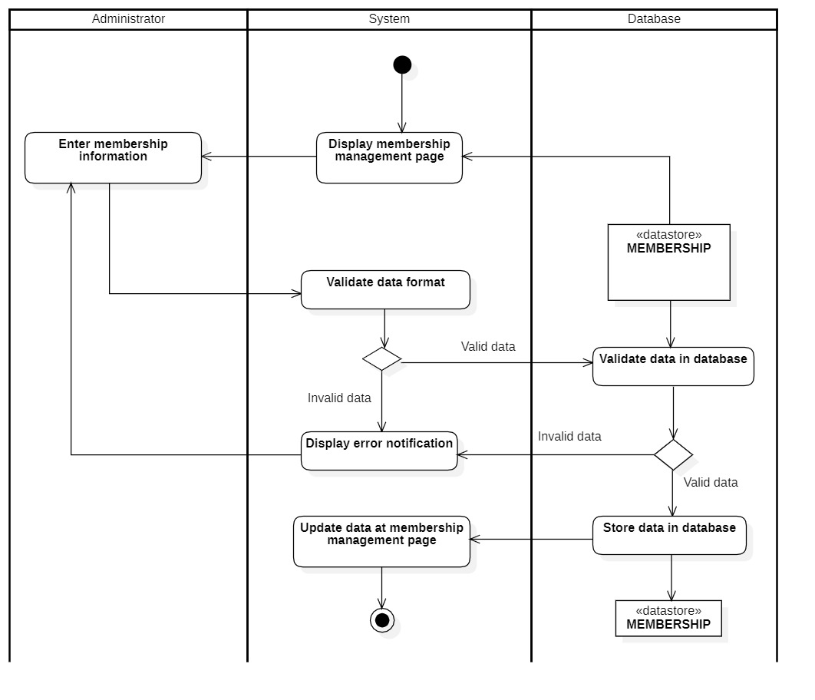

#### 3.2.6.2 Update Membership

|  |  |
| --- | --- |
| **Use-case name** | **Update membership** |
| Description | Administrator can update membership’s information to database |
| Trigger | Administrator click on button “Update” at manage membership’s page |
| Precondition | Administrators’ account existed  Administrator’s status is signed-in.  Membership information must be existed in database before updating |
| Post-condition | Data at management is updated (with updated information at selected membership) |
| Basic flow | 1. System display membership management page with data loaded from database (existed membership)  2. Administrators select item to be updated  3. System display membership information form with existed data  4. Administrators modify membership information  5. System validate membership information in correct format  6. System validates membership information with existing data in the database.  7. System updates membership information in the database  8. System updates data at membership management page with updated data at selected item. |
| Alternative flow | 5a. System displays invalid information due to the wrong format.  Use-case continues at step 4.  6b. System display invalid information because selected data hadn’t been existed in the database.  Use-case continues at step 4. |
| Exception flow |  |

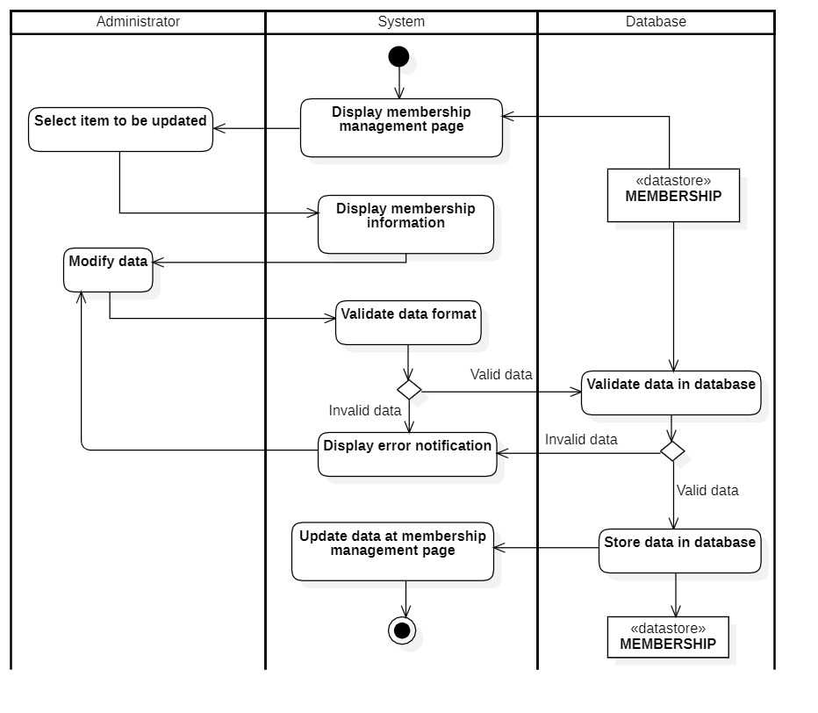

#### 

#### 3.2.6.3 Delete Membership

|  |  |
| --- | --- |
| **Use-case name** | **Delete mermbership** |
| Description | Administrator can delete an existed membership’s information from database |
| Trigger | Administrator click on button “Delete” at manage membership page |
| Precondition | Administrators’ account existed  Administrator’s status is signed-in.  Membership information must be existed in database before deleting |
| Post-condition | Data at management page is updated (selected membership had been deleted) |
| Basic flow | 1. System display membership management page with data loaded from database (existed membership)  2. Administrators select item to be deleted and delete button.  3. System display confirm message  4. System deletes membership information in the database  5. System updates data at membership management page with selected item deleted. |
| Alternative flow |  |
| Exception flow | 3a. Administrator choose no  Use-case stop. |

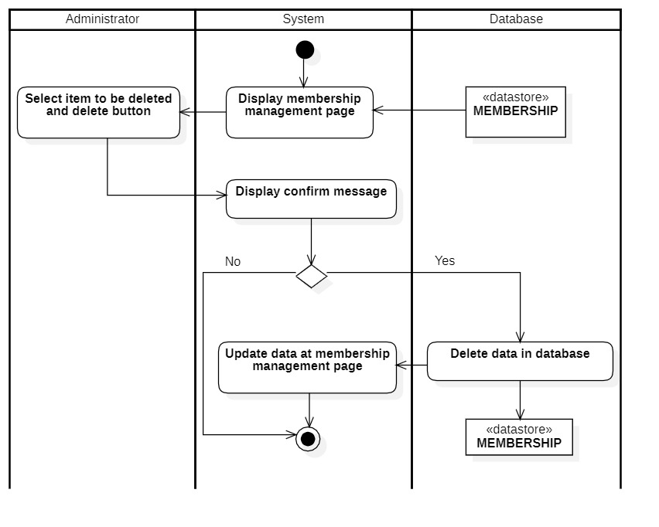

#### 

#### 3.2.6.4 Search Membership

|  |  |
| --- | --- |
| **Use-case name** | **Search membership** |
| Description | Administrator can search membership’s information in the database |
| Trigger | Administrator click on button “Search” at manage membership page |
| Precondition | Administrators’ account existed  Administrator’s status is signed-in |
| Post-condition | Data at management page is filtered by keywords |
| Basic flow | 1. System display membership management page with data loaded from database (existed membership)  2. Administrators enter keywords in the search box  3. System processes searching data  4. System queries data based on keywords  5. System updates data at membership management page (data related to keyword is retained) |
| Alternative flow | 4a. Use-case stops because there is no result related to keywords |
| Exception flow |  |

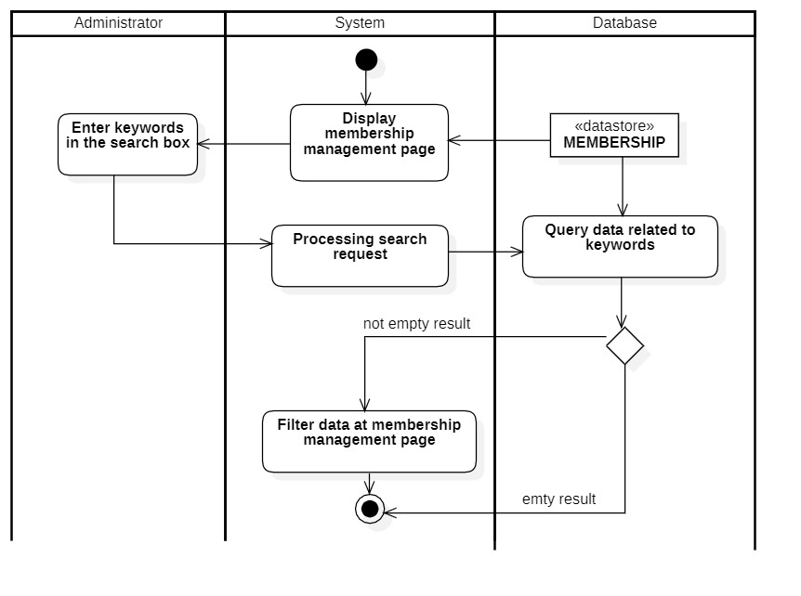

### 

### 3.2.7 Statistic product

#### 3.2.7.1 Analysis

|  |  |
| --- | --- |
| **Use-case name** | **Analysis** |
| Description | Administrator can see the best seller from the product statistic function |
| Trigger | Administrator after using the statistic product function |
| Precondition | Administrators’ account existed  Administrator’s status is signed-in  Statistic product function is finished |
| Post-condition | Have best seller information of products |
| Basic flow | 1. System display statistic product page with data loaded from database (existed invoices)  2. Administrators select statistic function  3. System processes the statistical result  4. System displays the best seller at statistic product page |
| Alternative flow |  |
| Exception flow |  |

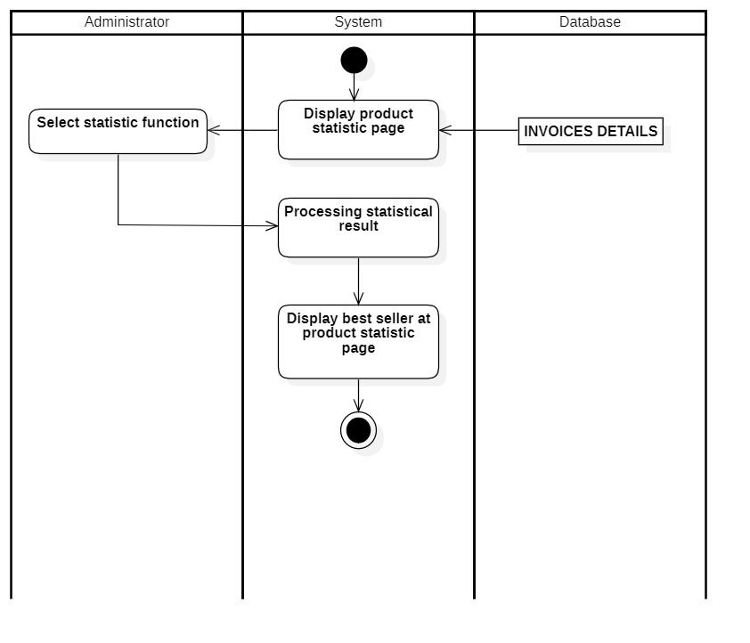

#### 3.2.7.2 Statistic (for the product)

|  |  |
| --- | --- |
| **Use-case name** | **Statistic (for product)** |
| Description | Administrator can statistic products by various categories |
| Trigger | Administrator clicks to button “Statistic” on the statistic product page |
| Precondition | Administrators’ account existed  Administrator’s status is signed-in. |
| Post-condition | Have a chart statics orders information |
| Basic flow | 1. Administrator select statistic category (food, drink, month)  2. System get list of invoice details from database  3. Group data by selected category  4. Create an interactive visual chart  5. Display charts |
| Alternative flow |  |
| Exception flow |  |

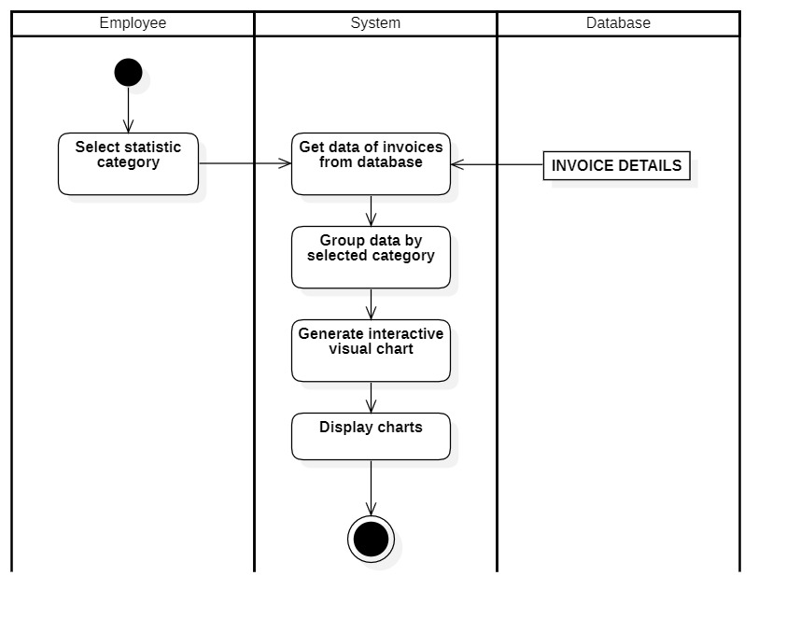

### 

### 3.2.8 Statistic revenue

#### 3.2.8.1 Search revenue history

|  |  |
| --- | --- |
| **Use-case name** | **Search revenue history** |
| Description | Administrator can search the revenue history every month in the database |
| Trigger | Administrator click on button “Search” at revenue report page |
| Precondition | Administrators’ account existed  Administrator’s status is signed-in |
| Post-condition | Have a list of revenue history with detailed information |
| Basic flow | 1. System display revenue statistic page with data loaded from database (existed invoices)  2. Administrators select search function and enter keywords  3. System processes searching data  4. System queries list of reports related to keywords  5. System updates data at revenue statistic page (data related to keyword is retained) |
| Alternative flow | 4a. System displays empty result notification  Use-case continue at step 5 (no data is retained) |
| Exception flow |  |

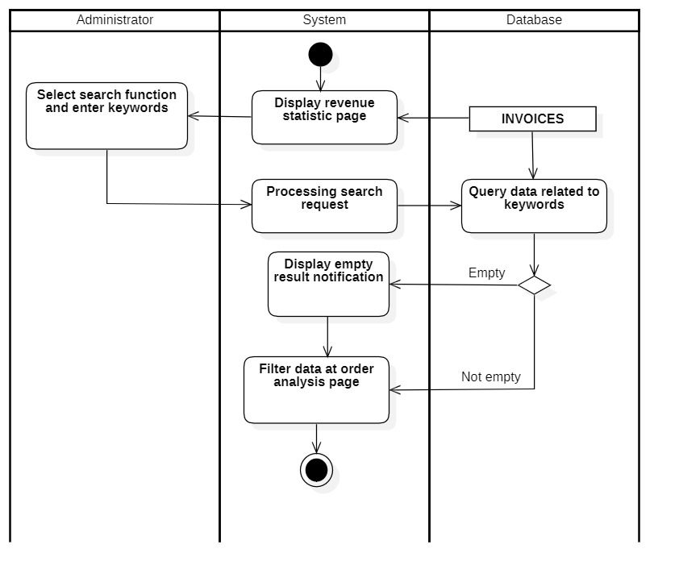

#### 3.2.8.2 Statistic (for revenue)

|  |  |
| --- | --- |
| **Use-case name** | **Statistic (for revenue)** |
| Description | Administrator can statistic revenue by various categories |
| Trigger | Administrators clicks to button “Statistic” at statistic revenue page |
| Precondition | Administrators’ account existed  Administrator’s status is signed-in. |
| Post-condition | Have a chart statics revenue reports information |
| Basic flow | 1. Administrator select statistic category (name, month)  2. System get list of invoices from database  3. Group data by selected category  4. Create interactive visual chart  5. Display charts |
| Alternative flow |  |
| Exception flow |  |

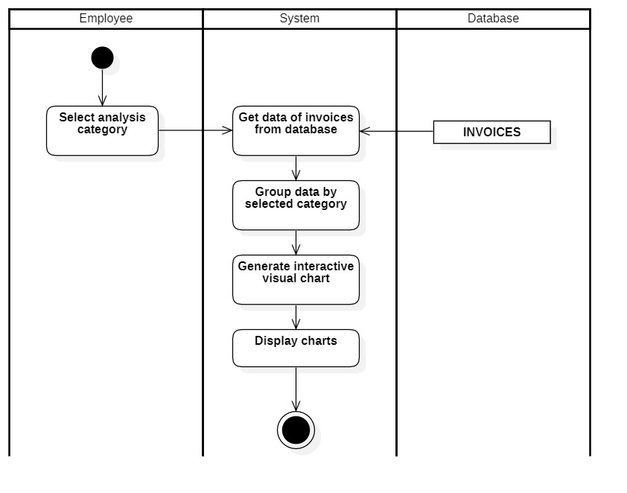

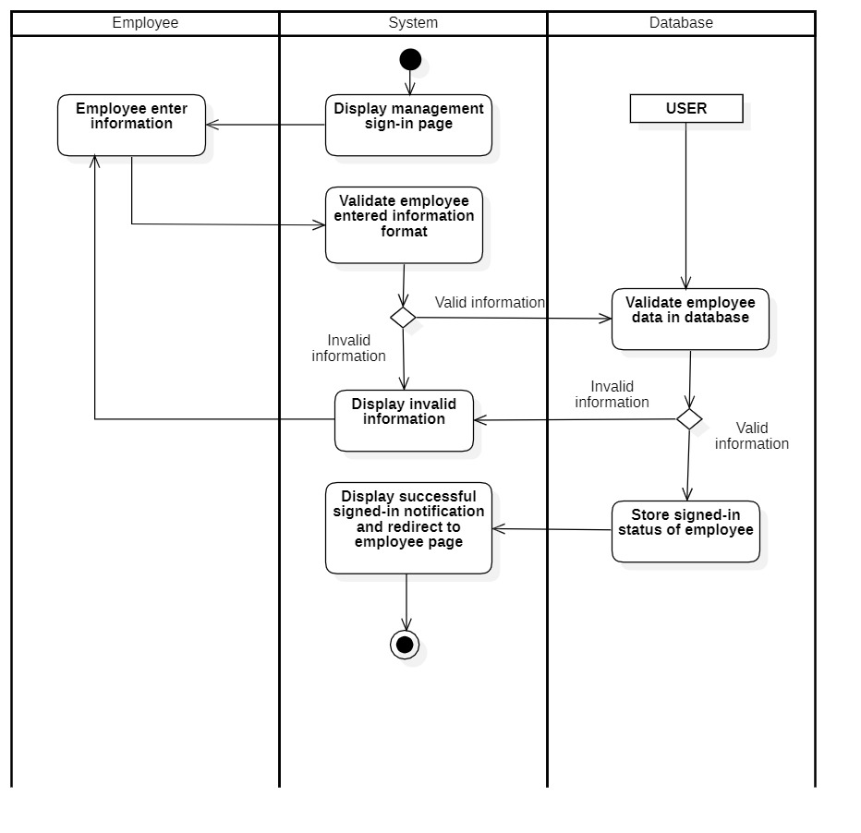

### 

### 3.2.9 Forgot password (for employee)

|  |  |
| --- | --- |
| **Use-case name** | **Forgot password (for employee)** |
| Description | The employee cannot sign in to the system because of forgetting the account password |
| Trigger | The employee clicks on the “Forgot password” button |
| Precondition | The employee’s account already existed  The employee forgot password and cannot sign-in  The employee must remember the username and the security question’s answers |
| Post-condition | The employee gets a notification about sign-in success  The employee’s password will be updated in the database |
| Basic flow | 1. The employee clicks on “Forgot password” button  2. The system displays forgot password page  3. The employee enters signed-up username  4. The system validates username and password in correct format.  5. The system validates username of the administrator in the database  6. The system displays the security questions  7. The employee enters the security question’s answers  8. The system validates the security question’s answers in the database  9. If the answers are correct, the employee can create and update a new password in the database  10. The system displays a notification about creating a new password success. |
| Alternative flow | 4a. The system displays invalid information due to the wrong format.  Use-case continues at step 3.  5a. The system displays invalid information due to no existing username in the database.  Use-case continues at step 3.  8a. The system displays invalid information due to the security question’s answers do not match with existing the security question’s answers in the database.  Use-case continues at step 7. |
| Exception flow |  |

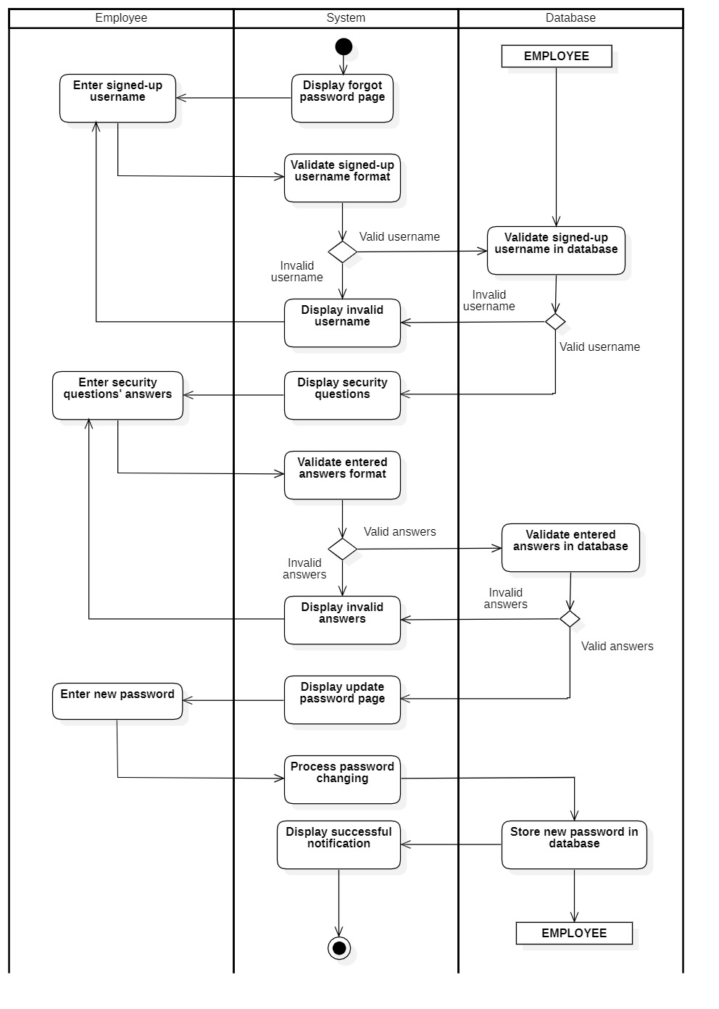

### 3.2.10 Change password (for employee)

|  |  |
| --- | --- |
| **Use-case name** | **Change password (for employee)** |
| Description | Employee want to change password |
| Trigger | Employee clicks on the button “Change password” at employee page |
| Precondition | Employees’ account existed  Employee’s status is signed-in.  Employee’s information must be existed in the database before changing |
| Post-condition | A new password will be updated in the database  Employee can use a new password to sign-in |
| Basic flow | 1. System displays change password form  2. Employee enters current password and new password  3. System validates password in correct format  4. System validates the employee’s password with an existed employee password in the database  5. System displays a successful notification and back to the current page |
| Alternative flow | 4a. System displays invalid information due to the wrong format.  Use-case continues at step 2. |
| Exception flow |  |

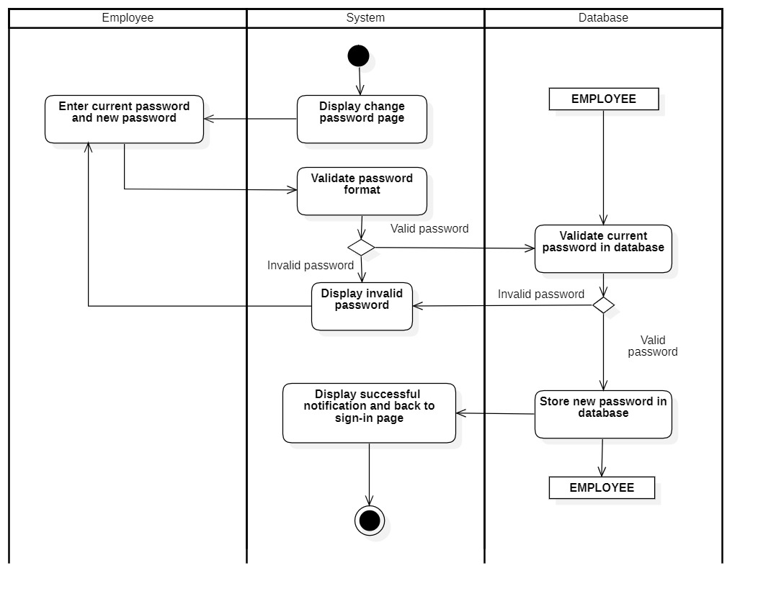

### 3.2.11 Place an invoice

#### 3.2.11.1 Add order

|  |  |
| --- | --- |
| **Use-case name** | **Add order** |
| Description | Employee adds foods and drinks based on customer orders |
| Trigger | Employee clicks on button “Add” at employee page |
| Precondition | Employees’ account existed  Employee’s status is signed-in  System displays employee page |
| Post-condition | Foods and drinks will be added to customer’s order |
| Basic flow | 1. Employee selects the menu category  2. System gets data on the menu from database  3. System groups data by selected category  3. Employee selects the add function  4. System displays the added item to the order  5. System displays the change of the bill price |
| Alternative flow |  |
| Exception flow |  |

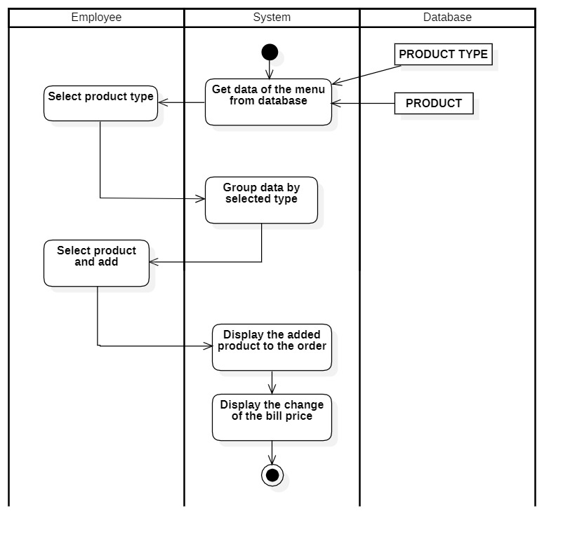

#### 3.2.11.2 Apply promotion

|  |  |
| --- | --- |
| **Use-case name** | **Apply promotion** |
| Description | Employee chooses which promotion will be applied to the bill |
| Trigger | Employee clicks on the promotion in the combo box “promotion” |
| Precondition | Employees’ account existed  Employee’s status is signed-in  System display employee page |
| Post-condition | The bill price will be changed based on the promotion |
| Basic flow | 1. Employee selects the promotion from option  2. System gets data of the promotion from database  3. System updates the bill price based on the selected promotion  4. System displays the change of the bill price |
| Alternative flow |  |
| Exception flow |  |

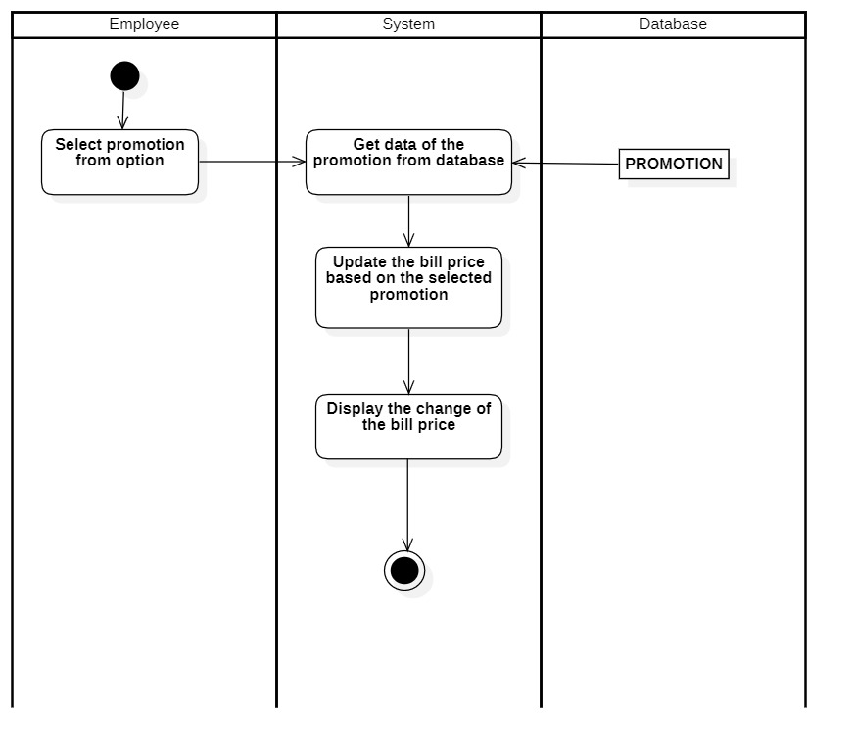

#### 3.2.11.3 Apply membership

|  |  |
| --- | --- |
| **Use-case name** | **Apply membership** |
| Description | Employee uses the customer points to the bill |
| Trigger | Employee clicks on the button “use points” on the employee page |
| Precondition | Employees’ account existed  Employee’s status is signed-in  System display employee page |
| Post-condition | The bill price will be changed based on the customer used points |
| Basic flow | 1. Employee enters customer phone number  2. System validates phone number format  3. System validates phone number with an existed phone number from the membership database  4. System displays the customer information  5. Employee enters number of customer points to use  6. System validates the entered points format  7. System validates the entered points to the customer’s current points  8. System updates the customer points in the database  9. System updates the customer points on the customer information field  10. System displays the change of the bill price |
| Alternative flow | 2a. System displays invalid phone number due to wrong format  Use-case continue at step 1  3a. System displays an invalid phone number due to the entered phone number does not exist in the membership database  Use-case continue at step 1  6a. System displays invalid points due to wrong format  Use-case continue at step 5  7a. System displays invalid points due to the entered points are higher than the customer current points or it is number 0  Use-case continue at step 5 |
| Exception flow |  |

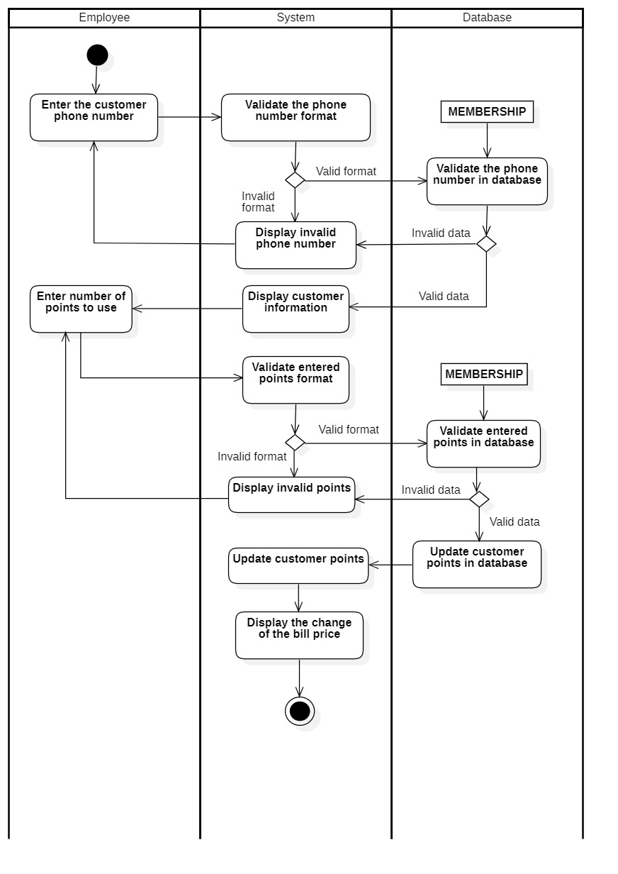

#### 3.2.11.4 Payment

|  |  |
| --- | --- |
| **Use-case name** | **Payment** |
| Description | Employee confirms customer orders and prints the bill |
| Trigger | Employee clicks on the button “save and print” on the employee page |
| Precondition | Employees’ account existed  Employee’s status is signed-in  System displays employee page  There is at least one item that has been added to the order |
| Post-condition | System will store the invoice in database and print the bill to the customer |
| Basic flow | 1. System displays the payment field  2. System calculates the total bill  3. Employee enters the customer-given money  4. System validates the entered data format  5. System calculates the customer change  6. System creates the invoice ID number  7. System stores the invoice in the database  8. System displays successful message and prints the bill |
| Alternative flow | 4a. System displays invalid number due to the wrong format  Use-case continue at step 3 |
| Exception flow |  |

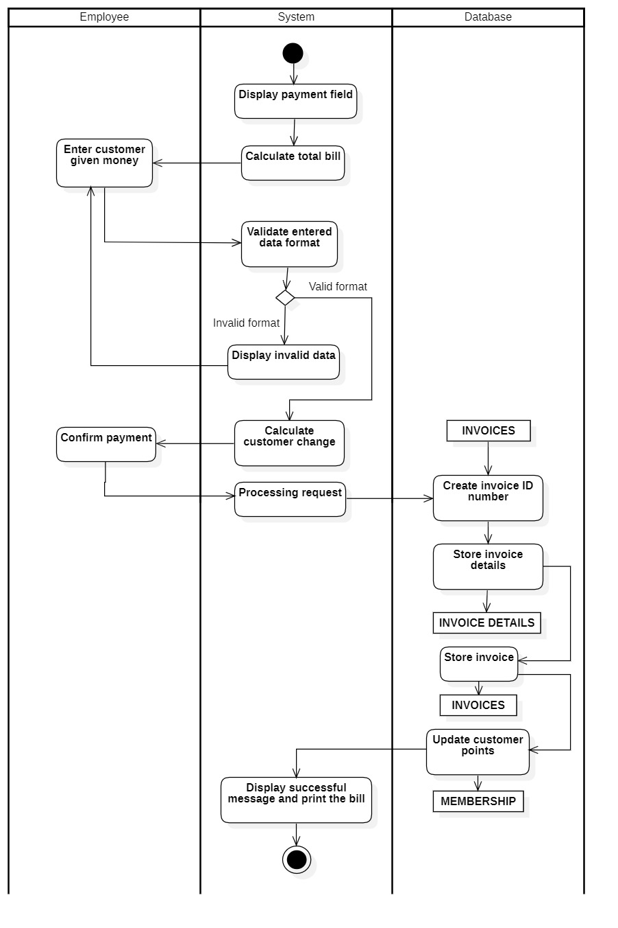

#### 3.2.11.5 Email

|  |  |
| --- | --- |
| **Use-case name** | **Email** |
| Description | Employee can send message to customer gmail |
| Trigger | Employee clicks on the button “send email” on the employee page |
| Precondition | Employee’s account existed  Employee’s status is signed-in  System displays employee page |
| Post-condition | Customer receives an email from the shop |
| Basic flow | 1. Employee enters customer email  2. System validates the entered email format  3. Gmail server receive customer email 4. Send message to customer email  5. System displays successful message |
| Alternative flow | 2a. System displays invalid email due to the wrong format  Use-case continue at step 1 |
| Exception flow |  |

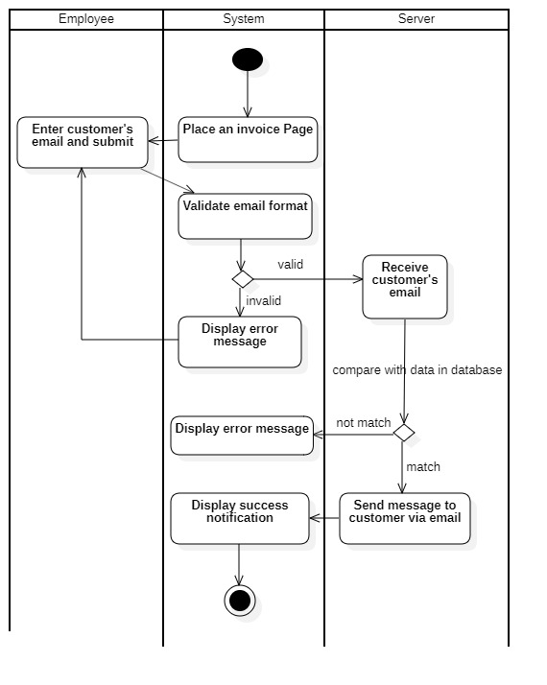

## 3.3. Sequence Diagram and Class Diagram

**Administrator**

### 3.3.1 Sign in

#### 3.3.1.1 Sequence Diagram

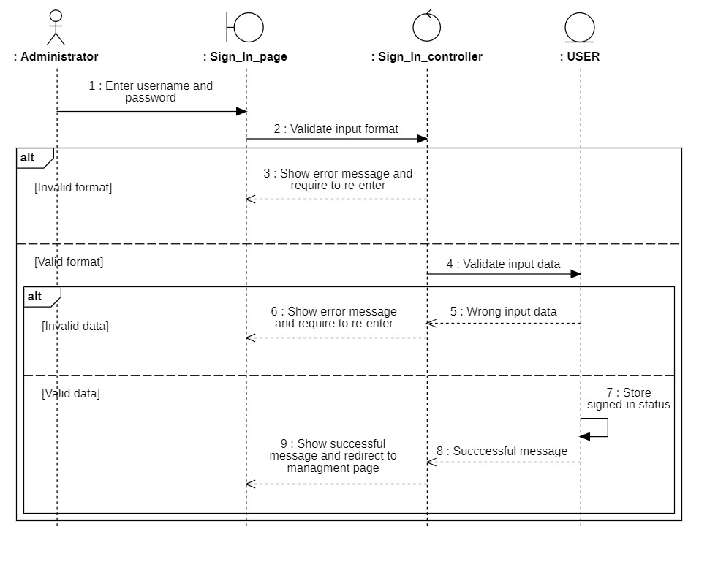

#### 3.3.1.2 Class Diagram

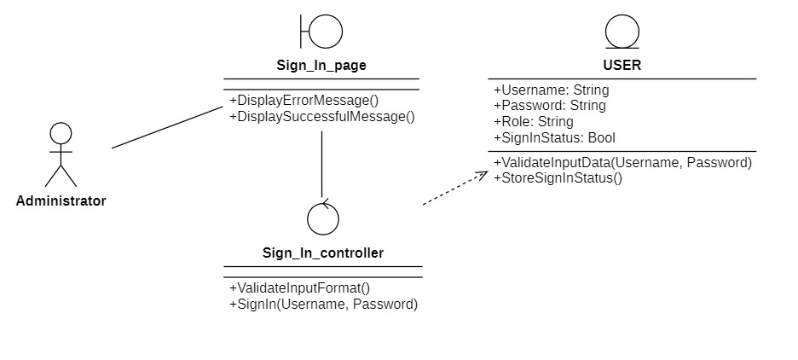

Note: Employee sign in function work same as the administrator

### 3.3.2 Manage employees

#### 3.3.2.1 Sequence Diagram

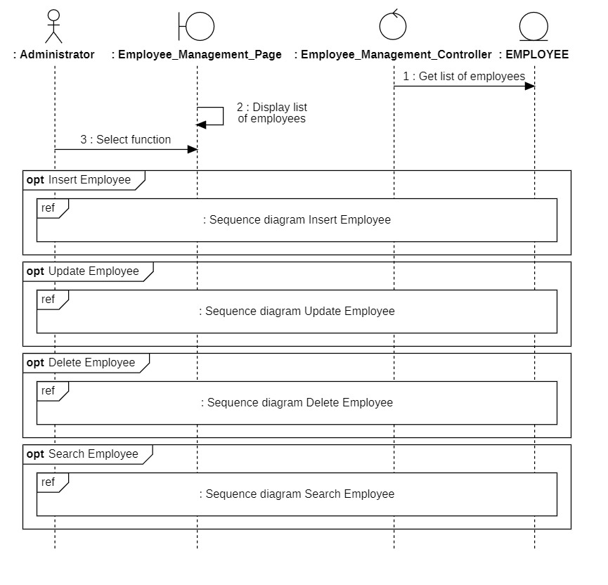

Insert

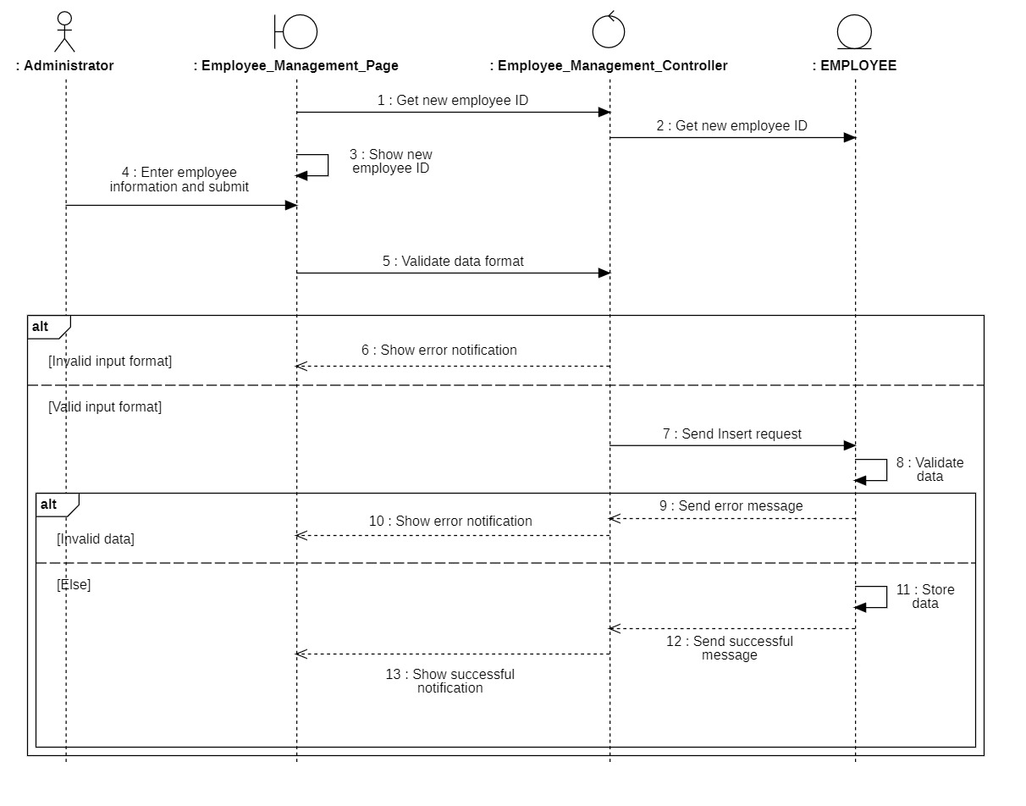

Delete

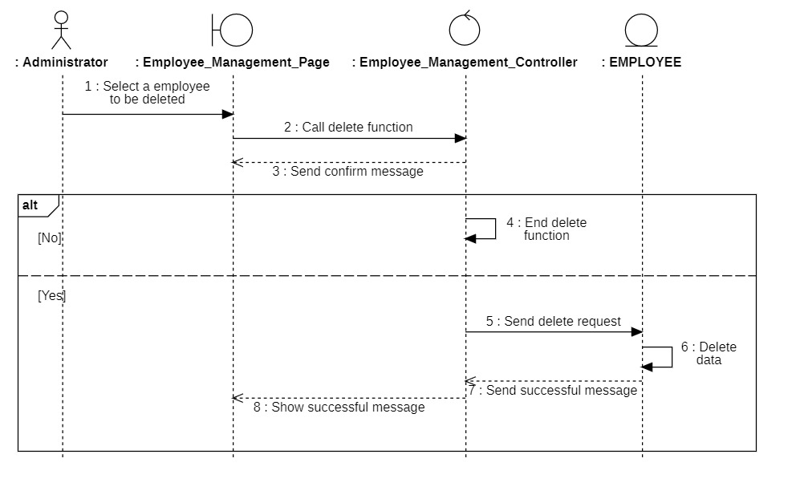

Update

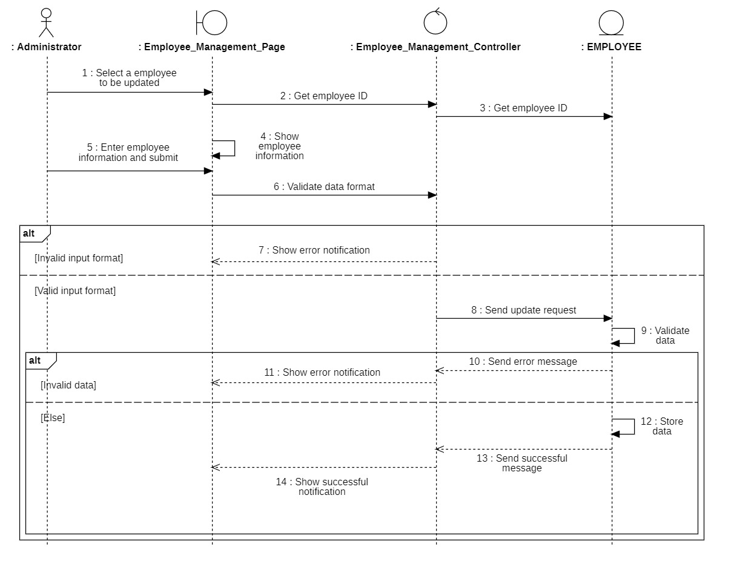

Search

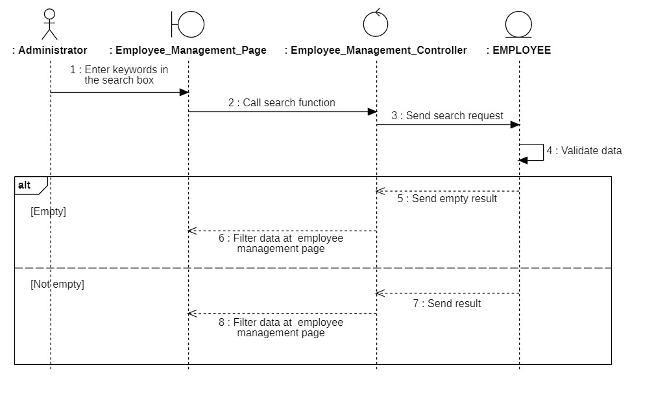

#### 3.3.2.2 Class Diagram

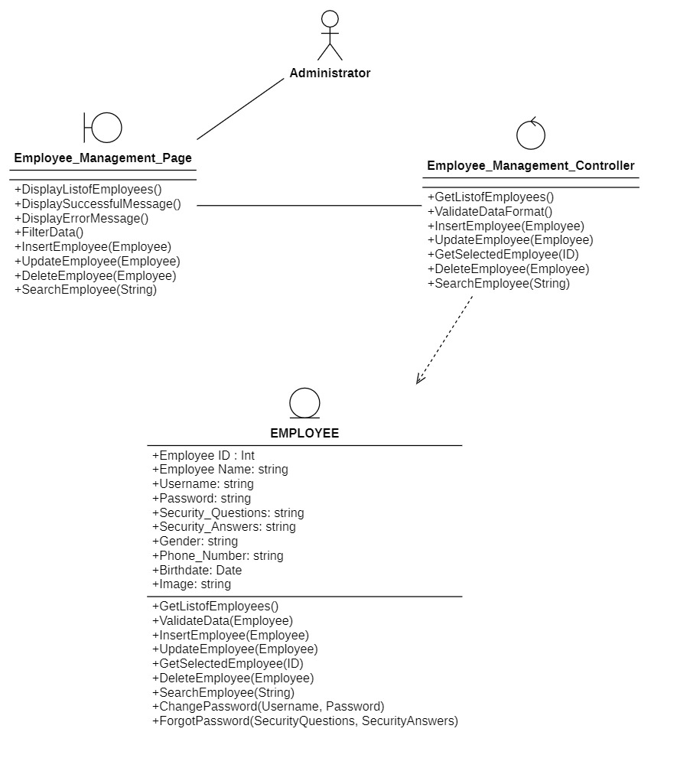

### 

### 3.3.3 Manage product

#### 3.3.3.1 Sequence Diagram

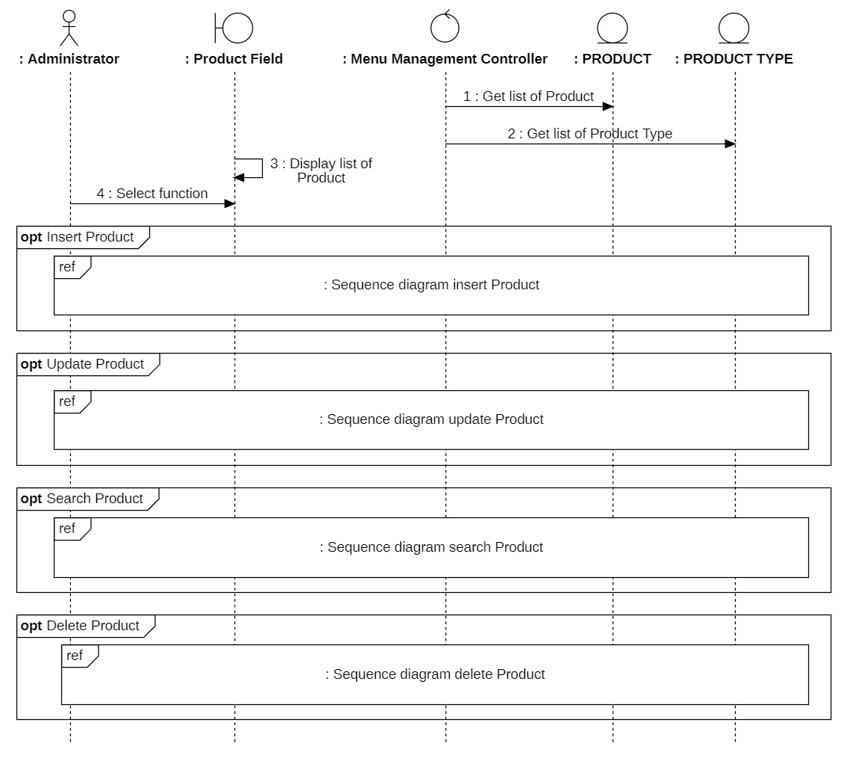

Insert

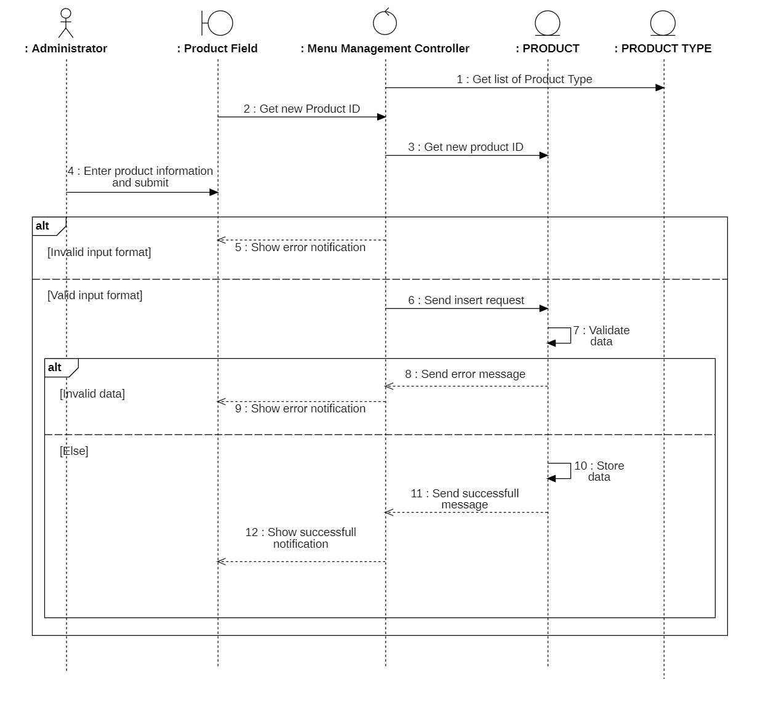

Delete

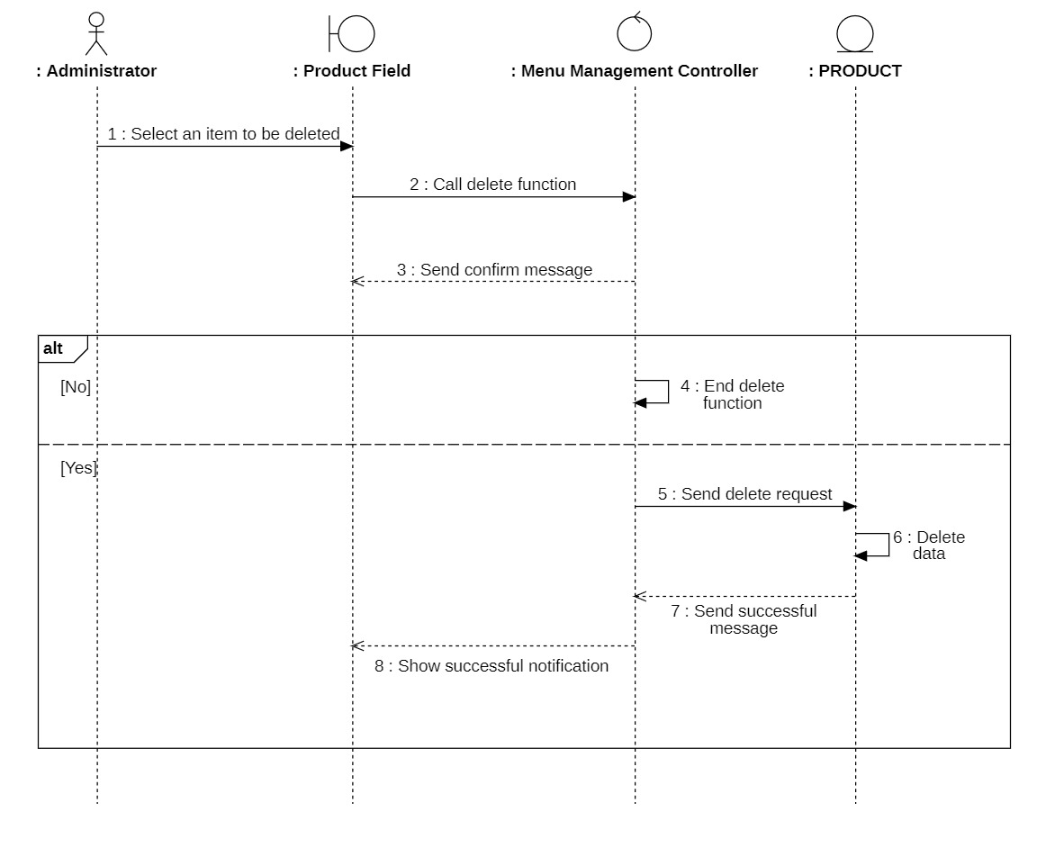

Update

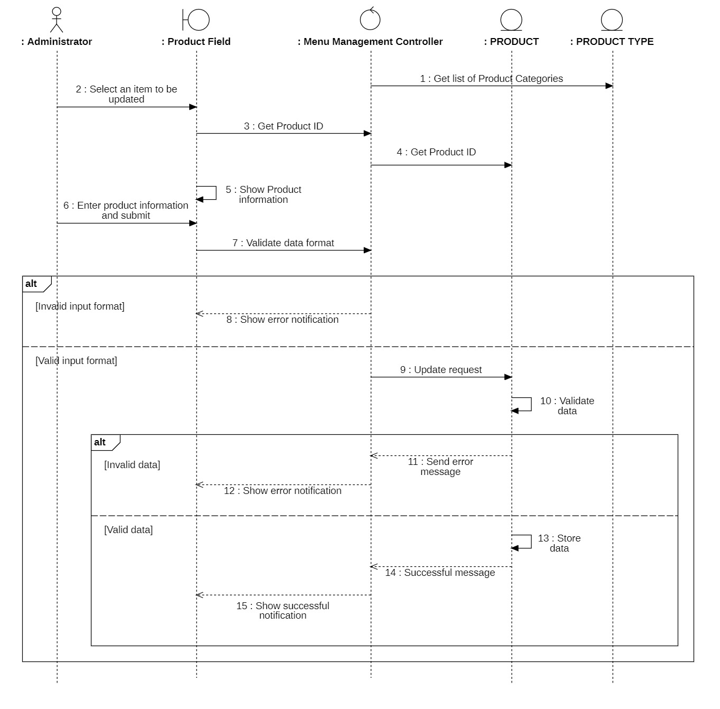

Search

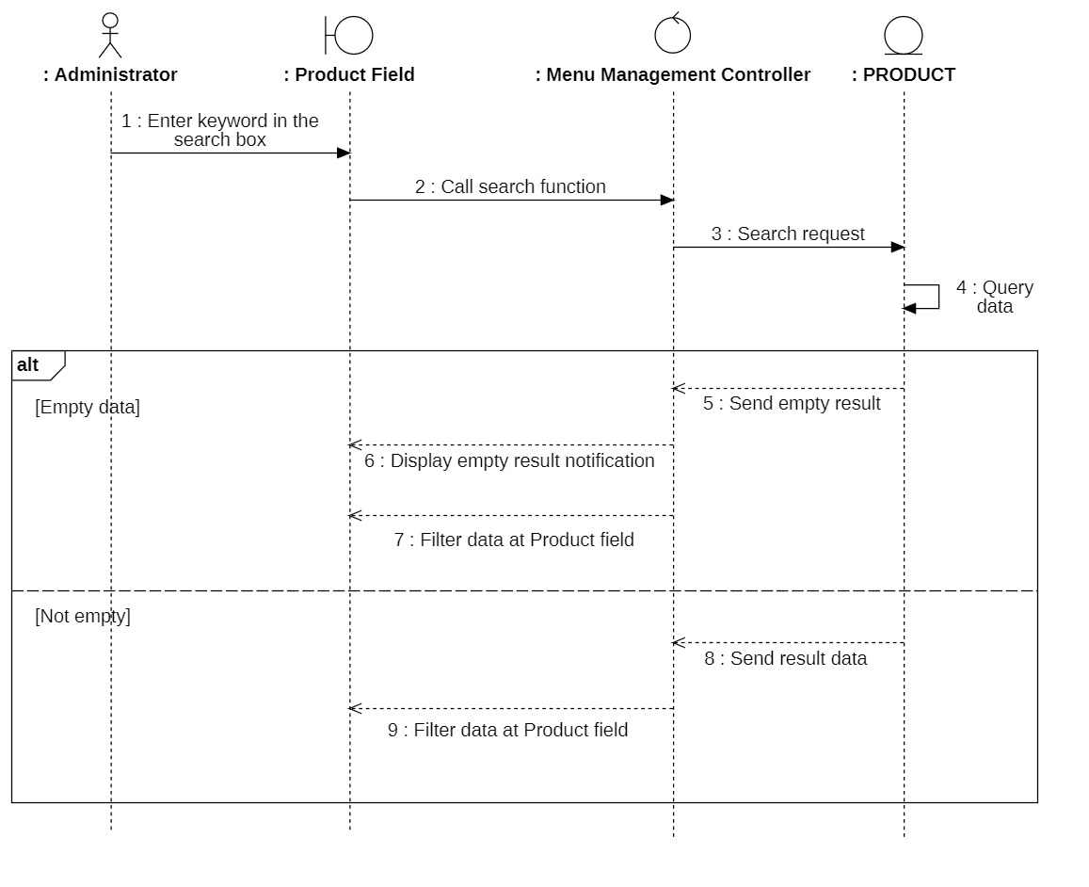

#### 3.3.3.2 Class Diagram

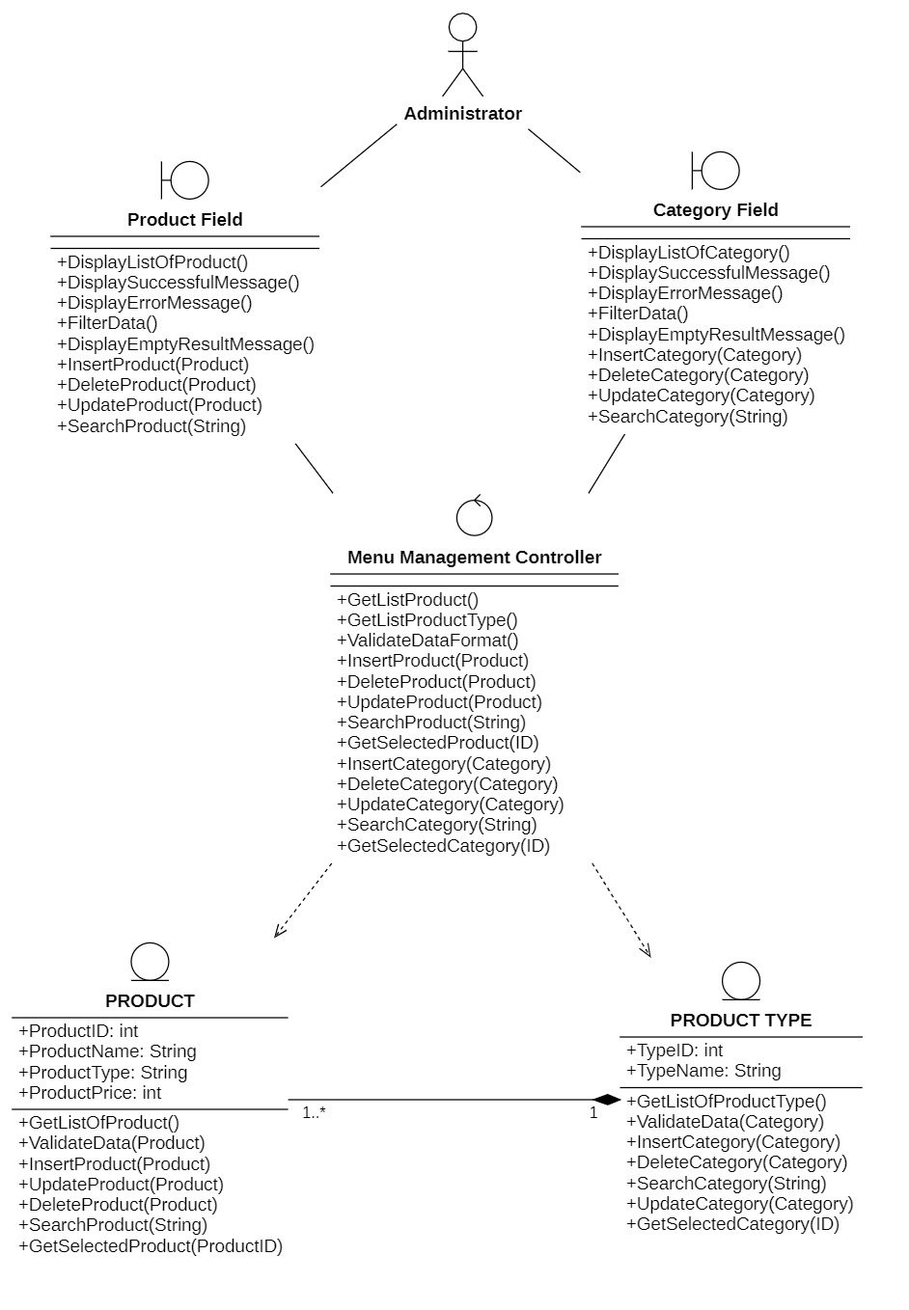

### 3.3.4 Manage category

#### 3.3.4.1 Sequence Diagram

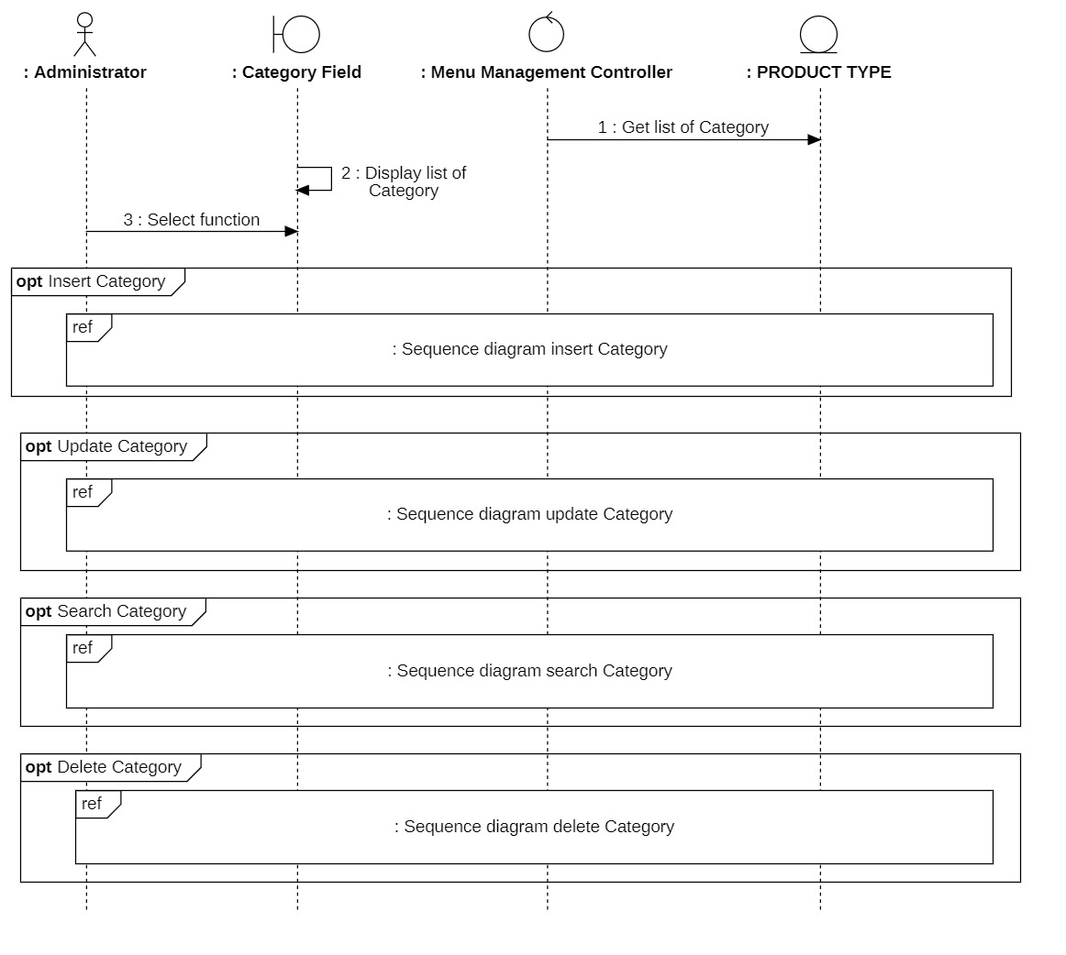

Insert

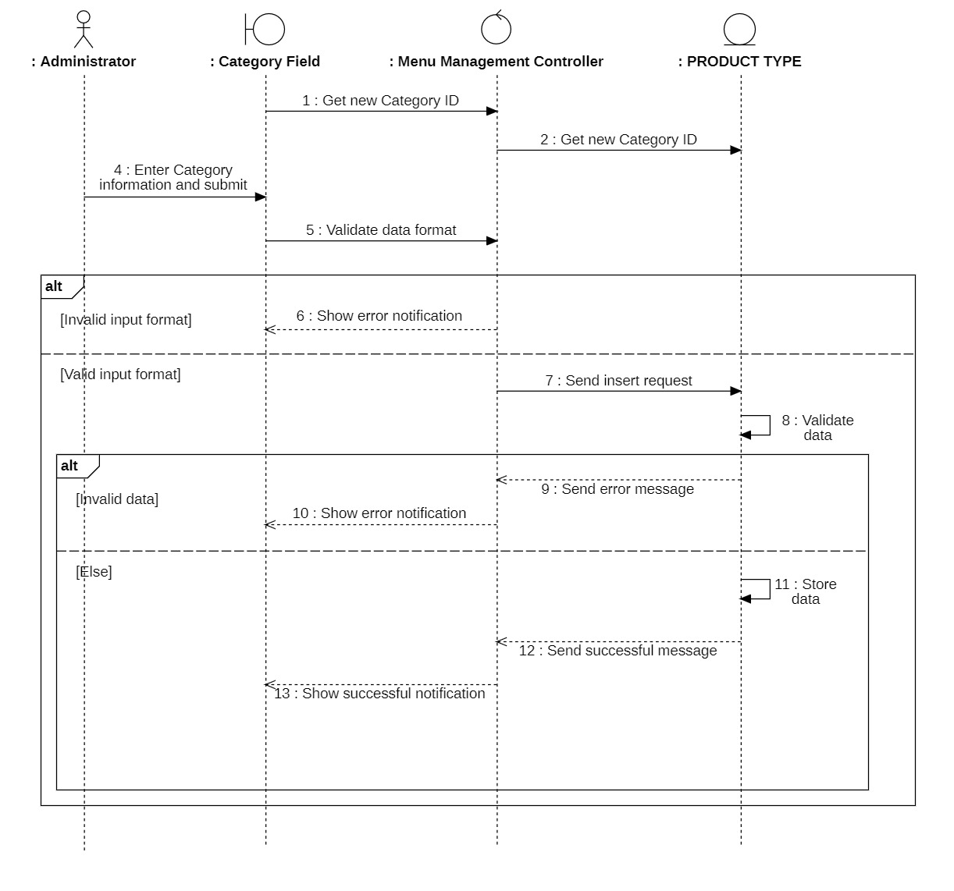

Delete

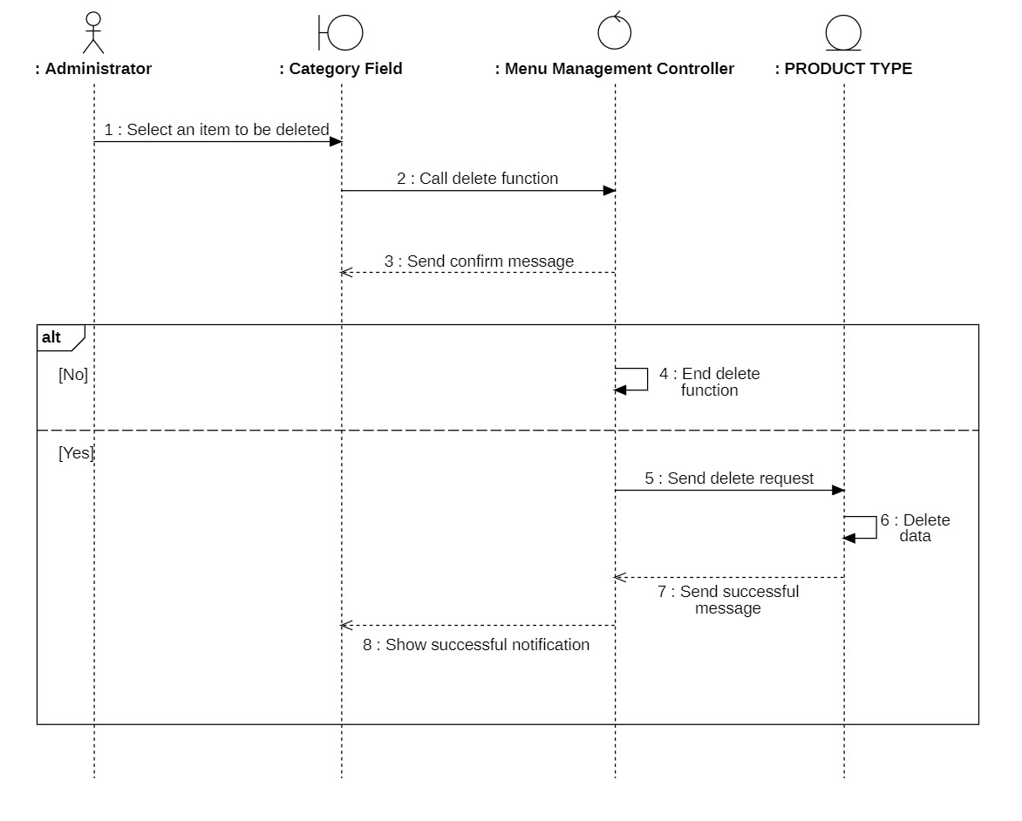

Update

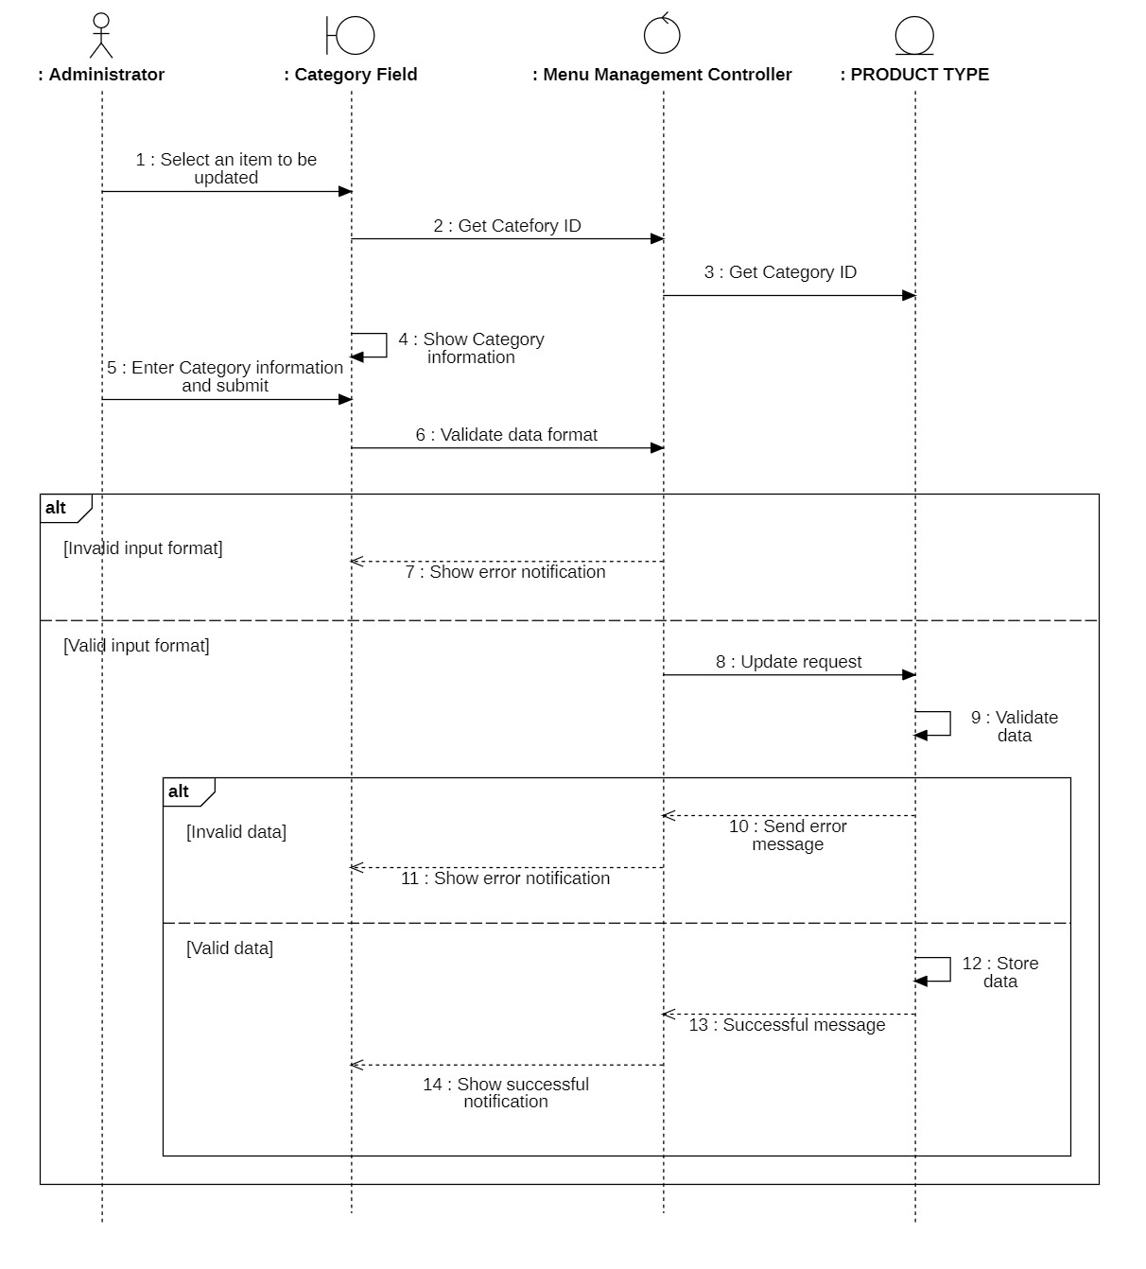

Search

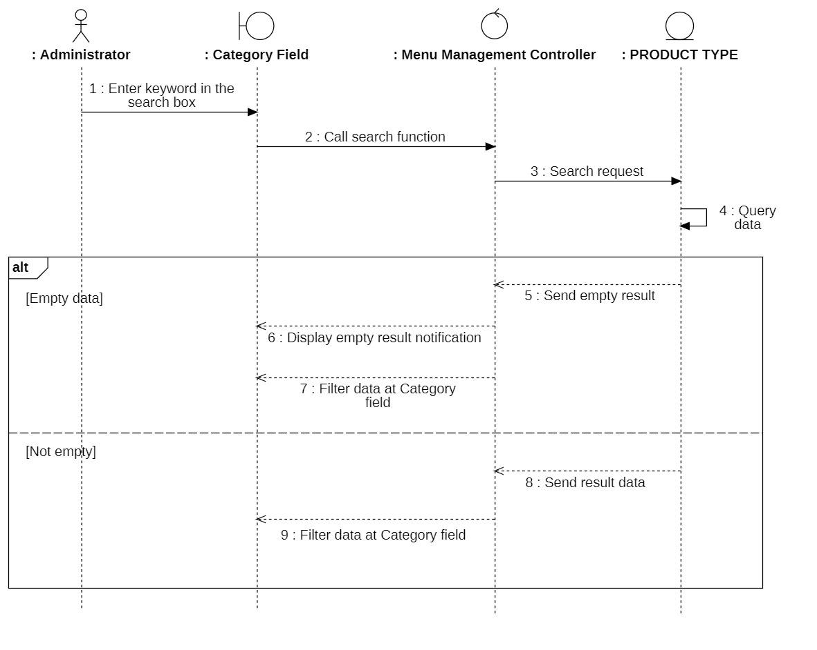

#### 3.3.4.2 Class Diagram



### 3.3.5 Manage membership

#### 3.3.5.1 Sequence Diagram

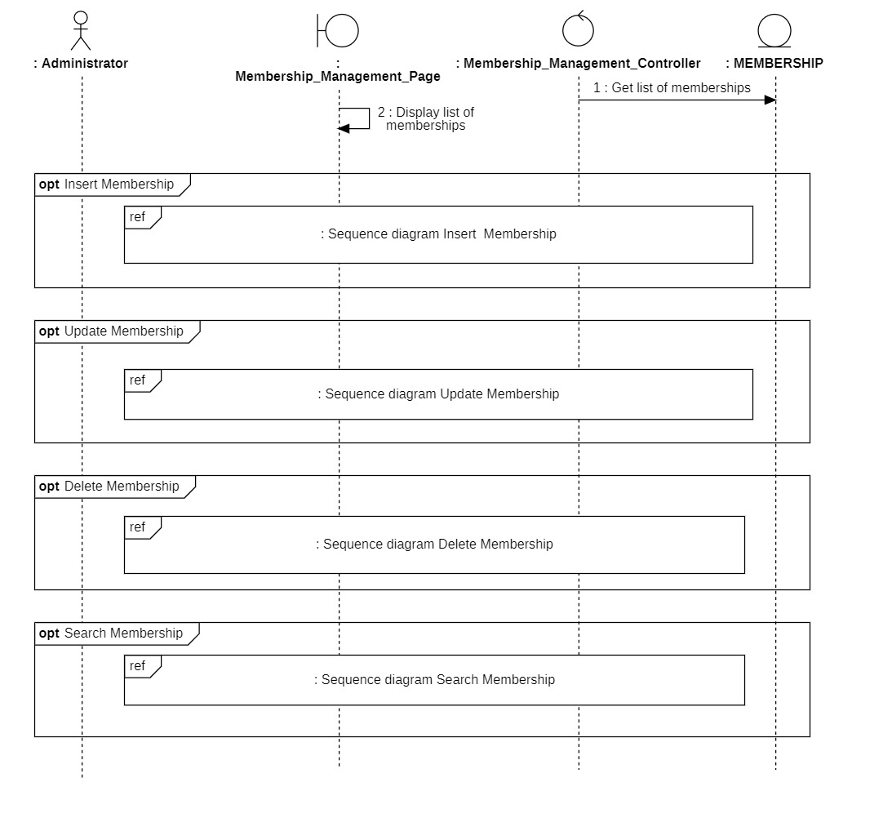

Insert

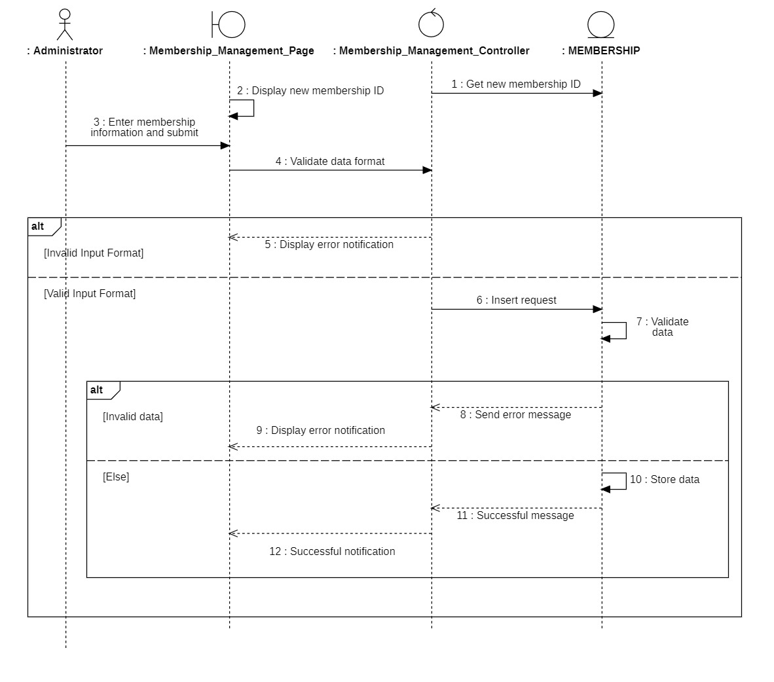

Delete

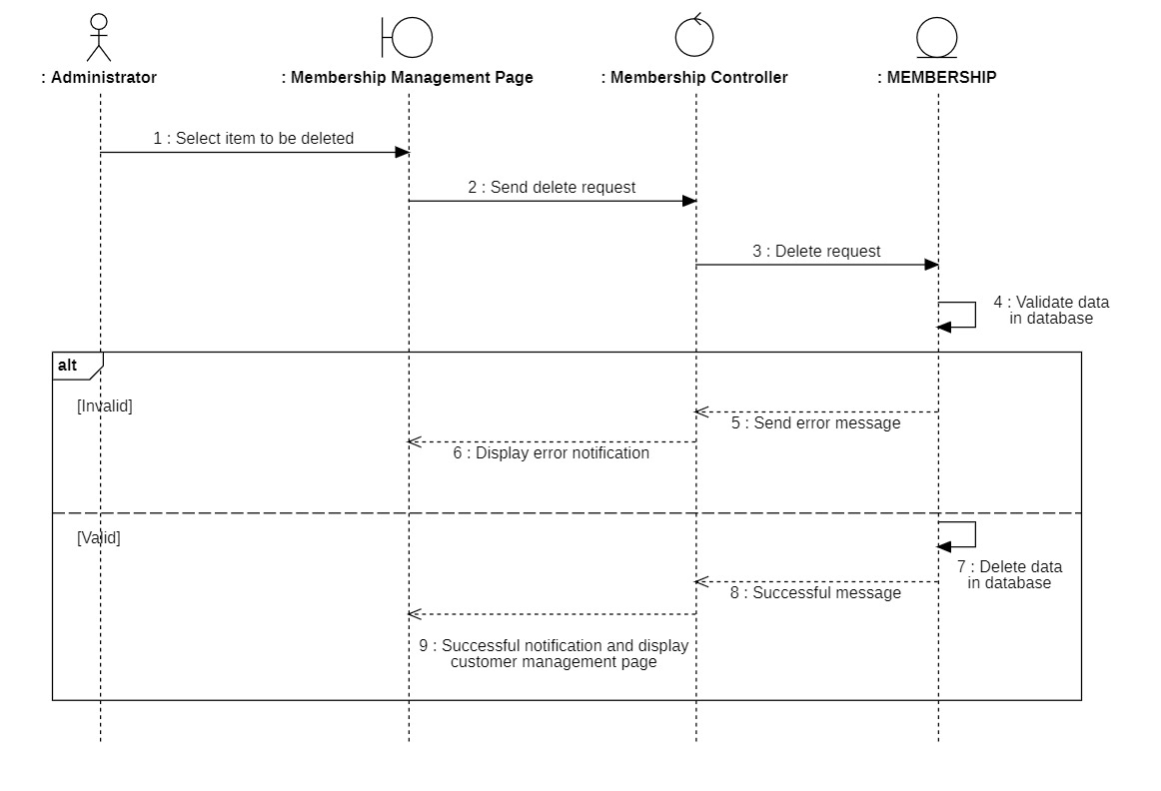

`

Update

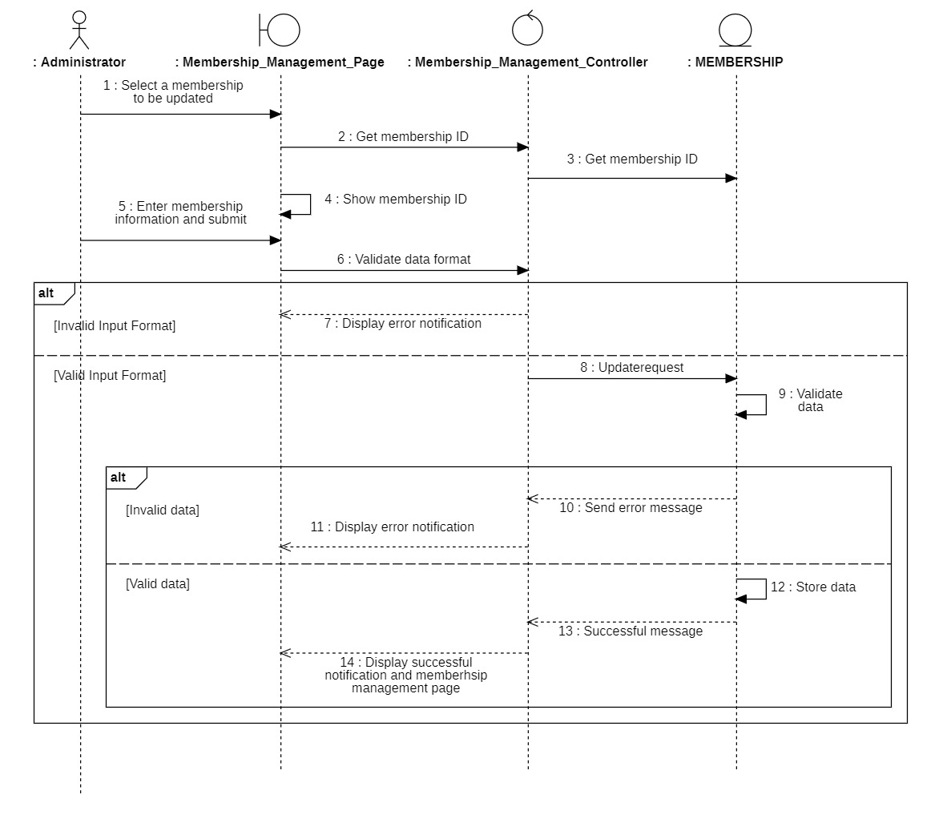

Search

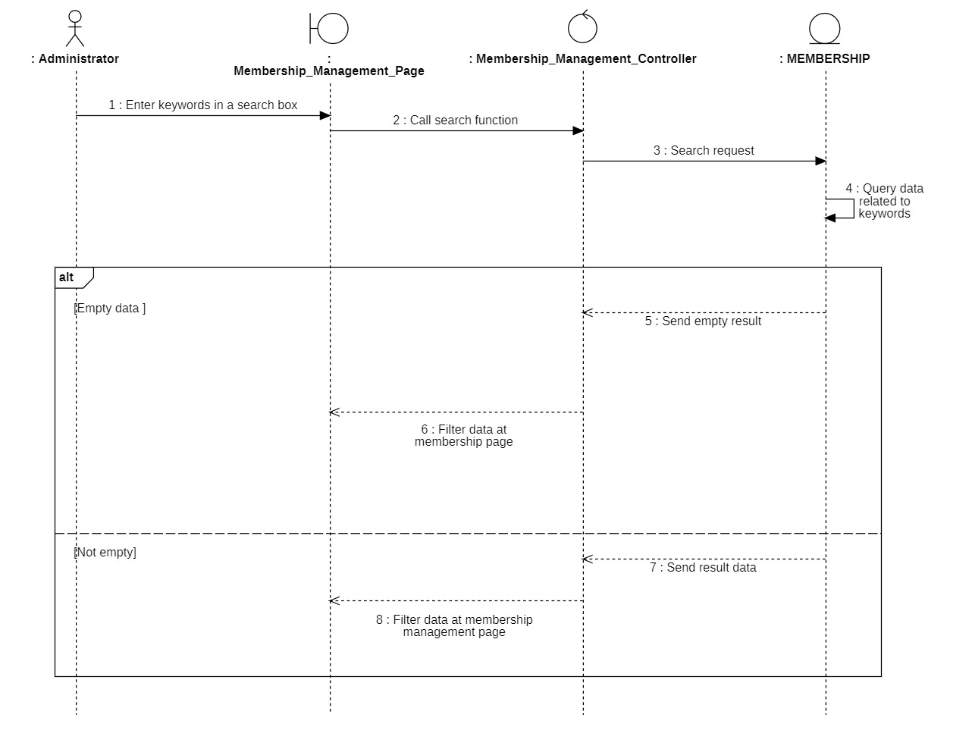

#### 3.3.5.2 Class Diagram

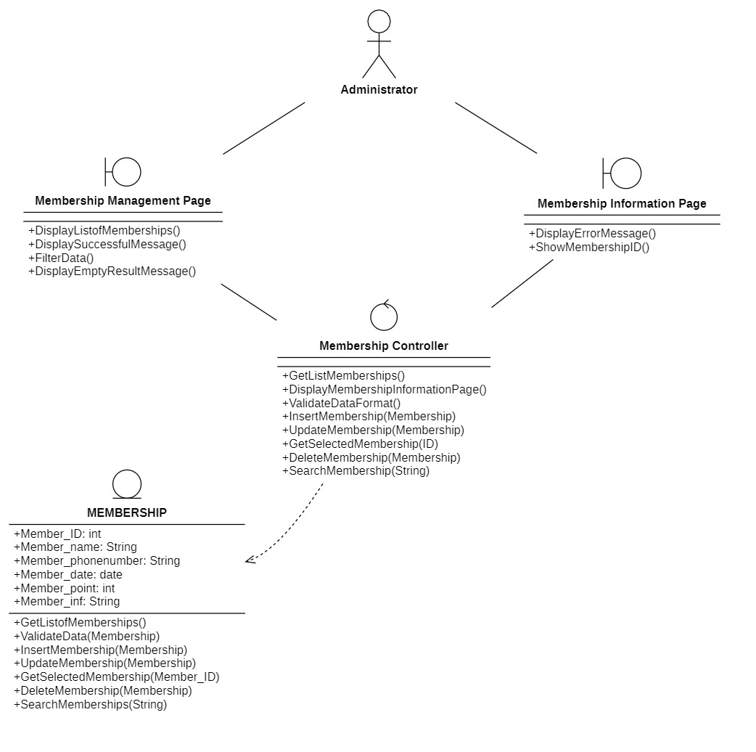

### 

### 3.3.6 Manage promotion

#### 3.3.6.1 Sequence Diagram

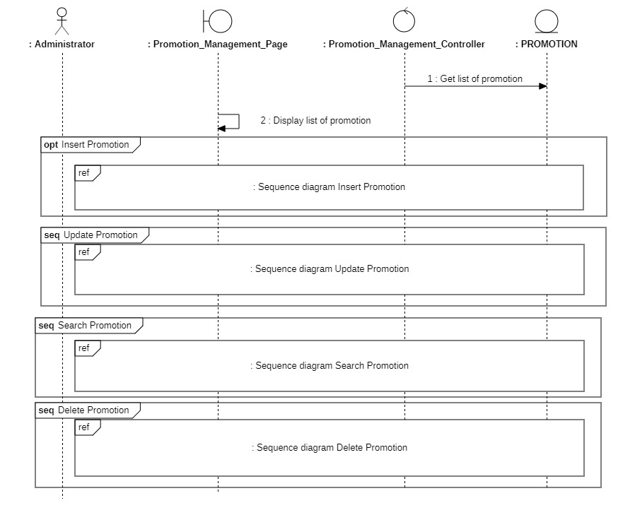

Insert

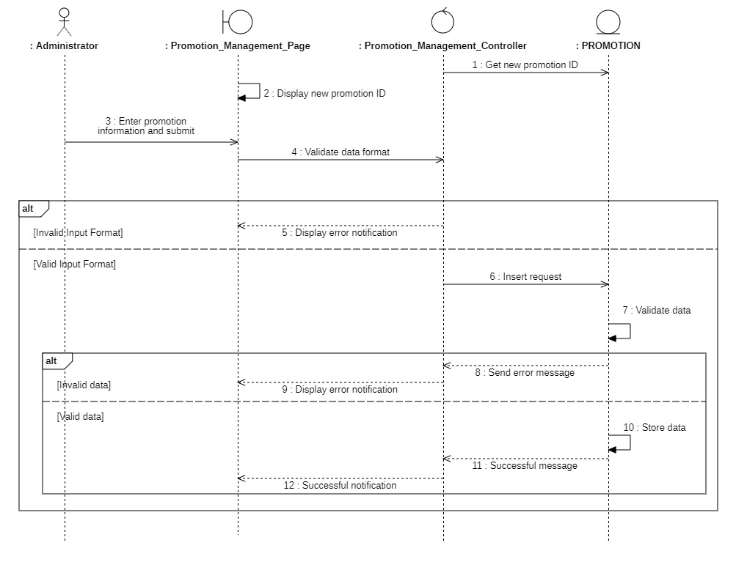

Delete

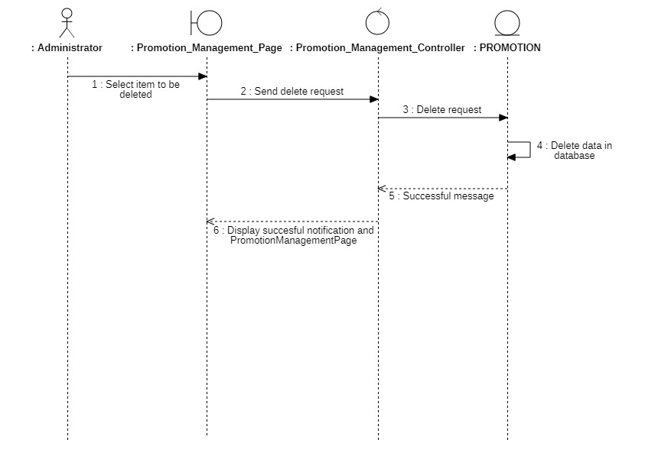

Update

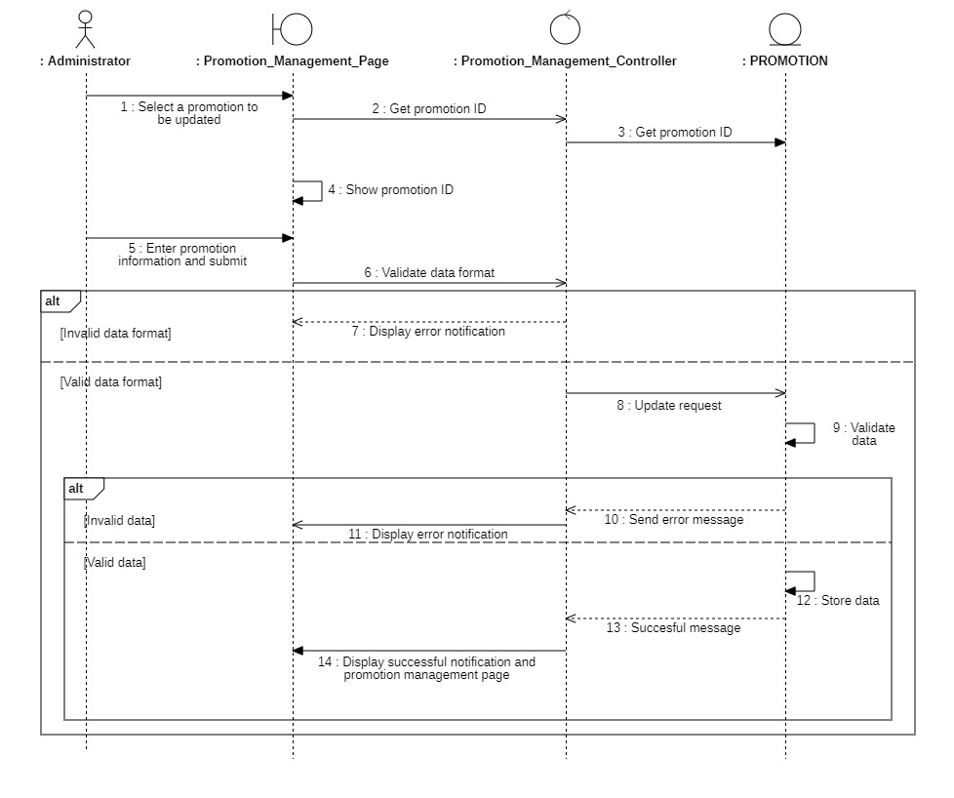Search

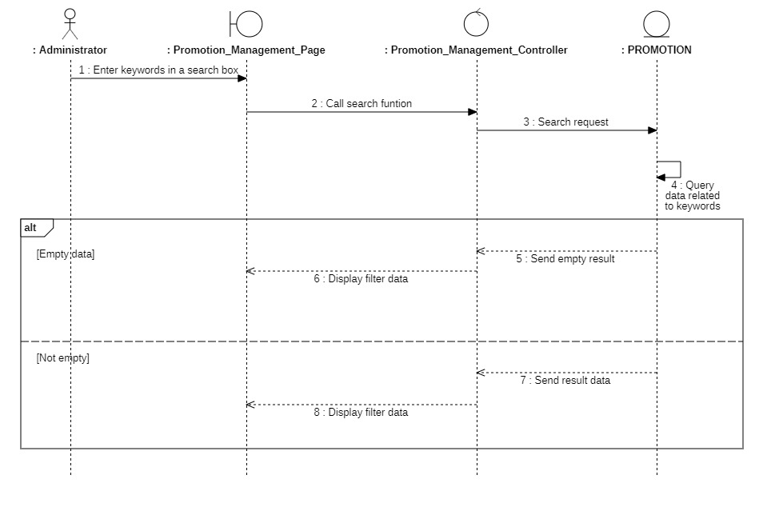

#### 3.3.6.2 Class Diagram

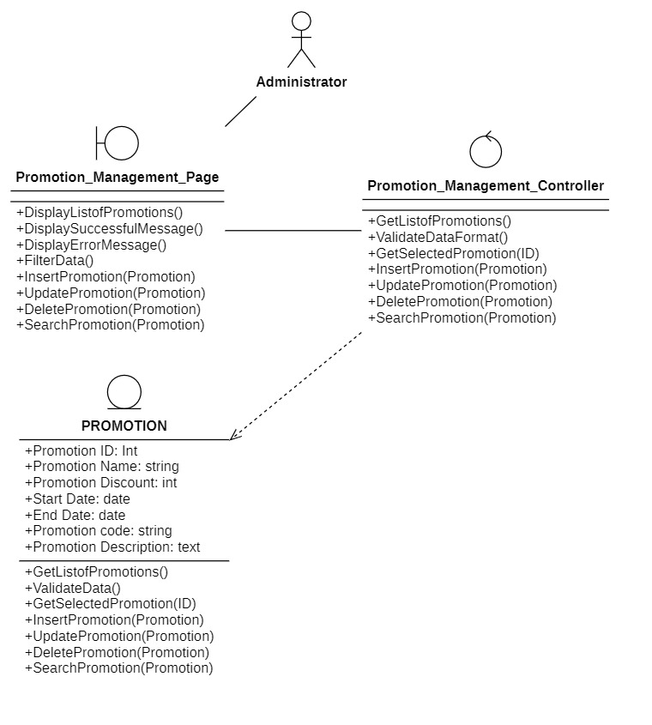

### 3.3.7 Statistic product

#### 3.3.7.1 Sequence Diagram

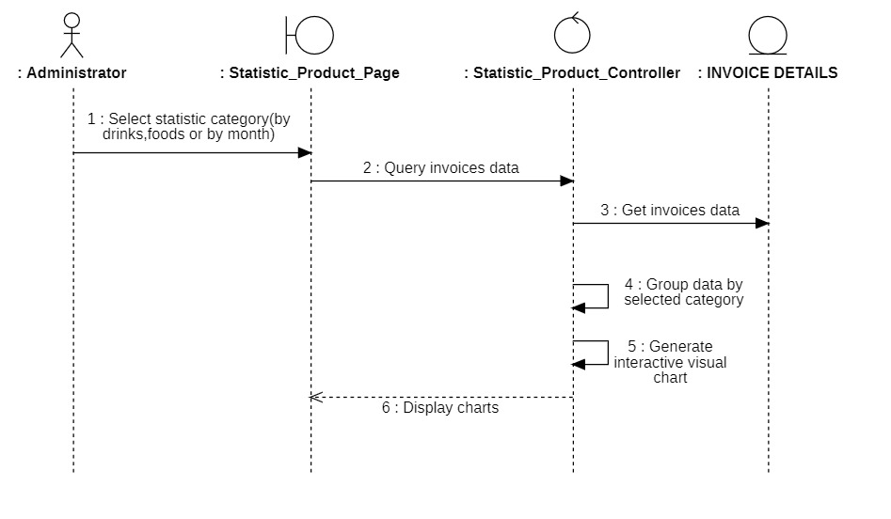

#### 3.3.7.2 Class Diagram

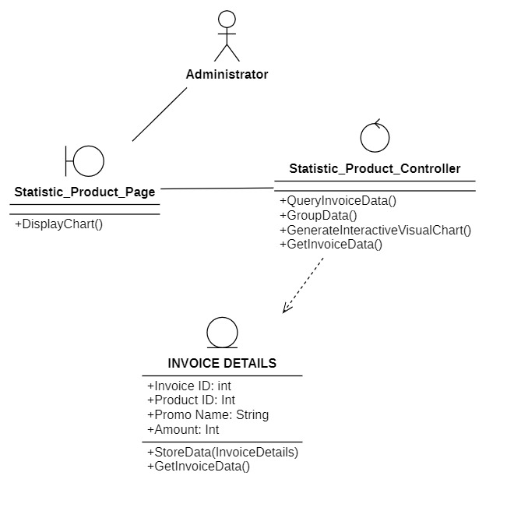

### 3.3.8 Statistic revenue

#### 3.3.8.1 Sequence Diagram

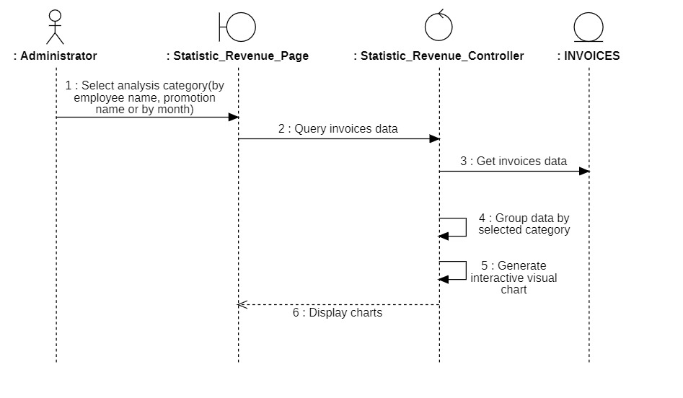

#### 3.3.8.2 Class Diagram

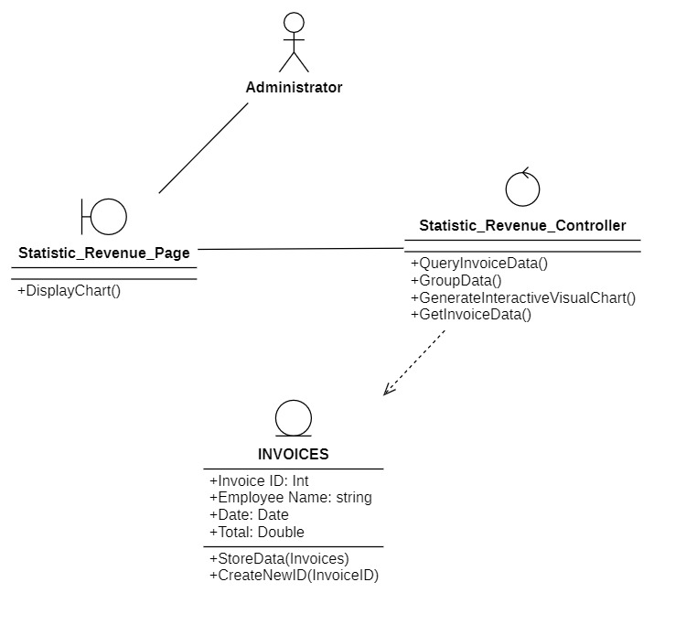

Employee

### 3.3.9 Change password

#### 3.3.9.1 Sequence Diagram

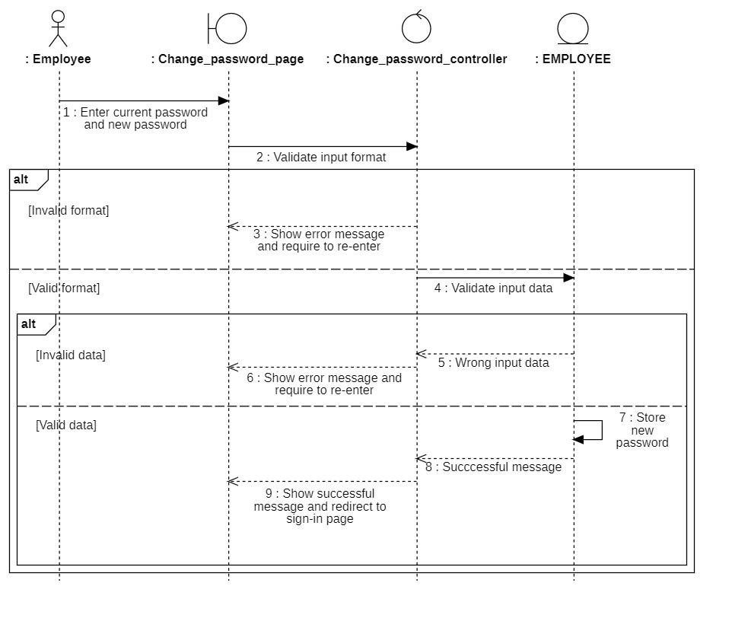

#### 3.3.9.2 Class Diagram

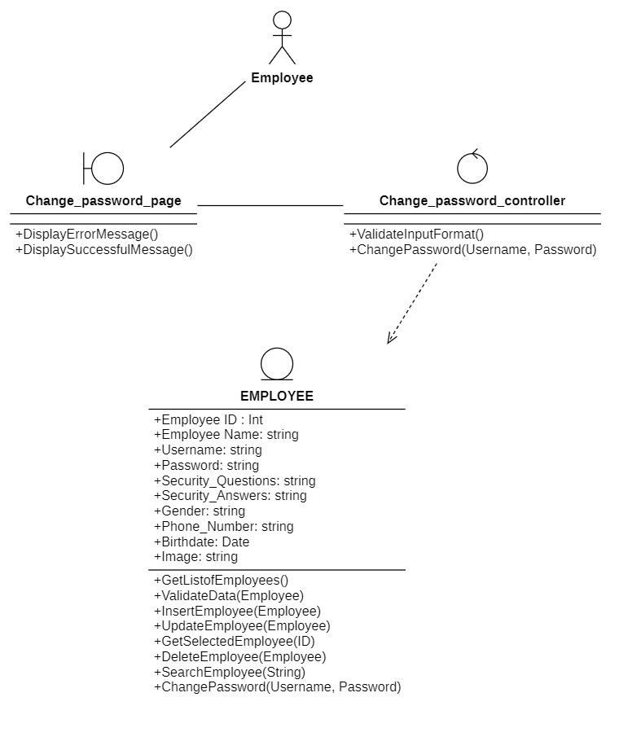

### 3.3.10 Forgot password

#### 3.3.10.1 Sequence Diagram

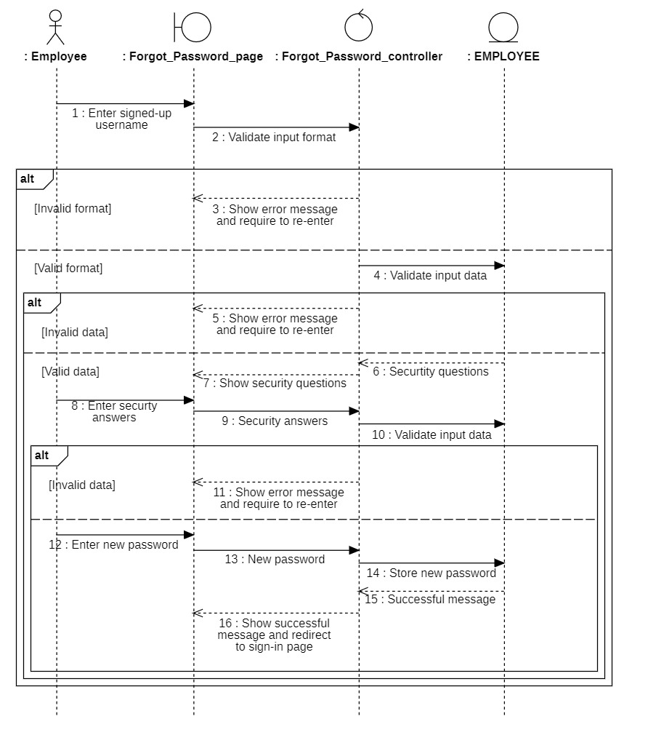

#### 3.3.10.2 Class Diagram

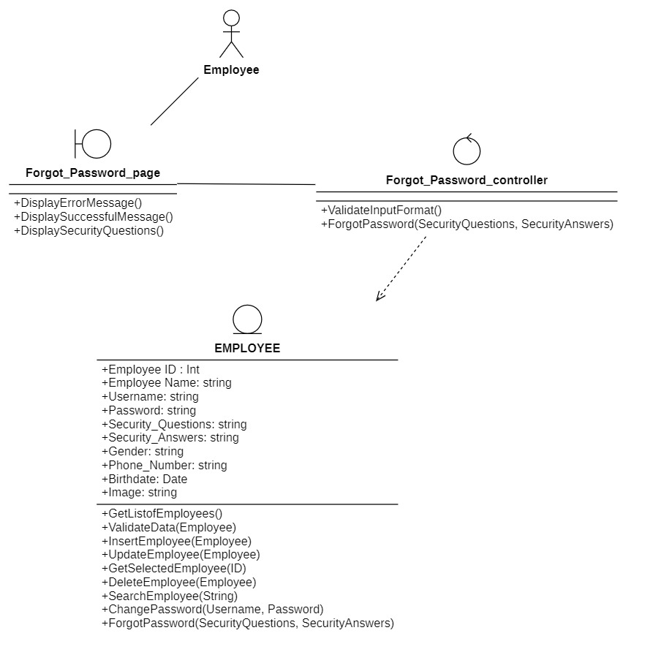

### 3.3.11 Place an invoice

#### 3.3.11.1 Sequence Diagram

Note:

Place an invoice Page boundary includes:

* Add Order Form boundary
* Apply Promotion Form boundary
* Apply Membership Form boundary
* Payment Form boundary

Place an Invoice

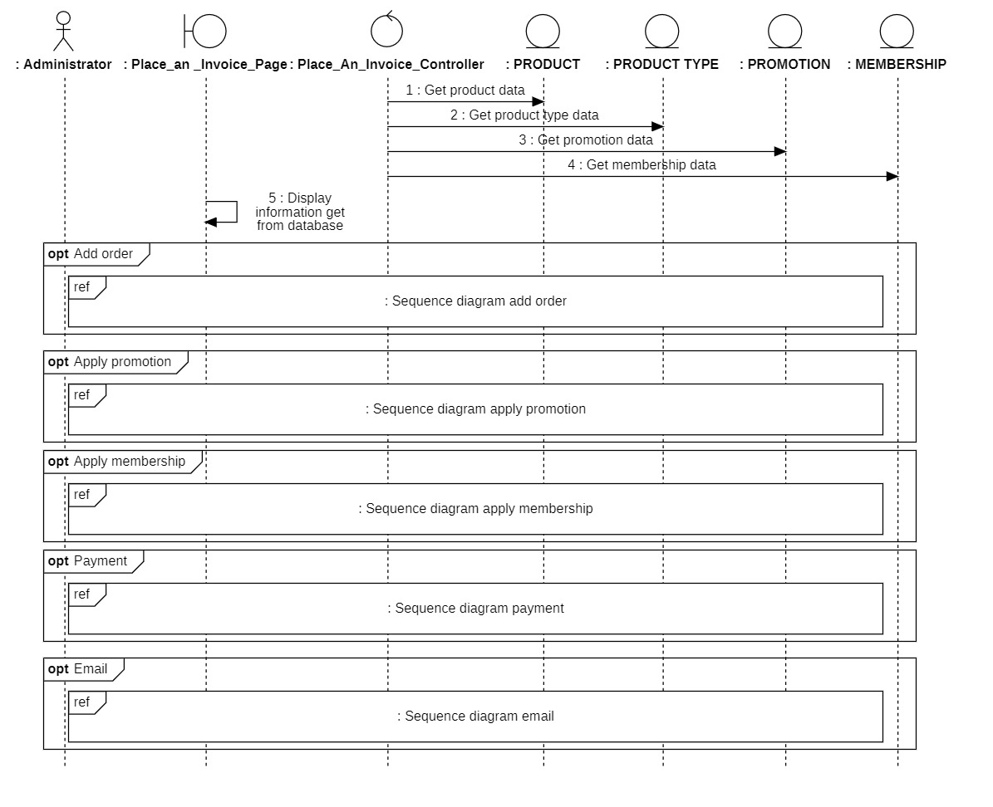

Add order

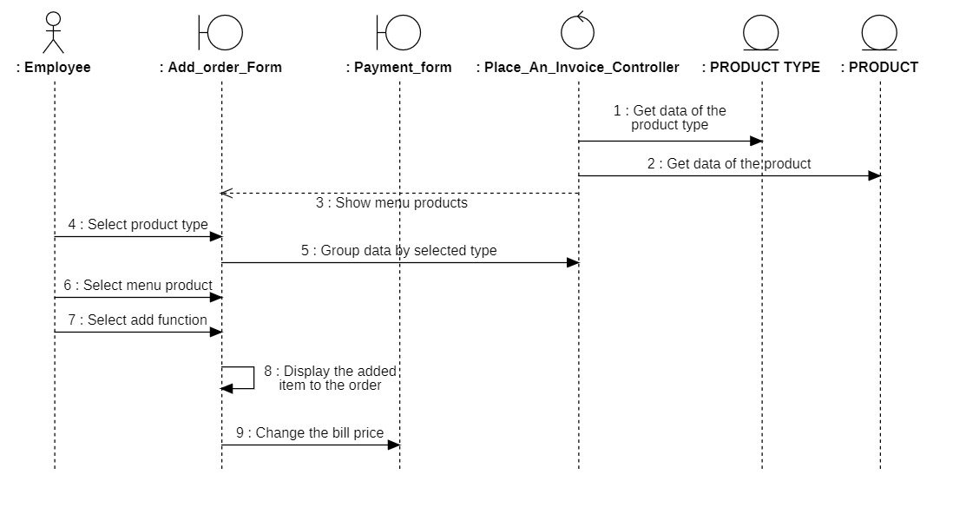

Apply promotion

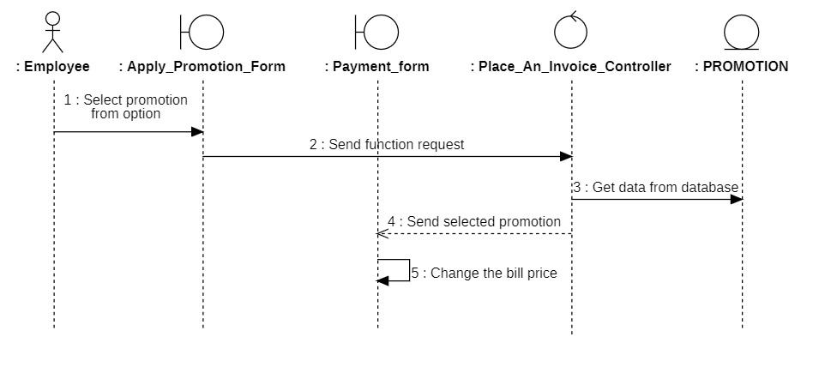

Apply membership

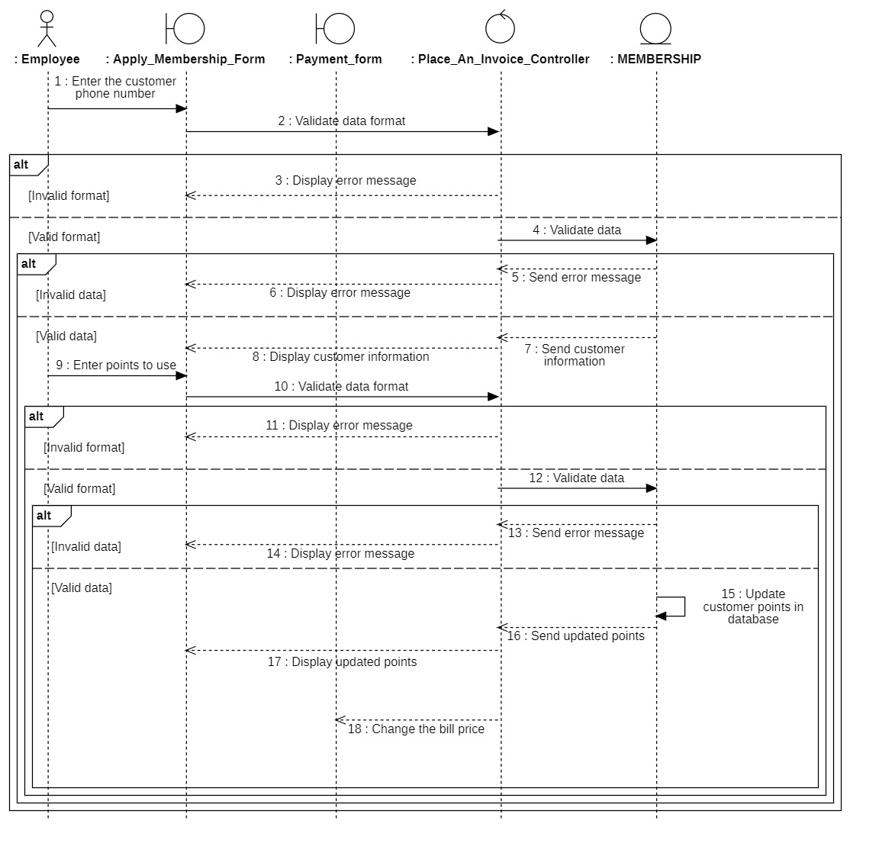

Payment

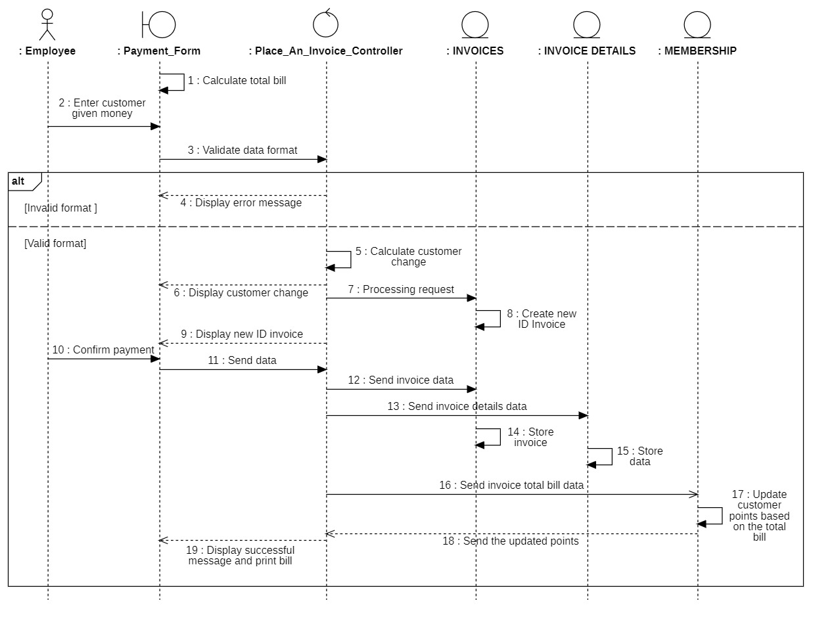

Email

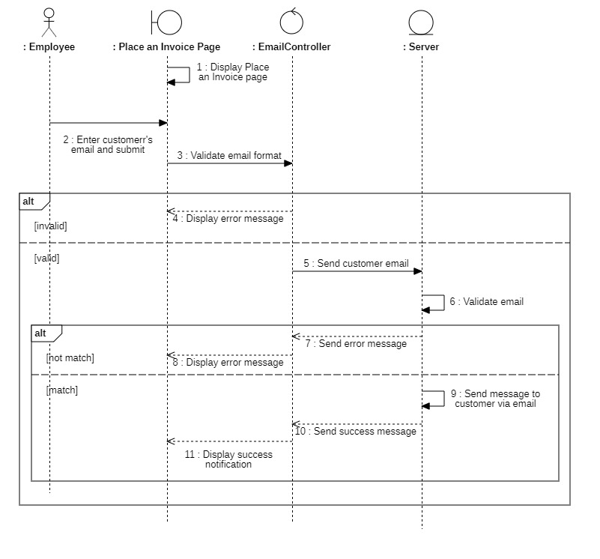

#### 3.3.11.2 Class diagram

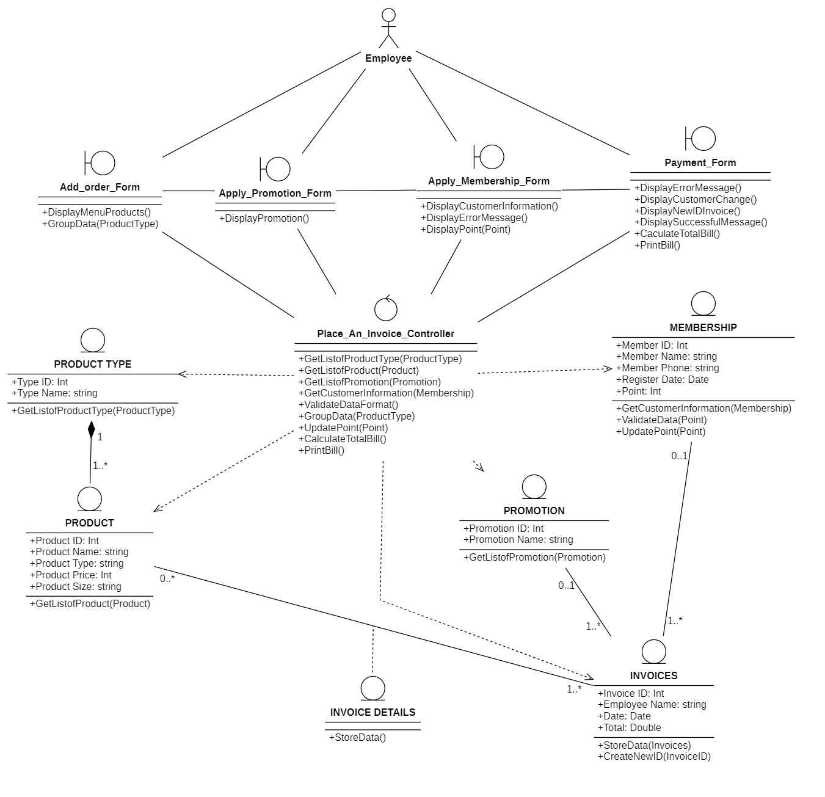

## 

## 3.4. Class Diagram and Entity class diagram

### 3.4.1 Administrator overview class diagram

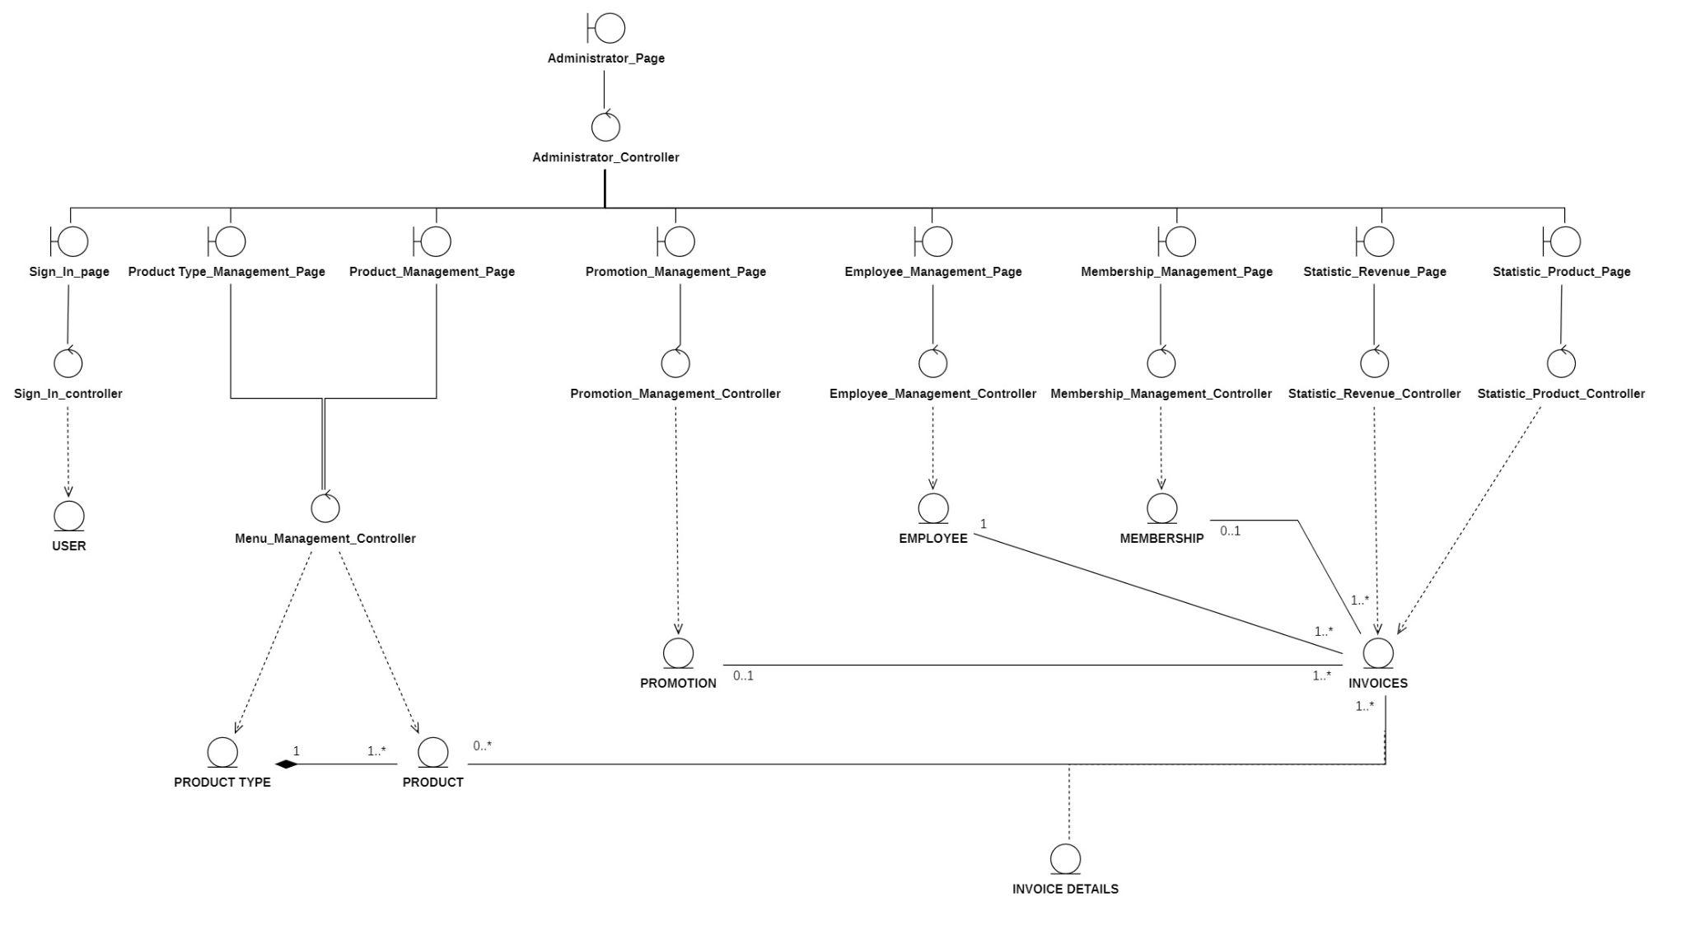

### 3.4.2 Employee overview class diagram

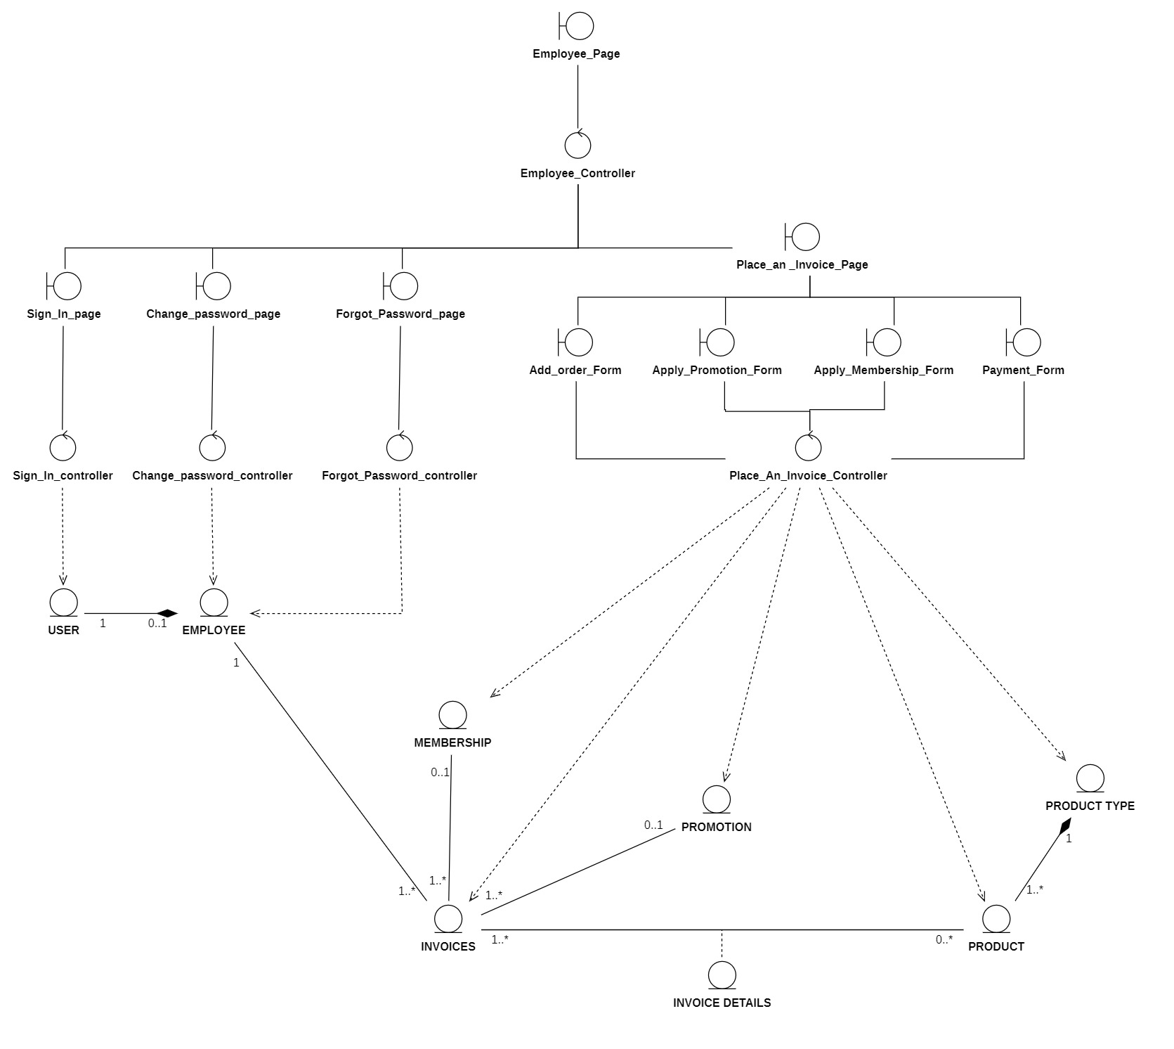

### 3.4.3 Entity class diagram

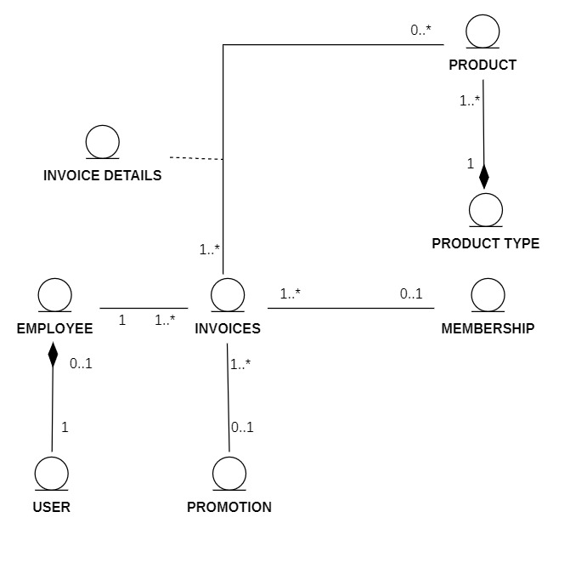

Note:

A product has one product type and a product type have one or many products

None or many products include in one or more invoices

Invoice details include in invoice

Invoice includes one or none membership, one or none promotion and one employee

One employee is one user.

Employees can make many invoices.

### 3.4.4 Class diagram specification

#### 3.4.4.1 User

|  |  |  |
| --- | --- | --- |
| **User** | | |
| **Attribute** | **Variable** | **Meaning** |
| Username: String | Registered username of account |
| Password: String | Password of user’s account |
| Role: String | Accounts divide into two role: one is for admin role and the other is for employee role. |
| SignInStatus: Bool | This status is used when an account signs in. True is signed-in status. False is the not-signed-in status. |
| **Operation** | Function | Meaning |
| ValidateInputData(Username, Password) | Validate if the sign in data is correct with the database. |
| StoreSignInStatus(): Bool | Change the sign in status attribute. |

#### 3.4.4.2 Employee

|  |  |  |
| --- | --- | --- |
| **Employee** | | |
| **Attribute** | **Variable** | **Meaning** |
| Employee ID: Int | Employee ID generated by system |
| Employee Name: String | Full name of employee |
| Username: String | Registered username of employee account |
| Password: String | Password of employee’s account |
| Security_Questions: String | Security questions for forget password function |
| Security_Answers: String | Security answers for forget password function |
| Gender: String | Gender of employee |
| Phone_Number: String | Employee contact phone number |
| Birthdate: Date | Employee birthdate |
| Image: String | Given image of employee’s face |
| **Operation** | Function | Meaning |
| GetListofEmployee() | Get list of employees to perform on the employee’s management page of administrator. |
| ValidateData(Employee) | Validate if the sign in data is correct with the database |
| InsertEmployee(Employee) | Create a new employee in the database. The validation function is prerequisite for this function. |
| UpdateEmployee(Employee) | Update information of an existing employee.  Validation function is prerequisite for this function. |
| GetSelectedEmployee(ID) | Return employee information matched with the ID. This function is used to get a specific data to pour into the information form. |
| DeleteEmployee(Employee) | Delete an employee existed in database. |
| SearchEmployee(String) | Return a list of employees related to the keyword. |
| ChangePassword(Username, Password) | Change the employee account password if the employee wants to. |
| ForgotPassword(Security_Questions, Security_Answers) | Change the employee account password if the employee forgot it by answering the security questions. |

#### 3.4.4.3 Product type

|  |  |  |
| --- | --- | --- |
| **Product type** | | |
| **Attribute** | **Variable** | **Meaning** |
| TypeID: int | Type ID generated by system |
| TypeName: String | Name of product type |
| **Operation** | **Function** | **Meaning** |
| GetListofProductType() | Get list of product types to display on the menu management page of administrator |
| ValidateData(Product) | Validate if the sign in data is correct with the database |

#### 3.4.4.4 Product

|  |  |  |
| --- | --- | --- |
| **Product** | | |
| **Attribute** | **Variable** | **Meaning** |
| ProductID: int | Product ID generated by system |
| ProductName: String | Name of product |
| ProductType: String | Type of product |
| ProductPrice: int | Price of product |
| **Operation** | **Function** | **Meaning** |
| GetListofProduct() | Get list of products to display on the menu management page of administrator. |
| ValidateData(Product) | Validate if the sign in data is correct with the database. |
| InsertProduct(Product) | Create a new product in the database. Validation function is prerequisite for this function. |
| UpdateProduct(Product) | Update information of an existing product.  Validation function is prerequisite for this function. |
| GetSelectedProduct(ProductID) | Return product information matched with the ID. This function is used to get a specific data to pour in the information form. |
| DeleteProduct(Product) | Delete an product existed in database. |
| SearchProduct(String) | Return a list of products related to the keyword. |

#### 3.4.4.5 Membership

|  |  |  |
| --- | --- | --- |
| **Membership** | | |
| **Attribute** | **Variable** | **Meaning** |
| Member ID: Int | Membership ID generated by system |
| Member Name: String | Full name of membership |
| Member Phonenumber: String | Membership contact phone number |
| Member Register Date: date | Date regist to be membership |
| Member Point: int | Membership’s points which was awarded based on their payment |
| **Operation** | **Function** | **Meaning** |
| GetListofMembership() | Get list of memberships to perform on the memberships management page of administrator. |
| ValidateData (Membership) | Validate if the sign in data is correct with the database. |
| InsertMembership (Membership) | Create a new membership in the database. Validation function is prerequisite for this function. |
| UpdateMembership (Membership) | Update information of an existing membership.  Validation function is prerequisite for this function. |
| GetSelectedMembership (Member_ID) | Return membership information matched with the ID. This function is used to get a specific data to pour in the information form. |
| DeleteMembership (Membership) | Delete a membership existed in database. |
| SearchMembership(String) | Return a list of memberships related to the keyword. |

#### 3.4.4.6 Promotion

|  |  |  |
| --- | --- | --- |
| **Promotion** | | |
| **Attribute** | **Variable** | **Meaning** |
| Promotion ID: Int | Promotion ID generated by system |
| Promotion Name: String | Full name of promotion |
| Promotion Discount | Percentage of price discount |
| Start Date: Date | Date that promotion start to apply |
| End Date: Date | Date that promotion end applying |
| Promotion Code: String | Code name of the promotion |
| Promotion Description: Text | Description of the promotion |
| **Operation** | **Function** | **Meaning** |
| GetListofPromotion() | Get list of promotions to perform on the promotions management page of administrator. |
| ValidateData (Promotion) | Validate if the sign in data is correct with the database. |
| InsertPromotion (Promotion) | Create a new promotion in the database. Validation function is prerequisite for this function. |
| UpdatePromotion(Promotion) | Update information of an existing promotion.  Validation function is prerequisite for this function. |
| GetSelectedPromotion (ID) | Return promotion information matched with the ID. This function is used to get a specific data to pour in the information form. |
| DeletePromotion(Promotion) | Delete a promotion existed in database. |
| SearchPromotion(String) | Return a list of promotions related to the keyword. |

#### 3.4.4.7 Invoices

|  |  |  |
| --- | --- | --- |
| **Invoices** | | |
| **Attribute** | **Variable** | **Meaning** |
| Invoice ID: Int | Invoice Id created by system automatically |
| Employee Name: String | Name of the employee who create the invoice |
| Date: Date | The creation day of the invoice |
| Total: Double | Total cost of the invoice |
| **Operation** | **Function** | **Meaning** |
| StoreData(Invoices) | After customer making a purchase, store the invoice information into database. |
| CreateNewID(Invoice ID) | Create a new invoice with new ID. |

#### 3.4.4.8 Sign_In_Controller

|  |  |  |
| --- | --- | --- |
| **Sign_In_Controller** | | |
| **Operation** | **Function** | **Meaning** |
| ValidateInputFormat() | Validate if the input information format is  correct |
| SignIn(Username, Password) | Request to sign in to the database |

#### 3.4.4.9 Employee_Management_Controller

|  |  |  |
| --- | --- | --- |
| **Employee_Management_Controller** | | |
| **Operation** | **Function** | **Meaning** |
| GetListofEmployee() | Get list of employees to perform on the employees management page of administrator. |
| ValidateDataFormat() | Validate if the input information format is correct. |
| InsertEmployee(Employee) | Create a new employee in the database. Validation function is prerequisite for this function |
| UpdateEmployee(Employee) | Update information of an existing employee.  Validation function is prerequisite for this function. |
| GetSelectedEmployee(ID) | Return employee information matched with the ID. This function is used to get a specific data to pour in the information form. |
| DeleteEmployee(Employee) | Delete an employee existed in database. |
| SearchEmployee(String) | Return a list of employees related to the keyword. |

#### 3.4.4.10 Menu_Management_Controller

|  |  |  |
| --- | --- | --- |
| **Menu_Management_Controller** | | |
| **Operation** | **Function** | **Meaning** |
| GetListofProduct() | Get list of products to display on the menu management page of administrator. |
| GetListProductType() | Get list of product's types to display on the menu management page of administrator. |
| ValidateDataFormat() | Validate if the input information format is correct. |
| InsertProduct(Product) | Create a new product in the database. Validation function is prerequisite for this function. |
| InsertProductType(ProductType) | Create a new product type in the database. Validation function is prerequisite for this function. |
| UpdateProduct(Product) | Update information of an existing product.  Validation function is prerequisite for this function. |
| UpdateProductType(ProductType) | Update information of an existing product type.  Validation function is prerequisite for this function. |
| GetSelectedProduct(ID) | Return product information matched with the ID. This function is used to get a specific data to pour in the information form. |
| GetSelectedProductType(ID) | Return product type information matched with the ID. This function is used to get a specific data to pour in the information form. |
| DeleteProduct(Product) | Delete an product existed in database. |
| DeleteProductType(ProductType) | Delete an product type existed in database. |
| SearchProduct(String) | Return a list of products related to the keyword. |
| SearchProductType(String) | Return a list of product types related to the keyword. |

#### 3.4.4.11 Membership_Management_Controller

|  |  |  |
| --- | --- | --- |
| **Membership_Management_Controller** | | |
| **Operation** | **Function** | **Meaning** |
| GetListofMembership() | Get list of memberships to perform on the memberships management page of administrator. |
| DisplayMembershipInformationPage() | Display membership information form for  updating or inserting function. |
| ValidateDataFormat() | Validate if the input information format is correct. |
| InsertMembership(Membership) | Create a new membership in the database. Validation function is prerequisite for this function. |
| UpdateMembership(Membership) | Update information of an existing employee.  Validation function is prerequisite for this function. |
| GetSelectedMembership(ID) | Return membership information matched with the ID. This function is used to get a specific data to pour in the information form. |
| DeleteMembership(Membership) | Delete an membership existed in database. |
| SearchMembership(String) | Return a list of memberships related to the keyword. |

#### 3.4.4.12 Promotion_Management_Controller

|  |  |  |
| --- | --- | --- |
| **Promotion_Management_Controller** | | |
| **Operation** | **Function** | **Meaning** |
| GetListofPromotion() | Get list of promotions to perform on the promotions management page of administrator. |
| ValidateDataFormat() | Validate if the input information format is correct. |
| InsertPromotion(Promotion) | Create a new promotion in the database. Validation function is prerequisite for this function. |
| UpdatePromotion(Promotion) | Update information of an existing promotion.  Validation function is prerequisite for this function. |
| GetSelectedPromotion(ID) | Return promotion information matched with the ID. This function is used to get a specific data to pour in the information form. |
| DeletePromotion(Promotion) | Delete an promotion existed in database. |
| SearchPromotion(String) | Return a list of promotions related to the keyword. |

#### 3.4.4.13 Statistic_Product_Controller

|  |  |  |
| --- | --- | --- |
| **Statistic_Product_Controller** | | |
| **Operation** | **Function** | **Meaning** |
| QueryInvoiceData() | Query all invoices information. |
| GroupData(Invoice Details) | Group the data by selected category. |
| GenerateInteractiveVisualChart() | Create visual chart based on selected category. |
| GetInvoiceData(Invoice Details) | Return the invoice information for analysis function. |

#### 3.4.4.14 Statistic_Revenue_Controller

|  |  |  |
| --- | --- | --- |
| **Statistic_Revenue_Controller** | | |
| **Operation** | Function | Meaning |
| QueryInvoiceData() | Query all invoices information. |
| GroupData(Invoices) | Group the data by selected category. |
| GenerateInteractiveVisualChart() | Create visual chart based on selected category. |
| GetInvoiceData(Invoices) | Return the invoice information for analysis function. |

#### 3.4.4.15 Change_Password_Controller

|  |  |  |
| --- | --- | --- |
| **Change_Password_Controller** | | |
| **Operation** | **Function** | **Meaning** |
| ValidateInputFormat() | Validate if the input information format is correct. |
| ChangePassword(Username, Password) | Change the employee account password if the employee want to. |

#### 3.4.4.16 Forgot_Password_Controller

|  |  |  |
| --- | --- | --- |
| **Forgot_Password_Controller** | | |
| **Operation** | **Function** | **Meaning** |
| ValidateInputFormat() | Validate if the input information format is correct. |
| ForgotPassword(Security_Questions, Security_Answers) | Change the employee account password if the employee forgot it by answer the security questions. |

#### 3.4.4.17 Place_An_Invoice_Controller

|  |  |  |
| --- | --- | --- |
| **Place_An_Invoice_Controller** | | |
| **Operation** | **Function** | **Meaning** |
| GetListofProductType(Product Type) | Get list of product types to perform on the place an invoice page of employee. |
| GetListofProduct(Product) | Get list of products to perform on the place an invoice page of employee. |
| GetListofPromotion(Promotion) | Get list of promotions to perform on the place an invoice page of employee. |
| GetCustomerInformation(Membership) | Get customer information to perform on the membership area in place an invoice page of employee. |
| ValidateDataFormat() | Validate if the input information format is correct. |
| GroupData(ProductType) | Group the data by selected category. |
| UpdatePoint(Point) | Update customer points in the membership database.  Validation function is prerequisite for this function. |
| CalculateTotalBill(Total) | Calculate the total bill and display on the payment area. |
| PrintBill() | Export the text file with the invoice information on it. |

#### 3.4.4.18 Email_Controller

|  |  |  |
| --- | --- | --- |
| **Email_Controller** | | |
| **Operation** | **Function** | **Meaning** |
| GetCustomerEmail (Email) | Get customer email from the entered email. |
| ValidateDataFormat() | Validate if the input information format is correct. |

## 3.5. State Diagram

### 3.5.1 Employee

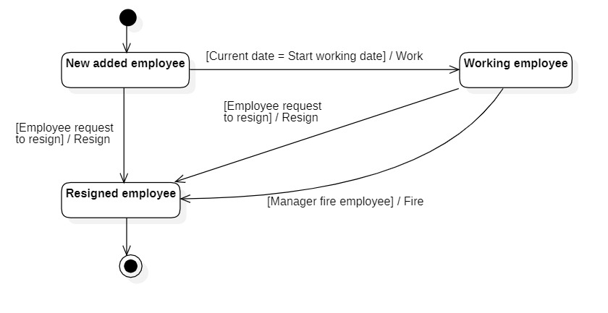

### 3.5.2 Promotion

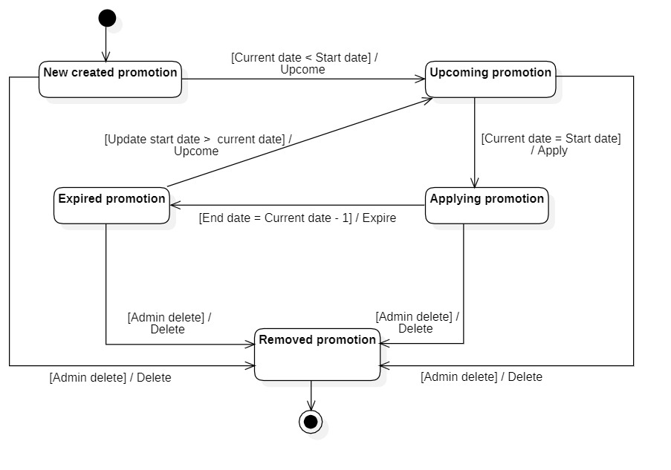

### 3.5.3 Membership

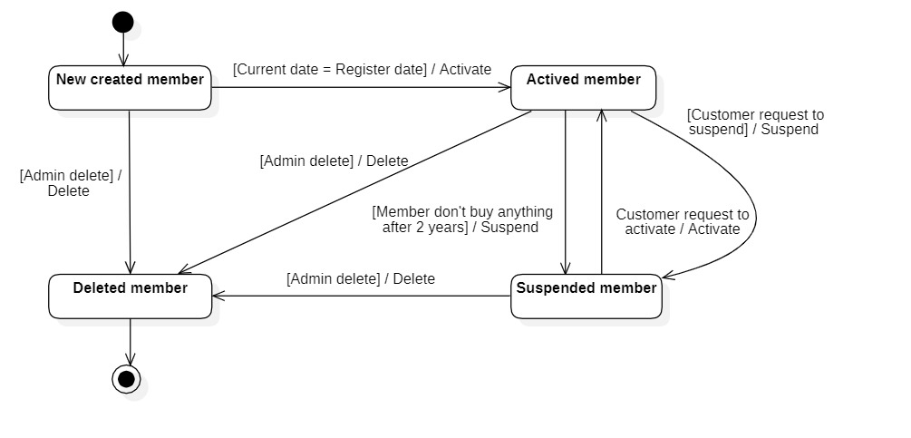

### 3.5.4 Invoice

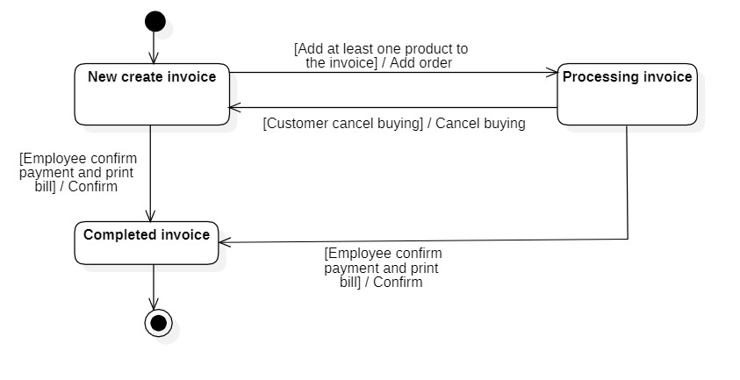

## 3.6. Mapping to Relational Model from Entity class diagram

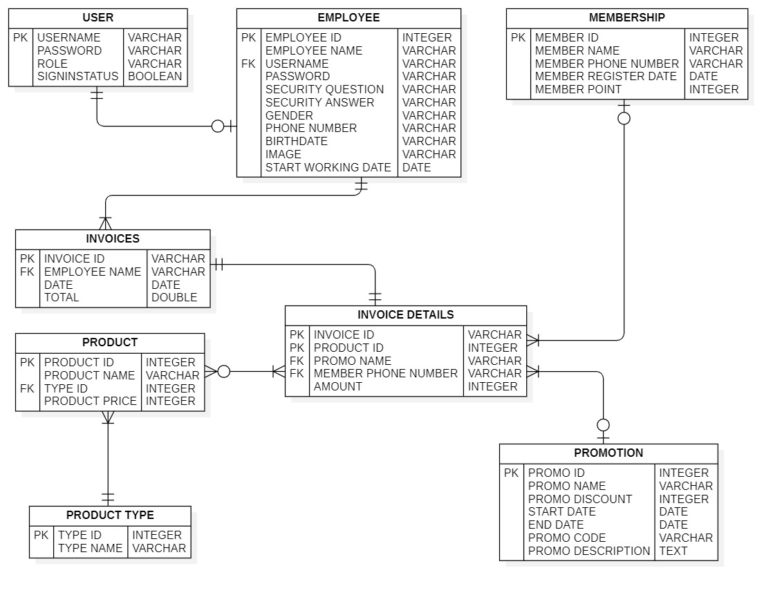

# 

# Chapter 4: IMPLEMENTATION AND TESTING

## 4.1. Introduction to the implementationenvironment

### 4.1.1 Development System

* Operating System: Window 10
* Database: MySQL
* Text Editor: NetBeans

### 4.1.2 Deployment environment

* Operating system : Window 10 or higher version
* To be installed : XAMPP

## 4.2. User Interface

### 4.2.1 Employee Interface

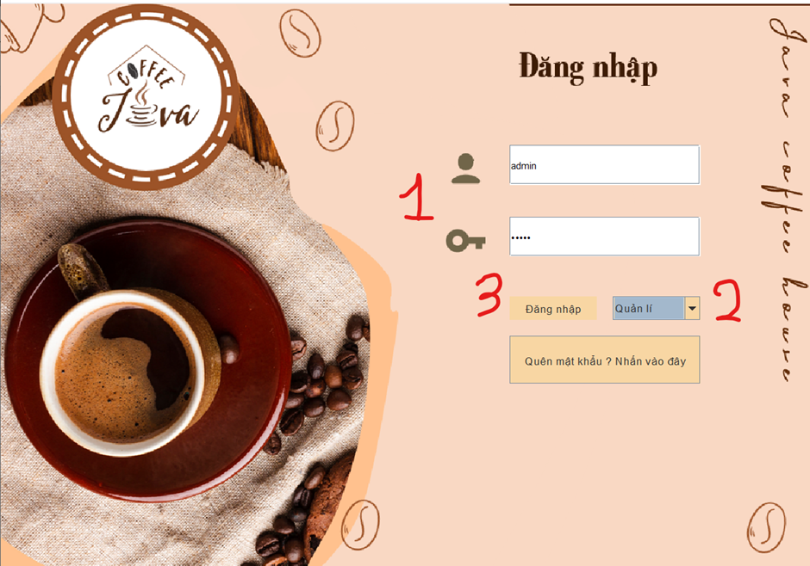

1.Login page

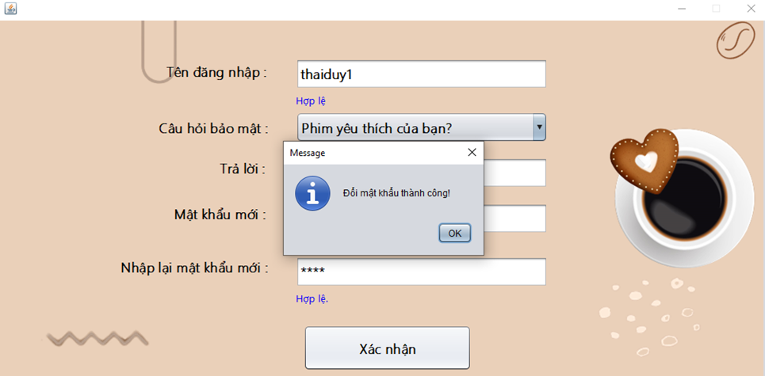

2.Forgot password page

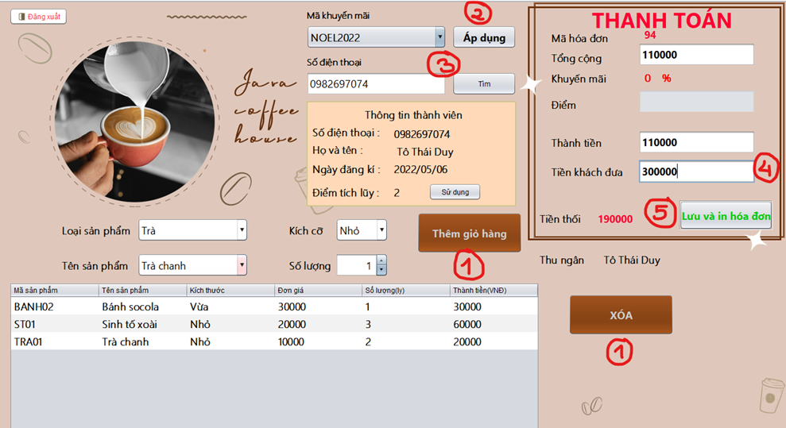

3.Bill page

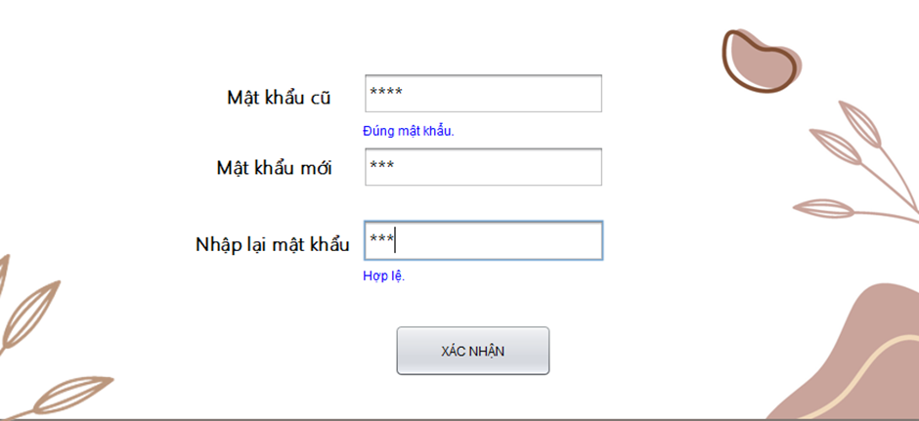

4.Change password page

### 4.2.2 Admin Interface



5.Login page

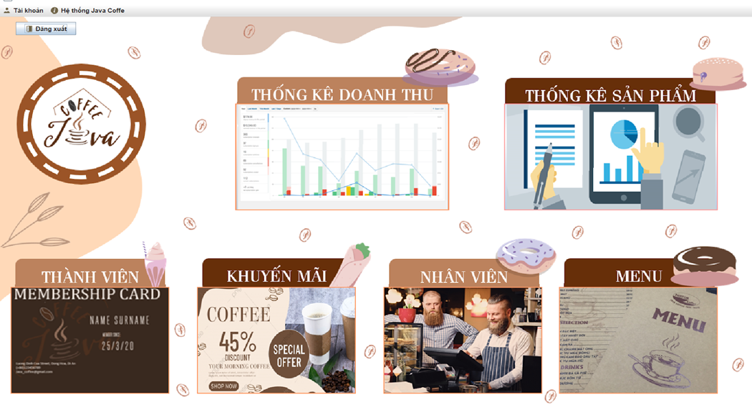

6.Manager management page

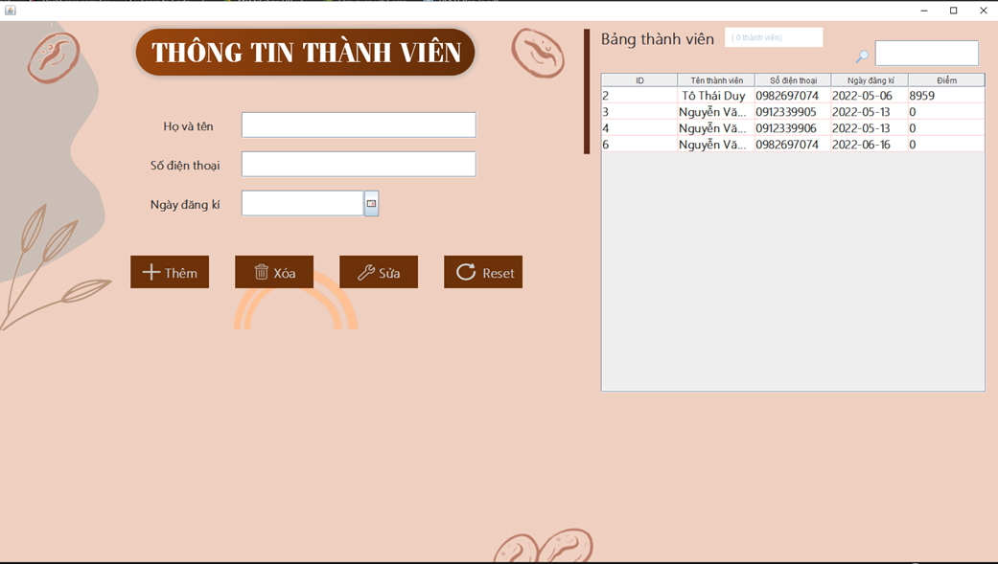

7.Customer management page

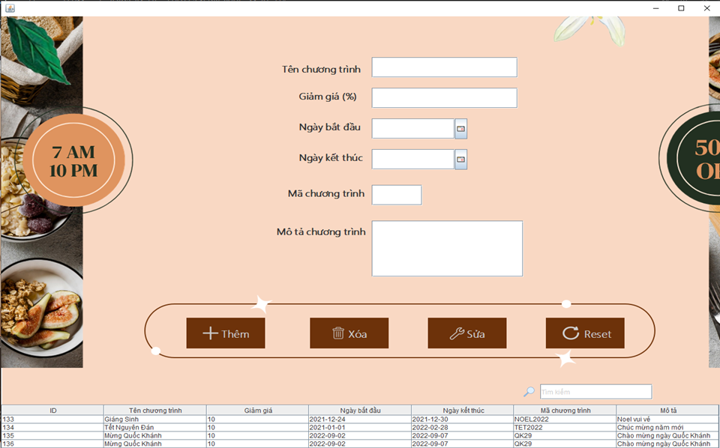

8.Promotion management page

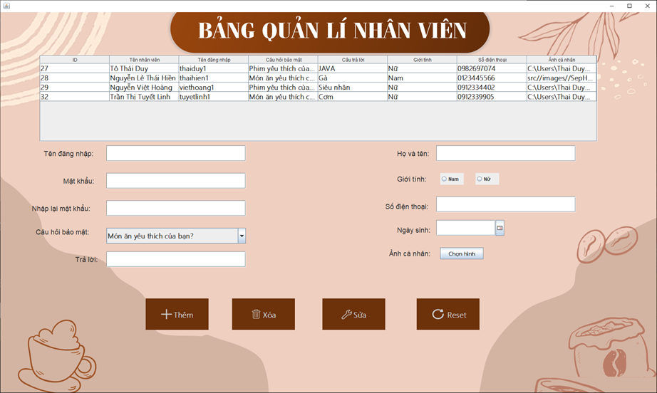

9.Employee Management Page

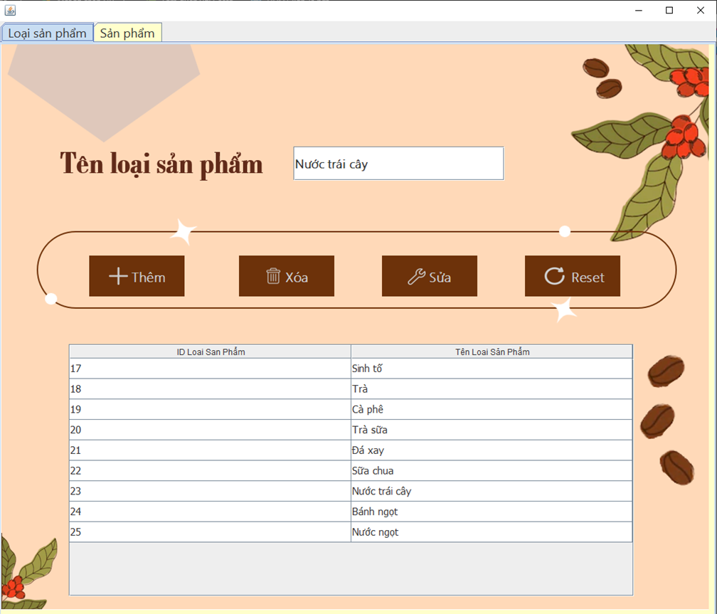

10.Menu management page

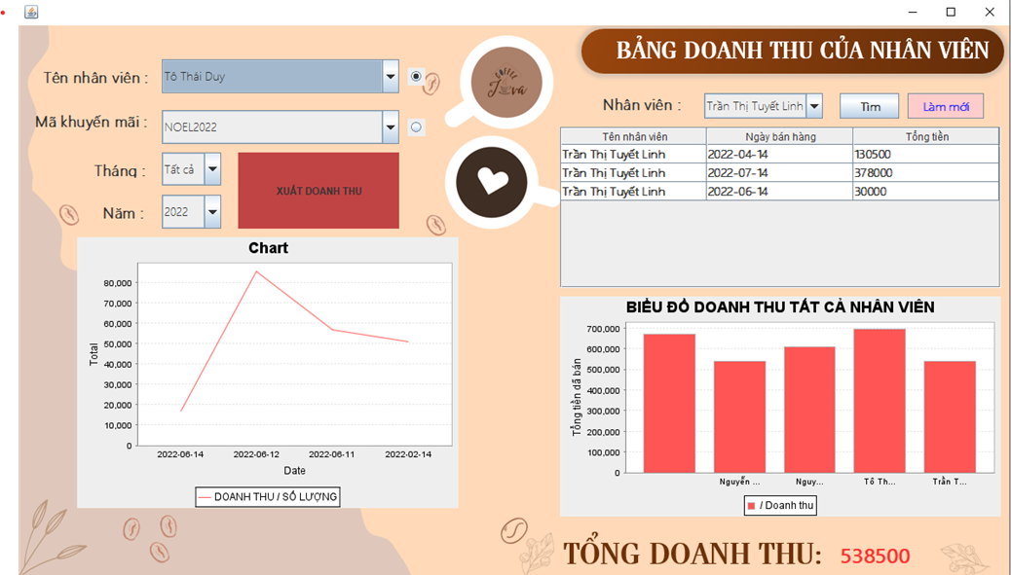

11.Revenue statistic page

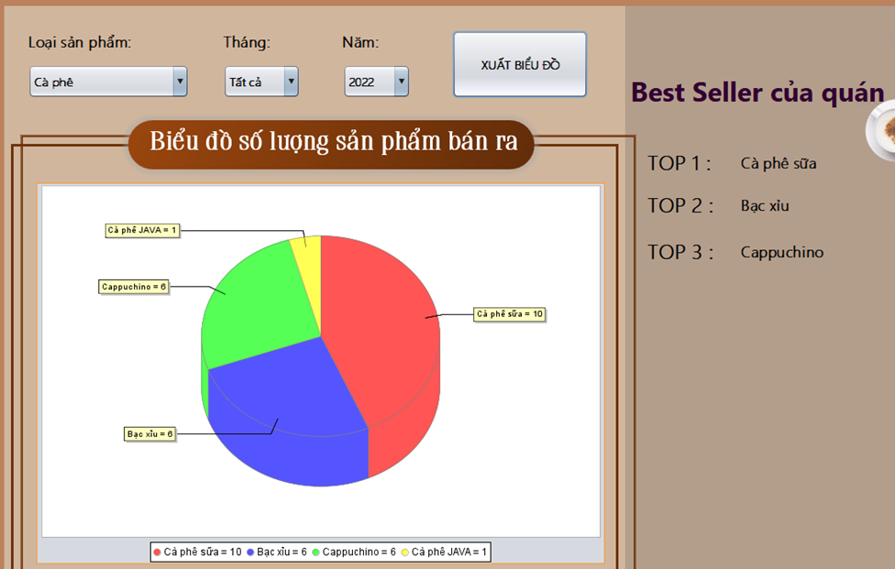

12.Analysis product page

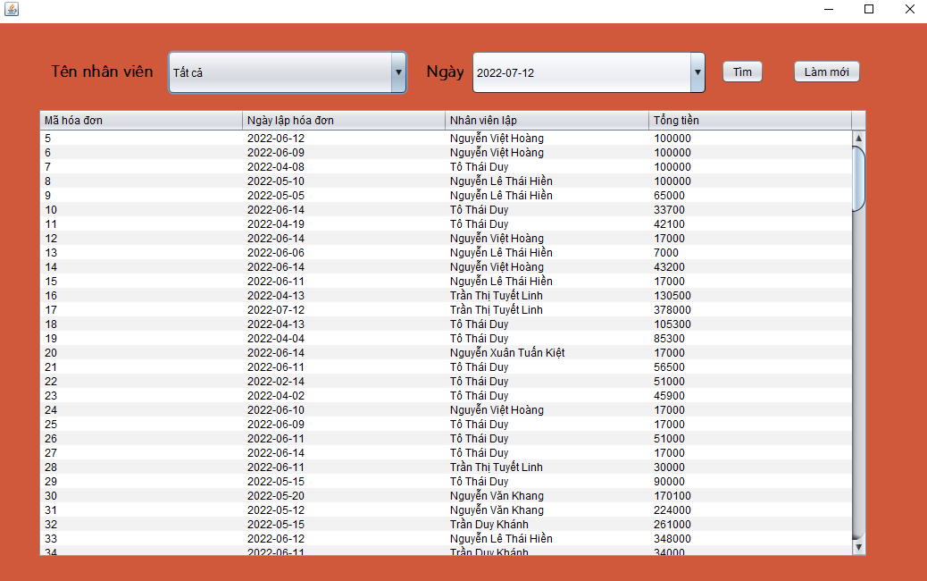

13.History page

# Chapter 5: CONCLUSION

## 5.1 Project achievement

In order to improve the business and attract customers as much as possible, using a management system in nowadays coffee shops plays an important role in it. With our coffee shop management application project, we ensure that our system functions benefit every shop manager who wants their management job more efficiently.

As for our system, we have provided functions for two users. One for managers who want to do shop management and the other is for the shop employees to sell shop products for customers.

This are primary functions which include in our system:

* Sign in for administrator/employees
* Change/Forgot password
* Manage employees
* Manage menu
* Manage membership
* Manage promotion
* Visualize statistic of revenue based on many criterias
* Analysis customer order based on statistic of order
* Create a point system for membership to apply to payment
* Print and export the bill

Thanks to Java and MySQL technologies we manage to build our system completely.

## 5.2 Limitations

Due to the limited time and study, our system still has some limitations:

* Have not built the import process management yet.
* The interface is not compatible with devices such as mobile and tablet.
* There is no data recovery and backup function yet.
* Analysis and statistical function are still not at our best state design.

## 5.3 Development direction

In the future, the team will develop and complete the project, specifically as follows:

* Finish building the import process management.
* The interface is compatible with devices such as mobile and tablet.
* Complete having data recovery and backup function.
* Analysis and statistical function will be at our best state design.
* Develop our already existing management functions more efficiently.